Proceedings   
of the   
11th Asia-Pacific Conference   
of the ISTVS

September 26-28, 2022 :: online  
hosted by Harbin Institute of Technology, China  
https://2022.istvs.org

ISBN 978-1-942112-53-2

*Proceedings of the 11th Asia-Pacific Conference of the ISTVS*

Copyright © 2022 by the International Society for Terrain-Vehicle Systems. All rights reserved.

Copyright and Reprint Permission

Abstracting is permitted with credit to the source. Libraries are permitted to photocopy beyond the limit of U.S. copyright law, for private use of patrons, those articles in this volume that carry a code at the bottom of the first page, provided that the per-copy fee indicated in the code is paid through the Copyright Clearance Center, 222 Rosewood Drive, Danvers, MA 01923.

Other copying, reprint, or reproduction requests should be addressed to General Secretariat, International Society for Terrain-Vehicle Systems, 72 Lyme Road, Hanover, NH 03755.

ISBN 978-1-942112-53-2

Additional copies of this publication are available from

https://www.istvs.org/proceedings

Contents

Conference overview 3

Conference program 6

Technical papers 11*

Conference overview

The aim of the conference is to further advance knowledge in terrain-vehicle and road- vehicle system dynamics and design and, thus, to discuss and suggest new frontiers and research directions, facilitate engineering practice, and benefit the society at large in the area of the energy conservation, environmental sustainability, safety, cyber/physical security, application of artificial intelligence (AI) techniques in terramechanics and development of vetronics systems for civil and on ground-moving military vehicles.

* Terramechanics, locomotion, and soil/terrain modeling
* Recent accomplishments in terramechanics research and education
* Locomotion systems
* Soil and terrain modeling and characterization
* Advances in mobility, energy efficiency, ground vehicle dynamics, and high-fidelity simulation
* Agricultural, forestry, construction equipment, and machinery
* Mobile robotics for ground applications, planetary exploration, and other environments
* Design/control, sensing/actuation in cyber-physical systems for vehicle dynamics and mobility
* Innovative system designs for terrain and road-vehicle applications
* Application of artificial intelligence to vehicles

Conference Chair

Liang Ding

Harbin Institute of Technology | [liangding@hit.edu.cn](mailto:liangding@hit.edu.cn)

Scientific Committee

Liang Ding, China, Chair Massimo Martelli, Italy

Corina Sandu, U.S.A. Mehari Tekeste, U.S.A.

Dror Rubinstein, Israel Parish Nalavade, India

Genya Ishigami, Japan Peter Kiss, Hungary

George Mason, U.S.A. Qingqing Wei, China

Haibo Gao, China Rámon Gonzalez, Spain

Heidi R. Howard, U.S.A. Sally Shoop, U.S.A.

Hiroshi Nakashima, Japan Schalk Els, South Africa

Jianqiao Li, China Shashank Agarwal, U.S.A.

József Kövecses, Canada Shingo Ozaki, Japan

Junya Yamakawa, Japan Taizo Kobayashi, Japan

Kyeong Uk Kim, S. Korea Thomas R. Way, U.S.A.

Lei Jiang, China Vilas Salokhe, India

Luquan Ren, China Vladimir Vantsevich, U.S.A.

Lutz Richter, Germany Zhenyu Xu, China

Keynote Speakers

 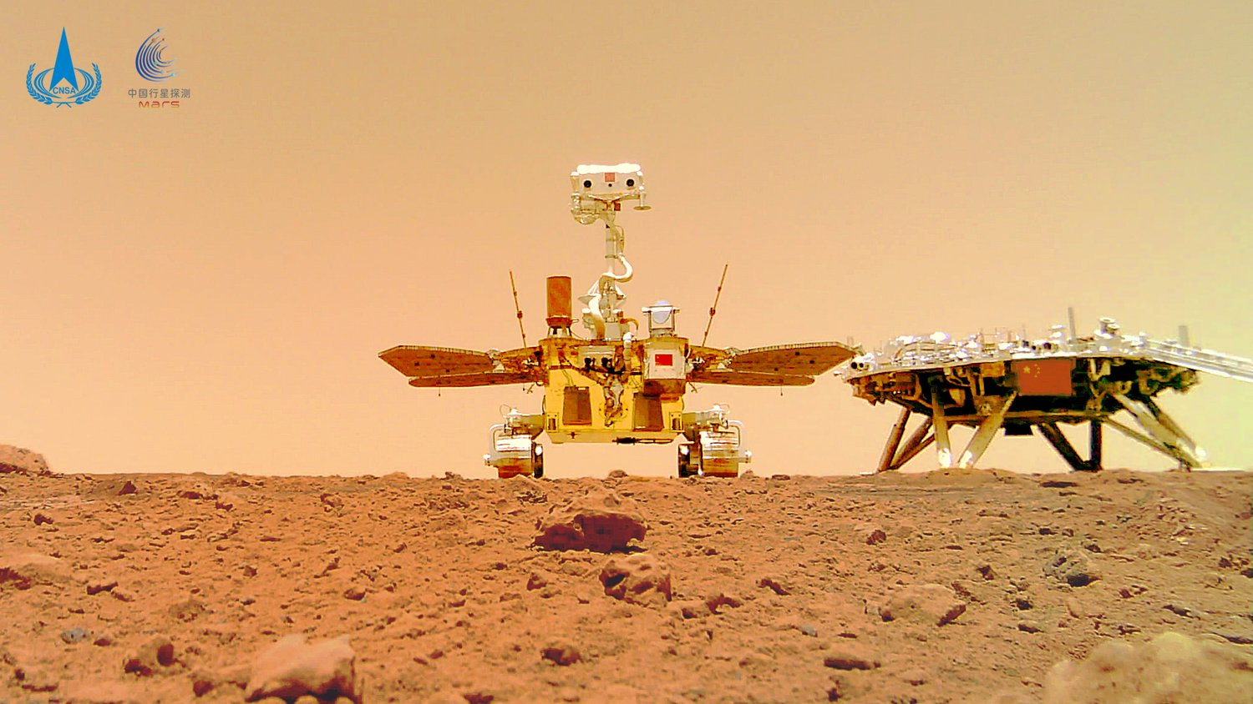

**Baofeng Yuan**

*Locomotion and Exploration of Zhurong Mars Rover*

Chief designer of the Zhurong Mars Rover mobility system

China Academy of Space Technology

Researcher, Space robot technology, China Academy of Space Technology | Beijing Institute of Space Systems Engineering

Baofeng Yuan has been engaged in the research of space robot technology since 2006. His research interests include space robot system design, precision transmission and mechanism design, drive control and dynamic analysis, perception and measurement technology. His research projects include Zhurong Mars rover mobile system, space station manipulator and Chang’e 5 sampling manipulator. He has published 5 SCI journal papers and 11 EI journal papers and applied 13 patents.



**Salah Sukkarieh**

*Agriculture Robotics—Mechatronic and AI design for all terrain operations*

Professor, Robotics and Intelligent Systems, University of Sydney | Sydney Institute of Agriculture | The University of Sydney Nano Institute | the Charles Perkins Centre | CEO of Agerris | [C.V.](https://www.sydney.edu.au/engineering/about/our-people/academic-staff/salah-sukkarieh.html)

Dr. Salah Sukkarieh was the Director Research and Innovation at the Australian Centre for Field Robotics from 2007-2018. He was awarded the NSW Science and Engineering Award for Excellence in Engineering and Information and Communications Technologies in 2014, the 2017 CSIRO Eureka Prize for Leadership in Innovation and Science, and the 2019 NSW Australian of the Year nominee. He is a Fellow of Australian Academy of Technological Sciences and Engineering (ATSE) and has over 500 academic and industry publications in robotics and intelligent systems.



**Guangming Chen**

*Development of a Biologically Inspired Walking Robot for Mars Exploration*

Instructor, School of Mechanical and Electrical Engineering, Nanjing University of Aeronautics and Astronautics | Institute of Bio-Inspired Structure and Surface Engineering | [C.V.](https://cmee.nuaa.edu.cn/2019/0222/c11675a189008/page.htm) | [ResearchGate](https://www.researchgate.net/profile/Guangming-Chen-8)

Dr. Guangming Chen obtained his Ph.D. from Delft University of Technology, Netherlands. Since November 2017, he works at the Nanjin University of Aeronautics and Astronautics. His research interest is mobile robotics for unstructured environments. He has published 13 SCI journal papers and 10 conference papers and applied for 8 patents.

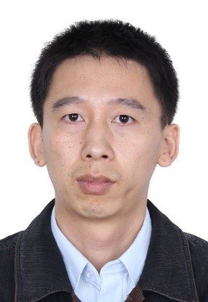

**Ye Zhuang** | on behalf of FISITA

*Semi-Active Reinforcement Learning Suspension Control for Off-Road Vehicles*

Professor | State Key Lab of Automotive Simulation and Control, College of Automotive Engineering | Jilin University | [website](https://auto.jlu.edu.cn/info/1139/2391.htm)

Professor Ye Zhuang obtained his Ph.D. from Jilin University, China. Since September 2005, he works at Jilin University. His research interest is vehicle multibody dynamics and control. He has published 20 SCI journal papers and 10 conference papers and been granted 12 patents.

Hosting Institution

Harbin Institute of Technology, affiliated with the Ministry of Industry and Information Technology of the People’s Republic China, focuses on science and engineering and maintains the coordinated development of multiple disciplines including science, engineering, management, literature, economics, law, and art.

Since its founding in 1920, HIT has been well-known as the cradle of engineers today. HIT has three campuses in Harbin, Weihai, and Shenzhen.

Sponsors—Gold



**Research Center of Aerospace Mechanism and Control** relies on the mechanical engineering of Harbin Institute of Technology and carries out relevant basic theory and key technology research in view of the serious shortage of basic theory and basic technology in the development of Aerospace Science and technology. It carries out research on international cooperation projects by actively introducing and gathering international academic masters and backbones around seven specific academic directions, including planetary exploration robots, and space folding institutions.

Contact: [yanghuaiguang@hit.edu.cn](mailto:yanghuaiguang@hit.edu.cn)



**Sunrise Instruments** is a leading manufacturer of 6 axis force/torque sensor for robotics, automation, bio­mechanics, automotive crash dummies, and vehicle durability tests. It is specialized in the development of six axis force/torque sensors, multi-axis force/torque sensor, 6 axis load cell, 6 axis force transducer, and robot force-controlled grinding, robot grinding, robot polishing, and robot sanding.

Contact: +86-13061612685, [sri@srisensor.com](mailto:sri@srisensor.com), [www.srisensor.com](http://www.srisensor.com)

Sponsors—Silver



**HRG International Institute (Hefei) of Research and Innovation** (HRG (Hefei) for short) founded in August 2016, which is a new R&D institution of “city campus-enterprise cooperation.” Its main business focuses on the research and development of high and new technologies and the transformation of scientific and technological achievements in the field of robot, artificial intelligence, intelligent equipment and the Internet of Things. HRG (Hefei) , which has set up six front-end scientific research industry research institutes, is committed to building an intelligent robot research system of “behavioral intelligence-brain-like intelligence-cloud brain intelligence. HRG (Hefei) has built an ecological chain of the upper, middle and lower reaches of the robot industry, covering the core key components of the robot, ontology, system integration and software services.

Contact: 861-0551-68996766, [www.hiiri.cn](http://www.hiiri.cn), marketinghf@hitrobotgroup.com

Sponsor—Bronze



Weihai Tiante Intelligent Technology Co., Ltd., is a professional company of skateboard chassis + scene customized unmanned operation module. The core R&D team of the company comes from the Institute of Intelligent and Special Vehicles of Harbin University of Technology (Weihai) and has been engaged in the research of special vehicles and driverless vehicles for many years. The company is a well-known supplier of intelligent mobile platform. Its service scope covers logistics, fire protection, security, national defense, and other industries. It has formed a general chassis + scene customized R&D mode to serve the development of robot technology in various industries.

Contact: +86-18249758524 | [wjfeee123@163.com](mailto:wjfeee123@163.com)

Conference program

All times are in Beijing time (UTC+8).

Check your local time here: [everytimezone.com](https://everytimezone.com/)

View full paper abstracts: <https://docs.qq.com/doc/p/790538998d6263416c70b49208393a57e93bb638?dver=3.0.0>

View abstract-only abstracts: <https://docs.qq.com/doc/p/52ddd7f5e6b62fc416c6e1fd63b507f06c335ccc?dver=3.0.0>

View advance video presentations: <https://vimeo.com/showcase/istvs2022> (password sent to registered attendees)

|  |  |
| --- | --- |
| Monday, September 26, 2022 | |
| 19:00 - 19:40 | Opening Ceremony |
|  | Chair: Liang Ding  Welcome by Conference Chair: Liang Ding  Welcome by Zhiwu Han, Executive Director of Chinese Society for Agricultural Machinery  President Address: Corina Sandu  Report on Journal of Terramechanics: Corina Sandu for Vladimir Vantsevich |
| 19:40 - 19:45 | 5-minute break |
| 19:45 - 20:35 | Plenary — Keynote |
|  | Chair: Lutz Richter |
|  | Locomotion and Exploration of Zhurong Mars Rover  Baofeng Yuan |
|  | Chief designer of the Zhurong Mars Rover mobility system | China Academy of Space Technology |
| 20:35 - 20:45 | 10-minute break |

|  |  |  |  |
| --- | --- | --- | --- |
| 20:45 - 22:30 | Session 1-1-A  Best Paper Candidates | Session 1-2-A  Mobility and Traction Characterization I | Session 1-3-A  Control, Planning and Estimation I |
|  | Time: 20:45 - 21:25  Chair: Péter Kiss  Co-Chair: Dror Rubinstein | Time: 20:45 - 21:35  Co-Chair: Meng Zou  Chair: Chen Li | Time: 20:45 - 21:35  Chair: Parish Nalavade  Co-Chair: He Kong |
|  | Acquisition of Flipper Motion of Tracked Robot in Step-Climbing Using Reinforcement Learning | A Wheel and Vehicle Mobility Index Based on Traction and Velocity for Optimization of Mobility Performance | Semi-active Reinforcement Learning Suspension Control for the Off-road Vehicles |
|  | Ryosuke Eto, Junya Yamakawa| 9913 | Vladimir Vantsevich, David Gorsich, Jesse Paldan, Masood Ghasemi, Lee Moradi| 0963 | Ye Zhuang, Haojie Sun, Yingchun Qi, Weiguang Fan, Hui Ye| 1128 |
|  | Research on Drag Reduction Performance of Sliding Plate of Rice Direct Seeding Machine Based on Non-smooth Structure of Loach Surface | A Comprehensive Lumped Parameter Approach for the Dynamic Simulation of Agricultural Tractors in Real Operating Conditions | Foothold Selection Considering Constraint and Slippage Evaluation for Legged Robots |
|  | Hongchang Wang, Zhen Jiang, Kaiquan Ding, Guozhong Zhang, Abouelnadar Salem, Yuan Gao| 5979 | Marco Polastri, Damiano Chiarabelli, Silvia Gessi, Massimo Martelli, Emiliano Mucchi, Pietro Marani| 2034 | Yufei Liu, Lei Jiang, Chong Tian, Boyang Xing, Zhirui Wang, Bo Su, Tong Yan, Liang Ding, Haibo Gao| 1534 |
|  | Factors Affecting Bevameter Soil Characterization | Investigation of the Shear Stress Dynamics on Silty Loam Soil and Measurement of Traction-Wheel Slip Relationship of a Tractor Tire | Model Predictive Control of a Robot Driven Vehicle for Testing of Advanced Driver Assist Systems |
|  | Schalk Els, Herman Hamersma, Ray Kruger| 6174 | César Andrés Arévalo-Montaña, Stefan Böttinger| 2149 | Mike Huang, Qiu Haixuan,Yang Chunyu, Xia Lian, Lin Zhaomin, Wang Yanqing, Xu Zongqing, Mingfu Tang| 2539 |
|  |  | Research on High Traction Bionic Wheel Based on Traction Characteristics of Jerboa Foot | Energy Consumption Analysis of Door Opening with a Mobile Manipulator in the Nuclear Power Plants |
|  |  | Hao Pang, Liangliang Zhao, Huailiang Wang, Rui Zhang| 2681 | Changyou Ma, Binbin Yan, Xu Xiong, Haibo Gao, Liang Ding| 2632 |
|  |  | The Running Gear Construction Impact on Obstacles Overcoming by Light High-Mobility UGV | An Improved Simultaneous Localization and Mapping Method Based on LeGO-LOAM and Motion Compensation |
|  |  | Daniela Szpaczyńska, Marian Łopatka, Piotr Krogul| 4260 | Mengyang Li, Xinsheng Wang, Xiyue Wang, Shuang Liu| 2643 |
|  | Session 1-1-B  Best Student Paper Candidates | Session 1-2-B  Mobility and Traction Characterization II | Session 1-3-B  Control, Planning and Estimation II |
|  | Time: 21:30 - 22:30  Chair: Péter Kiss  Co-Chair: Shashank Agarwal | Time: 21:40 - 22:30  Co-Chair: Chen Li  Chair: Meng Zou | Time: 21:40 - 22:30  Chair: Parish Nalavade  Co-Chair: He Kong |
|  | The Effect of Integrating a Bio-inspired Convex Structure with a Low-Surface Energy Polymer on Soil Adhesion and Friction | Steadily Learn to Drive with Virtual Memory | Obstacle Avoidance of Mobile Robots Using Modified Artificial Potential Field Algorithm Based on Vortex and PID Adjustment |
|  | Abouelnadar Salem, Guozhong Zhang, Hongchang Wang| 8349 | Yuhang Zhang, Yao Mu, Shengbo Li, Yangang Ren, Liye Tang, Yujie Yang, Chen Chen| 4774 | Zhuoran Sheng, Song Wang| 3004 (Abstract only) |
|  | A Time Domain Passivity Controller for Teleoperation of Four-Wheeled Differential Mobile Robot on Slippery Surface | Research on Vehicle Running Performance on Paved Roads Covered with Falling Volcanic Ash | Perceptive Locomotion of Legged Robot Coupling Model Predictive Control and Terrain Mapping |
|  | Hui Xi, Yanjing Li, Pengyu Sun, Weihua Li, Jianfeng Wang| 7092 | Junya Yamakawa, Ryosuke Eto, Yasuhiro Ichikado, Mitsuhiro Yoshimoto, Tatsuji Nishizawa, Tomohiro Kubo, Hiroyuki Yamada| 6718 | Boyang Xing, Lei Jiang, Bo Su, Yufei Liu, Zhirui Wang, Tianqi Qiu,Jianxin Zhao| 6316 |
|  | Study of Passive Steering Mechanism for Mars Surface Exploration Rovers | Vehicle Dynamic Factor Characterized by Actual Velocity and Combined Influence of the Transmission and Driveline System | Study of Passive Steering Mechanism for Mars Surface Exploration Rovers  Vehicle Dynamic Factor Characterized by Actual Velocity and Combined Influence of the Transmission and Driveline System  Research on Energy-Saving Underactuated Bionic Biped Robot |
|  | Asahi Oe, Shin-Ichiro Nishida, Shintaro Nakatani| 7233 | Vladimir Vantsevich, David Gorsich, Jesse Paldan, Jordan Whitson, Brian Butrico, Oleg Sapunkov| 7199 | Youhao Diao, Zhiqiang Zhuang, Xuebo Wang| 7349 (Abstract only) |
|  | Parameters Calibration of Red Clay Soil in Hilly Area of Southwest China for Discrete Element Simulation Based on Repose Angle Test | Determination of the Necessary Indicators of Vehicles and the Movement Surface for Calculating the Mobility Criterion |  |
|  | Le Yang, Qinghui Lai, Liangliang Zhao, Peihang Li, Zhihong Zhang, Zhaoyang Chen| 8131 | Alina Markovnina, Umar Vakhidov, Vladimir Belyakov, Vladimir Makarov| 8104 |  |
|  | Design and Verification of a Creeping Mars Rover | Force Chain Analysis on Wheel-Soil Interaction Using Photoelastic Method |  |
|  | Wangjun Zhang, Yang Jia, Zhuo Tao| 1491 | Yuto Yoshida, Sota Yuasa, Kenji Nagaoka| 9273 |  |
|  | A Review of Modeling and Validation Techniques for Tire-Deformable Soil Interactions |  |  |
|  | Varsha S Swamy, Rashna Pandit, Alba Yerro-Colom, Corina Sandu, Denise Rizzo, Katherine Sebeck| 7018 |  |  |
|  |  |  |  |

|  |  |
| --- | --- |
| Tuesday, September 27, 2022 | |
| 19:00 - 19:10 | Welcome |
|  | Chair: Liang Ding |
| 19:10 - 20:00 | Plenary — Keynote |
|  | Chair: Corina Sandu |
|  | Agriculture Robotics—Mechatronic and AI Design for All Terrain Operations Salah Sukkarieh |
|  | Professor, Robotics and Intelligent Systems, University of Sydney | Sydney Institute of Agriculture | The University of Sydney Nano Institute | the Charles Perkins Centre | CEO of Agerris |
| 20:00 - 20:05 | 5-minute break |
| 20:05 - 20:55 | Plenary — Keynote |
|  | Chair: Lutz Richter |
|  | Development of a Biologically Inspired Walking Robot for Mars Exploration Guangming Chen |
|  | Instructor, School of Mechanical and Electrical Engineering, Nanjing University of Aeronautics and Astronautics  Institute of Bio-Inspired Structure and Surface Engineering |
| 20:00 - 20:05 | 5-minute break |

|  |  |  |  |
| --- | --- | --- | --- |
| 21:05 - 22:30 | Session 2-1-A  Robotics and Space Applications I | Session 2-2-A  Modeling and Simulation I | Session 2-3-A  Modeling and Simulation III |
|  | Time: 21:05 - 21:45  Chair: Huaiguang Yang  Co-Chair: Jiayu Li | Time: 21:05 - 21:45  Co-Chair: Schalk Els  Chair: Zhenzhong Jia | Time: 21:05 - 21:45  Chair: Junya Yamakawa  Co-Chair: Kyeong Uk Kim |
|  | Analysis on Climbing Mode of Zhurong Rover | Modeling of Lunar Rover Vehicle Wheel-Soil Interaction Using FEM-DEM Method | Numerical Analysis of Multi-Pass Effect Based on the Extended Terramechanics Theory |
|  | Zhen Chen, Meng Zou, Dong Pan, Baofeng Yuan, Lining Chen| 0196  (Abstract only) | Kaidi Zhang, Yunqing Zhang, Junwei Shi, Weili Kong| 1655 | Shingo Nakano, Shingo Ozaki| 5636  (Abstract only) |
|  | Review on the Reconfigurable Wheel-Tracked System | Tyre Parameteriaztion Tests: Dynamic Vs. Static | Interaction Modeling and Dynamic Control Strategy for C-shaped Leg with Sandy Terrain in Terradynamics |
|  | Jiaxuan Wang, Cheng Liu, Wei Wei, Qingdong Yan| 0861 | Carl Becker, Schalk Els| 2190 | Chuanxiao Yang, Zhiyue Xin, Xiong Hu, Shibin Sun, Liang Ding, Dewei Tang| 5800 |
|  | Bearing Capacity Analysis of Bionic Walking Wheel for Manned Lunar Rover | Modeling Tire-Soil Compression Resistance on Artificial Soil Using a Scaling Law of Pressure—Soil Sinkage Relationship | Tire-Soil Tangential Force Reinforcement Learning Modelling |
|  | Rui Zhang, Liang Liang Zhao, Yupei Du, Bin Zhao, Hao Pang, Lige Wen, Weijun Wang, Hua Zhang, Zhenyu Hu, Meng Zou| 2928  (Abstract only) | Pius Jjagwe, Mehari Tekeste, Nisreen Alkalifa| 2398  (Abstract only) | Yingchun Qi, Jiaqi Zhao, Ye Zhuang| 7399 |
|  | Why We Need Alternative Ground Robots to Traverse Sandy and Rocky Extraterrestrial Terrain, and How We Can Progress Towards Them |  | Modelling of the Shear Displacement for Tracked Vehicles in Transient Maneuvers |
|  | Chen Li, Kevin Lewis| 3290  (Abstract only) |  | Yang Jiao, Jozsef Kovecses| 7739  (Abstract only) |
|  | Session 2-1-B  Robotics and Space Applications II | Session 2-2-B  Modeling and Simulation II | Session 2-3-B  Modeling and Simulation IV |
|  | Time: 21:50 - 22:30  Chair: Huaiguang Yang  Co-Chair: Jiayu Li | Time: 21:50 - 22:30  Co-Chair: Schalk Els  Chair: Zhenzhong Jia | Time: 21:50 - 22:30  Chair: Junya Yamakawa  Co-Chair: Kyeong Uk Kim |
|  | Field Validation of Egress Process for Planetary Rover | Terramechanics Model Augmentation Using Machine Learning | A Method for Fast Obtaining of Soil Shear Strength Index Based on DEM Free-Fall Cone Penetration Simulation |
|  | Dang Zhaolong, Chen Baichao| 4054 | Eric Karpman, Jozsef Kovecses, Marek Teichmann| 2960 (Abstract only) | Jincheng Diao, Jingwei Gao, Xiaobo Song, Baojun Di| 7878 |
|  | Development and Traveling Performance Analysis of Driving Test Rover in Sandy Terrain | DEM Analysis of the Dynamics of Granular Media Considering with Interparticle Forces under Low Gravity Condition | A High-Fidelity Dynamics Simulation Method for Legged Robot Based on Foot–Terrain Interaction Model |
|  | Masataku Sutoh, Yuji Katsumata, Sachiko Wakabayashi| 4170  (Abstract only) | Takuru Nishino, Kenta Takase, Shingo Ozaki, Takao Maeda, Mitsuhisa Baba, Masatsugu Otsuki| 4136  (Abstract only) | Jianghua Ge, Jianghu Wu, Xiaofei Zhu| 8362 (Abstract only) |
|  | Development and Demonstration of Robotic Investigation Tool for Terrain Mechanical Property | Multi-Fidelity Machine Learning Modeling for Wheeled Locomotion on Soft Soil | Examining the Simulation-to-Reality Gap of a Wheel Loader Interacting with Deformable Terrain |
|  | Yuzuki Morita, Genya Ishigami| 4323  (Abstract only) | Vladyslav Fediukov, Felix Dietrich, Fabian Buse| 4812 | Koji Aoshima, Daniel Lindmark, Martin Servin| 9092 (Abstract only) |
|  | Terrain Classification Using Mars Raw Images Based on Deep Learning Algorithms with Application to Wheeled Planetary Rovers |  | 3D-DEM Simulation and Post-process Method of Wheel-Terrain Interaction for Planetary Rovers |
|  | Junlong Guo, Xingyang Zhang, Yunpeng Dong, Zhao Xue, Bo Huang| 4744 |  | Qingning Lan, Zhengyin Wang, Huaiguang Yang, Liang Ding, Haibo Gao| 9352 |
|  |  |  |  |

|  |  |
| --- | --- |
| Wednesday, September 28, 2022 | |
| 19:00 - 19:10 | Welcome |
| 19:10 - 20:00 | Plenary — Keynote |
|  | Chair: Massimo Martelli |
|  | Semi-active Reinforcement Learning Suspension Control for Off-road Vehicles Ye Zhuang | on behalf of FISITA |
|  | Professor | State Key Lab of Automotive Simulation and Control, College of Automotive Engineering | Jilin University |
| 20:00 - 20:10 | 10-minute break |

|  |  |  |  |
| --- | --- | --- | --- |
| 20:10 - 21:25 | Session 3-1-A  Soil and Ground Testing and Characterization I | Session 3-2-A  Design I | Session 3-3-A  Soil and Ground Testing and Characterization II |
|  | Time: 20:10 - 20:50  Chair: Taizo Kobayashi  Co-Chair: Junlong Guo | Time: 20:10 - 20:50  Co-Chair: Linnea Hansson  Chair: Mehari Tekeste | Time: 20:10 - 20:50  Chair: Vilas M. Salokhe  Co-Chair: Genya Ishigami |
|  | Composite Beam Tests with Closed Cell Polyurethane and Aluminum Foam | Design and Simulation Analysis of Intelligent Suspension for Manned Lunar Rover | Ride Comfort Comparison between Suspension Modes: Input towards Designing Difference Threshold Experiments during Driving |
|  | George Mason, Ethan Salman, Shiraz Mujahid| 0303 | Tao Li, Chongfeng Zhang, Weijun Wang, Junwei Shi| 0356 | Cor-Jacques Kat, Kylian Praet, Miguel Dhaens, Schalk Els| 5408 |
|  | Benchmarking of Compression Testing Devices in Snow | Comparative Analysis of Hydrodynamical Efficiency of Full-submerged Archimedes Screws of Rotary-Screw Propulsion Units of Snow and Swamp-Going Amphibious Vehicles with Single and Tandem Propulsor Design | Nonparametric Terrain Estimation Based on the Interaction Simulation between Planetary Penetrator and Soil |
|  | Mohit Nitin Shenvi, Corina Sandu, Costin Untaroiu| 3351 | Svetlana Karaseva, Aleksey Papunin, Vladimir Makarov, Dmitry Malahov| 1704 (Abstract only) | Xintao Yang, Han Huang, Zhixin Xiang, Qinghao Yan, Haozhe Wang, Shucai Xu| 6796 |
|  | Soil Compaction Monitoring Technique Using Deep Learning | Design of Self-driving Bulldozer System | Construction of a Soil Clods Recognition Bench-Scale Experiment for Discrete Element Method Modeling of Tilling Phenomena |
|  | Shota Teramoto, Taizo Kobayashi| 4243 | Yang Junhua, Zhang Biao, Tang Haokai, Shen Binghua, Ou Linlin, Yu Xinyi, Feng Yuanjing, Feng Yu, Zhou Libo| 4409 | Shuto Ishii, Isami Suto, Hiroaki Tabe, Keisuke Nagato, Moju Zhao, Yoshifumi Ueshige, Takashi Iritani, Masayuki Nakao| 8654 |
|  | Experimental Study of Track-Soil Interactions of the Steering Performance of Tracked Robots over Soft Deformable Terrains | Introducing Polibot: A High Mobility Tracked Robot with Innovative Passive Suspensions | Investigation of the Relationship between the Cone Index and the Physical and Mechanical Parameters of the Soil of Typical Surfaces of the Movement of Agricultural Tractors and Machines |
|  | Qiaowen Wang, Zhenzhong Jia| 4782 (Abstract only) | Giulio Reina, Rocco Galati, Andrea Grazioso, Angelo Ugenti, Giacomo Mantriota| 4827 | Sergey Zhukov, Vladimir Makarov, Vladimir Belyakov| 8658 |
|  | Session 3-1-B  Soil and Ground Testing and Characterization I | Session 3-2-B  Design I | Session 3-3-B  Soil and Ground Testing and Characterization II |
|  | Time: 20:55 - 21:25  Chair: Taizo Kobayashi  Co-Chair: Junlong Guo | Time: 20:55 - 21:25  Co-Chair: Linnea Hansson  Chair: Mehari Tekeste | Time: 20:55 - 21:25  Chair: Vilas M. Salokhe  Co-Chair: Genya Ishigami |
|  | Bionic Quadruped Robot for Mars Surface Exploration | Research on Bionic Anti-skid Tires Suitable for Icy and Snow-Covered Roads | Prominent Problems and Thoughts of "Paddy Soil-Terrain Machine System" Based on Disturbed Saturated Paddy Soil Conditions in South China |
|  | Long Qiao, Guangming Chen, Lutz Richter, Aihong Ji| 5060 | Rui Zhang, Yu Han, Hao Pang| 5943  (Abstract only) | Guozhong Zhang, Hongchang Wang, Jun Du, Kaiquan Ding, Wanru Liu, Nanrui Tang, Yong Zhou| 1561 |
|  | Penetration Dynamics of Asteroid Exploration Landing Based on DEM | Design and Testing of Parallel Embedded Six-Axis Force Sensors for Paddy Walking Wheels | Experimental Analysis and Numerical Modeling of Bulldozing Force with Varied Soil Moisture Content |
|  | Yongbin Wang, Shiqing Wu, Shutong Chen, Xinghua Liu, Huan Liu, He Jia, Xuyan Hou, Shaomin Liang, Shunying Ji, Zijian Zhang| 9219  (Abstract only) | Zaiman Wang, Jianfei He, Erli Zhang, Miao Su, Yue Huang, Wenwu Yang, Minghua Zhang, Weiqin Jia, Yuanli Huang, Yifan Ma, Dongyang Yu, Peizhao Zhong, Zhihao Zeng, Ziyou Guo| 8685  (Abstract only) | Naohiro Sato, Genya Ishigami| 9260  (Abstract only) |
|  | Configuration Design and Nonlinear Mechanical Properties Analysis of Tensegrity Robot | Design and Traction Performance Test of Bionic Paddy Wheel Based on Cattle Hoof |  |
|  | Ruiwei Liu, Xuntao Lin, Hongwei Guo, Yating Fang| 9943 | Lan Li, Jing Li, Baofeng Xie, Fei Lin, Long Xue| 9768 |  |

|  |  |
| --- | --- |
| 21:25 - 21:30 | 5-minute break |
| 21:30 - 22:05 | Closing Ceremony |
|  | Chair: Liang Ding  Appreciations by Conference Chair: Liang Ding  Award Presentation: Best Paper & Best Student Paper: Péter Kiss  Announcement of new ISTVS Fellows: Corina Sandu  Introduction of 2022 ISTVS Americas Symposium, Montreal, October 5-7: Lutz Richter  Introduction of ISTVS 2023—16th European-African Regional Conference: Jaroslaw Pytka |

Proceedings of the   
11th Asia-Pacific Conference   
of the ISTVS

Technical papers

Tyre parameterization tests:   
Dynamic vs. Static2190

Carl Beckera*

[carl.becker@up.ac.za](mailto:carl.becker@up.ac.za)

Schalk Elsa

[schalk.els@up.ac.za](mailto:schalk.els@up.ac.za)

a University of Pretoria, Pretoria, South Africa

*Corresponding author

Abstract

Agricultural vehicles are used more on asphalt roads and needs to be safe in an evasive maneuver or during an emergency brake scenario. The designers of these vehicles require tyre parameterization data to obtain accurate and representative simulation results of these vehicles. The standard laboratory tyre testing procedures are not always possible on very large tyres. The limitations in the form of the actual size of the tyre and the required loads on the tyre cannot always be accommodated by the current equipment available to conduct dynamic tests.

This study investigates how the tyre parameterization results compare between a dynamic/rolling tyre test and a static/non-rolling tyre. This is in an attempt to parameterize tyre models using largely or only static test data. Tests are conducted on a smaller agricultural tyre where dynamic tyres test results are compared to static tests.

Keywords: Tyre parameterization, tyre models, static test, dynamic test, agricultural tyre.

1. Introduction

Over the last two decades considerable advances have been made in the levels of detail design and simulation of large off-road vehicles. This includes construction, mining and agricultural vehicles amongst others. Evolving vehicle design technology incorporates simulation up to the point where homologation of new vehicles is possible based on simulation results, instead of real-world testing (TüV SüD, 2021). Simulation results are however only as reliable as the input data. In vehicle ride or handling simulations the primary excitation into the vehicle is via the tyres, thus the importance of having reliable tyre data for accurate tyre modelling and vehicle simulation. With the tyres being the only suspension on many agricultural and construction vehicles, the importance of accurate tyre models is even more critical. Agricultural vehicles are used more on asphalt roads and needs to be safe in an evasive maneuver or during an emergency brake scenario. As a result, designers need to simulate these maneuvers to improve the safety of these vehicles. Stayner et al., (1984). Lines (1991) indicated that poor information about the agricultural tyre’s behavior over any terrain has a very large effect on the simulation errors. The advances made in tyre technology to date have placed a large question mark on the reliability on the limited historical collection of tyre data available especially in the agricultural and construction industry. Other vehicle factors that are affected by the tyre characteristics range from off-road traction and soil compaction to on-road handling, ride comfort, braking and motion resistance.

Obtaining tyre data is not a trivial or inexpensive exercise, as a result tyre manufactures are reluctant to freely supply tyre data. Tyre manufactures only supply high-end clients with limited tyre data or they simply do not have the required data. Test equipment suitable for large agricultural and off-road vehicles are very limited due to the size of the tyres, the required operating load and logistics around testing these large tyres at the designed operating conditions.

Tyre models

Every tyre model used in simulations requires different sets of parameterization data. Different tyre parameterization test methods exist and vary from laboratory tests to field tests on different surfaces. Tyre parameters include longitudinal, lateral and vertical stiffness which are dependent on the inflation pressure and carcass construction. The tyre-terrain interaction parameters are dependent on the friction coefficient between the tyre and terrain, which is dependent on the contact area which directly effects the motion resistance and maximum traction available. Each test surface has different surface roughness and will result in different measured tyre characteristics.

Tyre models fall broadly into two types of models namely:

1. Empirical or semi-empirical models, for example a Pacejka/ Magic Formula model, Hybrid Soft Soil Tire Model, etc.
2. Physics based models, for example FTire, RMOD-K, Hohenheim, etc.

The Pacejka tyre model, also known as the Magic Formula, MF, was formulated by Dr. H.B Pacejka in the 1980s (Bakker, et al., 1987). The model is widely known and used for handling simulations on smooth terrains, but has limitations when it comes to ride comfort simulations (Becker, 2009). The model is semi-empirical and completely dependent on experimental data for parameterization. The following data sets are the minimum required to parameterize a useful Pacejka model:

* Longitudinal force vs. % longitudinal slip at three vertical loads
* Lateral force vs. slip angle at three vertical loads
* Vertical stiffness and damping at three vertical loads

Curve fits are made to the test data and the curve fit coefficients are used in the simulation model. Changes in tyre operating conditions, for example a different inflation pressure, requires that a new MF model needs to be parameterized.

The FTire model is a physics-based flexible structure tyre model developed by cosin scientific software (2017). The model can be used for handling and ride comfort simulations on rough terrain. The FTire model can be parameterized at two inflation pressures with the use of static tests to obtain vertical stiffness (on flat surface and cleats), lateral stiffness and longitudinal stiffness together with footprints and tyre geometry. Modal analysis will contribute to model parameterization but it is not an essential requirement. Damping over cleats and dynamic tests in the form of lateral force vs. slip angle and longitudinal force vs. % longitudinal slip are used for validation. The required tests can be conducted on a flat track or drum tester. FTire is a very flexible/adjustable tyre model and enables the user to adjust the amount of tread on the belt and inflation pressure amongst other parameters.

Tyre parameterization tests

Tyre characteristics can be measured using multiple methods. Each method has different constraints and have their own set of positives and negatives features. This is the case for passenger cars, sports cars, motorcycles, commercial trucks, heavy duty trucks, agricultural and construction vehicles. Many test laboratories are spread worldwide and all have the capability to parameterize relatively small tyres. Testing larger tyres have its own challenges as one needs large amounts of driving power and infrastructure to test these tyres at the designed loads. Typical indoor laboratory test rigs include drum test rigs and flat track rigs. Some test rigs can only be used for traction characterization, where other test rigs can conduct lateral force vs. slip angle tests, motion resistance measurements or even simulate track racing conditions. These laboratory test rigs tend to have different test surfaces (corundum surfaces/sandpaper or steel belts) and on some of these test rigs the test surface can be changed.

The Vehicle Dynamics Group (VDG) in the Department of Mechanical and Aeronautical Engineering at the University of Pretoria in South Africa, has developed a Dynamic Tyre Test Trailer (DTTT) and a Static Tyre Test Rig (STTR) as described by Becker and Els (2018). The DTTT tests rolling tyres with diameters larger than 800mm and up to 2000mm, where two of the same tyres are tested in opposed lateral slip directions up to a maximum vertical load of 50kN per wheel. The DTTT can measure tyre forces and moments for lateral force vs. slip angle measurements, longitudinal brake force vs. longitudinal slip measurements as well as combined lateral and longitudinal force measurements during braking at pre-determined lateral slip angles. The STTR can measure the static stiffness of a tyre in the longitudinal or lateral direction for a predetermined vertical load on test surfaces that are interchangeable. The STTR is equipped with 1MN actuators and can accommodate 4000mm diameter tyres.

The University of Hohenheim, has multiple large tyre test rigs in the form of a flat belt test stand, single wheel test trailer and an instrumented test tractor as presented by Witzel (2018). These test rigs/platforms can be used to measure longitudinal forces, lateral forces and motion resistance on larger agricultural tyres. Other single wheel test trailers have been built for agricultural tyres, used and upgraded from early 1960’s to present. These trailers can be used on any terrain. Billington (1973) introduced the NIAE MkII single wheel tester in 1973. Ambruster and Kutzbach (1989), developed a single wheel tester which parameterized a driven wheel at pre-set slip angles. Shmuleviuch et al. (1996) presented a field single wheel tester. These trailers can be used on any terrain, however the size of the test tyres and the vertical load applied to them, with the use of these test rigs are limited. It is however possible to obtain static parameterization data on larger tyres with the use of the STTR at the University of Pretoria. This raised the question of how static parameterization data compares to dynamic parameterization data. Tests were conducted on a Trelleborg TM700 280/70R16 agricultural tyre with 100% tread. Although this is a relatively small tyre, the investigated principles can be used on large diameter tyres. The findings for this analysis are discussed in this paper.

Parameterization Test Results

In this section the different parameterization test results are presented and compared.

* 1. Static/non-rolling tyre

A large number of factors influence the characteristics of a tyre. This includes, but are not limited to, operating temperature, inflation pressure, rubber compound, terrain/test surface, vertical load, tread condition etc. Some of these factors can be controlled by the operator, designed and tyre manufacture, however none of them has control over all of these factors. As an example, **Error! Reference source not found.** shows the difference in measured longitudinal tyre characteristics, with the use of the STTR, by only changing the roughness of the test surface during static testing. The tests conducted on concrete will be used during the analysis in this study as the roughness of the concrete corresponded to the surface on the outdoor test track.



Figure 1: Longitudinal tyre characteristics for different test surfaces.

* 1. Dynamic/rolling tyre

Dynamic/rolling tyre characterization tests were conducted with the use of the DTTT in order to obtain the longitudinal and lateral characteristics of a tyre on concrete. Test were conducted at inflation pressures of 80kPa and 200kPa and a speed of 11km/h, with a vertical load of 5.68kN. This was representative operating conditions of the vehicle on which the tyre of interest is typically fitted to.

Unfiltered data for a typical rolling tyre, at 11km/h, longitudinal friction coefficient vs. longitudinal slip under braking test is shown in **Error! Reference source not found.**. The graph shows the longitudinal forces normalized with the vertical force to give the friction coefficient at 80kPa and 200kPa inflation pressure. It can be seen that for a rolling tyre, the longitudinal stiffness is very consistent and independent of the inflation pressure.



Figure 2: Unfiltered longitudinal friction coefficient vs. longitudinal slip measurements under braking on Trelleborg TM700 280/70R16 at a speed of 11km/h at 80 kPa and 200kPa inflation pressures.

The lateral friction coefficient vs. slip angle of a rolling tyre is as repeatable as the longitudinal test. An example of the unfiltered lateral test data is shown in **Error! Reference source not found.**, where it can be seen that the lateral stiffness of the rolling tyre is very consistent. This is caused by the stiffening of the carcass belt as the tyre rotates. The effect of the lugs in the tread pattern and radial runout are clearly seen in the vertical force oscillations in the data as seen in **Error! Reference source not found.**.



Figure 3: Unfiltered lateral friction coefficient vs slip angle measurements on Trelleborg TM700 280/70R16 at 11km/h, at 80kPa and 200kPa inflation pressure.

During the friction envelop tests the tyre is rolling at a set slip angle with the brakes applied up to wheel lockup. **Error! Reference source not found.** shows the state of the lateral deformation of the tyre before and during lockup, respectively. This is a clear representation of why a vehicle, that is operating at the limit, can only generate a maximum steering force or only apply a maximum braking force. The maximum combined forces will always be lower.

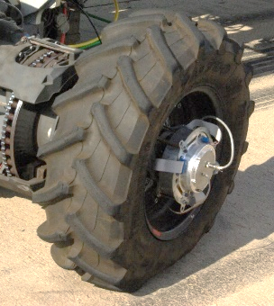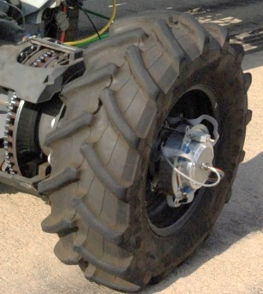

Fymax

Fxmax

Figure 4: Friction envelope tests on Trelleborg TM700 280/70R16 at 11km/h, vertical load at 5.68kN before and during lockup at a constant lateral slip angle, respectively.

The friction envelop describes the combination of the applied longitudinal and lateral forces during different slip angles and longitudinal wheel slip as shown in **Error! Reference source not found.**. It can be seen that at 80kPa inflation pressure a larger longitudinal friction coefficient can be generated due to a larger footprint at 80kPa, also noted in **Error! Reference source not found.** during pure longitudinal slip tests. The increased side wall stiffness, due to the increased inflation pressure, correlates to the increase maximum lateral friction coefficient generated at 200kPa.

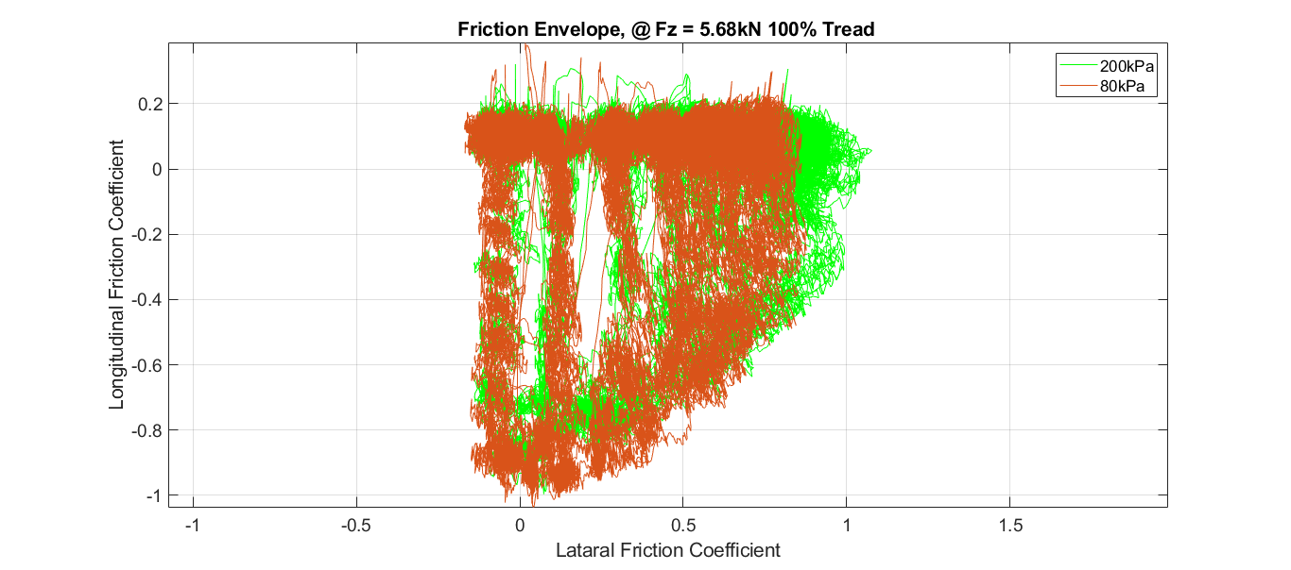

Figure 5: Friction envelop unfiltered measurement on Trelleborg TM700 280/70R16 at 11km/h, at 80kPa and 200kPa inflation pressure, respectively.

* 1. Static/Non-rolling vs. Dynamic/Rolling

Outdoor dynamic tyre tests are time consuming, expensive and less repeatable over different times of year testing than tests conducted in a laboratory. Also, tyre size/load limitations are a major factor when conducting dynamic/rolling tests on large tyres. If static test rig results could be used to, at least estimate, tyre parameters that represent dynamic/rolling characteristics, it can become more affordable to obtain tyre characteristics in order to parameterize more tyre models. A method to compare the longitudinal friction coefficient as a function of % longitudinal slip of a rolling tyre to static/non-rolling longitudinal friction coefficient as a function of longitudinal displacement, is to translate longitudinal slip of the contact patch to longitudinal displacement, DlongStatic.

For the dynamic longitudinal slip tests this can be achieved by calculating the longitudinal displacement of the contact patch, Dwheel, relative to the displacement of the vehicle (Dvehicle) and dividing it by the number of wheel rotations, Nrotate, during the longitudinal slip period from 0% to 100% slip as shown in Eq. 1:

$D_{longStatic}=\frac{\left( D_{vehicle}-D_{Wheel} \right)}{N_{rotate}}$ (1)

The result of this transformation from % longitudinal slip to relative longitudinal displacement is shown in **Error! Reference source not found.**.



Figure 6: Translated Rolling Longitudinal Friction Coefficient vs. Relative Longitudinal Displacement at 80kPa and 200kPa inflation pressure, respectively.

**Error! Reference source not found.** shows the comparison between the static tests conducted on the STTR on concrete and the translated DTTT tests.



Figure 7: Longitudinal Friction Coefficient vs. Longitudinal Displacement from different test methods.

Relatively good correlation is seen between the two test methods. The initial longitudinal stiffness correlates very well within the first 30mm of longitudinal stiffness, with the maximum sliding friction coefficient within 10 to 20% for the tests conducted on the outdoor test track with the DTTT. The difference in boundary conditions between the static and dynamic test methods will also contribute to the difference in the results.

The lateral friction coefficient vs. slip angle tests can be translated to the lateral friction coefficient vs. 90-degree lateral displacement with the use of trigonometry to calculate the lateral displacement component, SlipLat_mm, at the specific lateral slip angle, $β$, and the contact patch length, L, as shown in Eq. 2:

${Slip}_{Lat_mm}=Ltanβ$ (2)

The result of the comparison between the static tests on the STTR on concrete with the lateral translation of the friction envelope tests and lateral force vs. slip angle tests, as conducted with the DTTT at 200kPa inflation pressure is shown in **Error! Reference source not found.**.

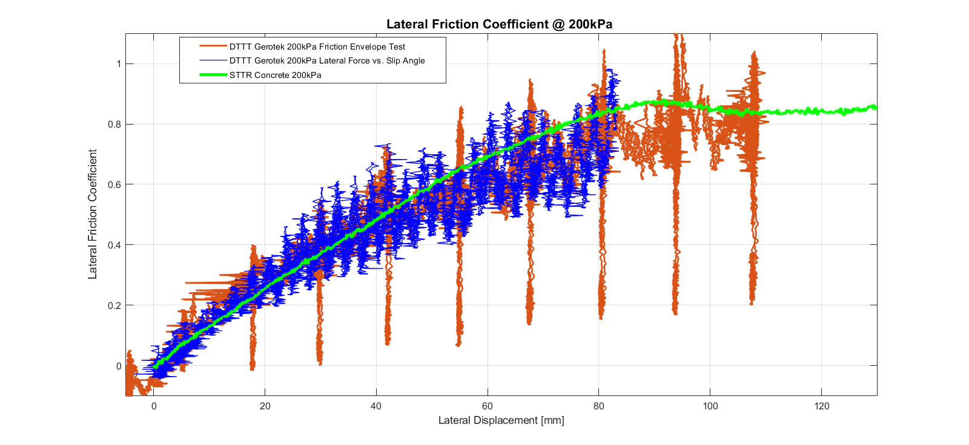

Figure 8: Dynamic lateral friction coefficient tests compared to static testes on concrete at 200kPa inflation pressure for 100% tread.

Very good correlation is seen at the high inflation pressure tests. This shows consistency for all three tests methods being static or dynamic.

Conclusions

The results from the dynamic/rolling tyre outdoor tests at a 100% tread condition is successfully compared to the static parameterization tests, with limited success at low inflation pressures due to the tyre belt stiffening for a rolling tyre. This indicates that it is possible to obtain accurate tyre characteristics from static tests which are representative of a rolling tyre at lower velocities and high inflation pressures. This is an important observation as most agricultural vehicles operate at low speeds and construction vehicles operate with higher inflation pressures. This will allow engineers to obtain valuable tyre parameterization data at a lower cost with the use of static tyre testing. This data can also be used to parameterize physics-based tyre models for rolling tyre simulations, only when using carefully executed static tests on representative test surfaces. The difference in boundary conditions can be eliminated during tyre model validation as the physics-based tyre model can simulate the boundary conditions and movements of the STTR which is used to measure the tyre characteristics.

Nomenclature

|  |  |  |
| --- | --- | --- |
| DlongStatic | Longitudinal displacement of static wheel | [mm] |
| DVehicle | Longitudinal displacement of vehicle | [mm] |
| DWheel | longitudinal displacement of the contact patch on rolling wheel | [mm] |
| L | Contact patch length | [mm] |
| Nrotate | Number of wheel rotations |  |
| $${Slip}_{Lat_mm}$$ | lateral displacement component | [mm] |
| β | Lateral slip angle | [°] |

References

Ambruster, K, Kutzbach, H.D., 1989, Development of a single wheel tester for measurement on driven angled wheel. In: Proceedings of 5th European conference of the ISTVS, Wageningen, The Netherlands; p. 8–14.

Bakker, E, Nyborg, L and Pacejka, H.B., 1987, Tyre modelling for use in vehicle dynamics studies, Society of Automotive Engineers, Warrendale, PA.

Becker, C.M, 2009, Profiling of rough terrain, Master of Engineering Thesis, University of Pretoria, South Africa, <http://hdl.handle.net/2263/29833>.

Becker, C.M. and Els, P.S., 2018, Static and Dynamic Parameterization Test Rigs for Large Tyres, Proceedings of the 10th Asia-Pacific Conference of the ISTVS, Kyoto, Japan, July 11-13.

Billington, P.W., 1973 The NIAE Mk II single wheel tester. J Agric Eng Res; 18:67–70.

Cosin scientific software, 2017, FTire, Modelization and Parameter Specification. 2017-1-r14630. [pdf]. Software documentation and user guide.

Lines, J.A., 1991, The Suspension Characteristics of Agricultural Tractor Tyres. PhD Thesis, Cranfield Institute of Technology Silsoe College.

Shmuleviuch, I., Ronai, D., Wolf, D., 1996. A new field single wheel tester. Journal of Terramechanics, Vol. 33(3), p133–41.

Stayner, R.M., Collins, J.A. and Lines, J.A., 1984, Tractor Ride Vibration Simulation as an Aid to Design. Journal of Agriculture Engineering Res. 29.345-355.

TüV SüD, 2021, Virtual Simulation to Ensure the Safety of Vehicles, website: <https://www.tuvsud.com/en/e-ssentials-newsletter/automotive-essentials/e-ssentials-3-2017/virtual-simulation-to-ensure-the-safety-of-vehicles>, accessed 5 October 2021.

Witzel, P., 2018. The Hohenheim tyre model: a validated approach for the simulation of high-volume tyres – Part I: Model structure and parameterisation. Journal of Terramechanics. 75, 3–14.

Parameters Calibration of Red Clay Soil in Hilly Area of Southwest China for Discrete Element Simulation Based on Repose Angle Test8131

Le Yang a

[1160384317@qq.com](mailto:1160384317@qq.com)

Qinghui Laia

[56170433@qq.com](mailto:56170433@qq.com)

Liangliang Zhaoa

1564964300@qq.com

Zhaoyang Chena

[893612562@qq.com](mailto:893612562@qq.com)

Peihang Lia

*957594722@qq.com*

Zhihong Zhanga*

zzh_0822@hotmail.com

aKunming University of Science and Technology, Kunming, Yunnan, China

*Corresponding author

Abstract

Its southwest's rugged and mountainous terrain has thick soil, which causes high resistance, poor efficiency, and sometimes even the impossibility to operate agricultural equipment. Using discrete element simulation, a cutting-edge technical technique, it is possible to optimize the agricultural machinery elements that come into contact with the soil in order to reduce drag and increase efficiency. Although there are presently no precise and trustworthy discrete element modeling parameters for red clay, the physical characteristics of red clay in the hilly and mountainous regions of the southwest are unique. As a result, in this study, the soil moisture content was 12.5%1% and 18.3%1%, respectively, for the actual working environment of the soil moisture content of 10%–20% in the hilly and mountainous areas of southwest China, and the experiment's measurement of the accumulation angle was 38.54°. This subject of the study was clay. To calibrate the appropriate model's physical characteristics, use the Hertz-Mindlin with JKR contact model in the EDEM simulation software. Prior to simulating the accumulation angle of soil particles, the intrinsic physical parameter values of the red loam soil are first obtained through actual experiments. The range of soil contact mechanical parameters in the GEMM database is then used to determine the optimal value interval of the contact parameters determined by the steepest slope test. In order to determine the regression model of the soil accumulation angle, the quadratic regression rotation orthogonal combination test is used to obtain the second-order regression model of the accumulation angle and the significant parameters. The significant parameters are then optimized using the actual accumulation angle as the target. In the end, it was found that the following contact mechanics characteristics worked well together in the EDEM simulation test: JKR surface energy 8 J/m2, restitution coefficient 0,35, dynamic friction coefficient 0,13, and static friction coefficient 0,56. The relative inaccuracy determined by the actual physical test is 1.80%, and the stacking angle is 39.24°. The study's findings demonstrate that the method has a high degree of calibration accuracy and is both reasonable and useful for calibrating soil discrete element simulation parameters. The pertinent calibration parameters can serve as a technological foundation for investigating machine-soil interaction and machine-tool optimization research in southwest China's hilly and mountainous regions.

Keywords: red clay, discrete element method, repose angle, parameter calibration, response surface methodology

1. Introduction

Hilly and mountainous regions in southwest of China plays a significant role in the cultivation of priceless Chinese medicines like ginseng and Panax notoginseng. It is ideal for the cultivation of some crops and Chinese medicinal ingredients because this region has an extended sunny period. One of the crucial farming steps in the southwest's hilly and mountainous regions is the farming operation before seeding agricultural crops. To decrease the adhesion resistance brought on by soil adhesion and boost production efficiency, it is crucial that high-passage crawler equipment be developed that can operate in the southwest's hilly and mountainous locations [1]. Studying the process of interaction between red clay and soil-contacting parts is the main challenge in the development of high-efficiency operating machinery. The relative motion between soil particles cannot be accomplished using the current finite element model while conducting field tests or soil tank experiments. Currently present models are based on continuous motion between media to replicate the overall behavior of soil degradation in addition to the dynamic process while engaging with the soil-contacting portions [2-3]. In recent years, discrete element method modeling has been gradually applied to agriculture. Modeling the material mechanics of minute particles is appropriate for this approach. Through this process, a single particle is divided into a number of smaller particles, each with a certain mass and form. The contact problem between various particles and their boundaries is frequently solved using it. so that its inner workings are seen [4-5]. There are numerous potential applications for the contact model between soil-soil and soil-contacting parts [6–8]. In discrete element simulations of other crops including rice, potatoes, and wheat, several contact models are typically employed [9–13]. Due to alteration in the field environment, while agricultural machinery is operating, the interactions between the soil and the contact components will also clearly differ [14]. To effectively calibrate the parameters of the chosen model and offer accurate simulation parameters for discrete element simulation experiments, different contact models are used when employing discrete elements for modeling in accordance with the real soil condition [15–18].

This research investigates the inter-particle cohesion using the "Hertz-Mindlin with JKR" contact model in the EDEM software to address the issue of the lack of precise and trustworthy discrete element simulation model parameters for the interaction mechanism between agricultural machinery and red clay in hilly and mountainous areas.

1. Parameter Calibration of Soil Particle Contact Model
   1. Selection of Contact Models

The water content of red sticks employed in physical tests in hilly and mountainous places, respectively, was 12.5% ±1% and 18.3% ±1% in the study, which is based on the concept of combining physical test and EDEM simulation test.

The choice of the contact model will directly impact the accuracy of the findings since the red clay in hilly and mountainous places exhibits a hard plastic condition and the thickness of the soil layer varies substantially. The classic Hertz-Mindlin contact model cannot mimic the adhesion between soils, just its elastic deformation, making it unsuitable for red clay with adhesive forces. The Hertz-Mindlin with JKR Cohesiveness model is a cohesion contact model that is based on the Hertz-Mindlin contact model mixed with the JKR theory, although it is only relevant to the occurrence of static electricity, moisture content, and other external factors between the material's particles [19-20]. Adhesion or agglomeration that is obviously present, such as with damp soil, agricultural products, etc. Red clay has a high water content, which increases the adhesion force between soil and soil or between soil and farming equipment. The parameters in this study were calibrated based on the Hertz-Mindlin with JKR Cohesion model, which was chosen to represent the red clay in hilly and mountainous environments. (*Equation 1 shows* *calculates the JKR normal elastic contact force* *whereas Eq. 2 defines the amount of normal overlap of particles in contact with each other*)

The model calculates the JKR normal elastic contact force F1 to describe the cohesiveness between particles.

 

where: *F1* is mean JKR normal elastic contact force; *γ* is mean surface tension; *E\** is mean equivalent modulus of elasticity; *α* is mean the amount of tangential overlap of particles in contact with each other; *R\** is mean equivalent contact radius.

The cohesion force created by the mutual attraction of the two particles also be calculated to approximate the model when the two particles are not in direct contact [22].( *Eq. 3 defines the maximum clearance in the normal direction when the cohesion between particles is not zero; Eq.4 defines* *When the cohesion between particles is not zero, the maximum gap in the tangent direction*)





The intrinsic parameters of the research object, its contact parameters, and the contact model parameters are how the model parameters are primarily broken down. By reading the relevant literature, you may find out the intrinsic parameters and contact model parameters of the study item. The cohesion between particles or the cohesion between particles and the surface of soil-contacting components should be stressed when evaluating the contact model for laterite with heavy adhesion in hilly and mountainous environments. Using the EDEM software, the JKR model may be utilized to describe the cohesive force between particles. The major task of this article is to calibrate the red clay contact model experimentally using two moisture contents.

* 1. Experiment Items and Simulation Parameters

With time and climate, clay moisture content does fluctuate dramatically. In order to establish a theoretical framework for investigating the interaction between implements and soil as well as the anti-sticking and drag reduction of soil-contacting portions, two typical moisture contents of clays12.5%±1% and 18.3%±1% were chosen as the research objects in this paper. This experiment suggested in this study can also be used to conduct calibration research for other clays with a high water content. The scientific foundation for the calibration of soil characteristics with various water contents is also provided by this study. Furthermore the simulated angle of repose of soil particles is employed as the response value, and the physical parameters serve as the calibration objects. The regression model of the angle of repose is created based on the Box-Behnken response surface optimization approach, and the regression model is optimized to get the optimization of model parameters for two water contents.

Red clay with moisture contents of 12.5%±1% and 18.3%±1% is used as the research object to calibrate the discrete element parameters of the soil particle contact model and conduct the angle of repose test. The soil type is typical hilly and mountainous red clay, with a bulk density of 1156 kg/m3. Table 1 displays the intrinsic characteristics of red clay and related minerals.

Table 1. EDEM simulation parameters of soil repose angle

|  |  |  |  |
| --- | --- | --- | --- |
| **Material** | **Parameter** | **Value** | **Source** |
| Soil | density/kg˙m-3  Poisson  Shearing model/MPa | 1156.4  0.4  1 | measured  measured  literature [22] |
| UHMW-PE | density/kg˙m-3  Poisson  Shearing model/MPa | 964  0.38  8.4×109 | literature [23]  literature [23]  literature [24] |
| 65Mn | density/kg˙m-3  Poisson  Shearing model/MPa | 7861  0.29  7.9×109 | literature [25]  literature [26]  literature [25-26] |
| PTFE | density/kg˙m-3  Poisson  Shearing model/MPa | 2.1×103  0.4  100 | literature [27]  literature [28]  literature [27-28] |
| 245 Boron Steel | density/kg˙m-3  Poisson  Shearing model/MPa | 7850  0.25  2.06×108 | literature [29]  literature [30]  literature [29-30] |

The red clay contact model parameters may be derived by importing the soil model parameters from the pre-experiment into the aforementioned material library, which is based on the pertinent properties of soil particles in the EDEM general granular material database [21]: JKR surface energy is 4~12 J/m2, the coefficient of restitution is 0.15~0.35, the rolling coefficient is 0.05~0.2, and the static friction coefficient is 0.2~0.92.

* 1. Angle of Rest Experiment
     1. Soil Moisture Determination

Experiments were conducted in the laboratory of modern equipment engineering, Faculty of Modern Agricultural Engineering, Kunming University of Science and Technology. The collected dirt is screened by a vibrating pendulum sand screener to reduce the soil particle size range to less than 1 mm after contaminants such big clods of soil and stones are removed. To equally spread the moisture inside the soil, wet, agitate, and wrap it in plastic wrap for a week. Then, use a moisture content measuring equipment (YF-100F, Puyan Trading Co., Ltd., Dongguan) to take multiple measurements. The soil then returns to its natural state of accumulation after a random measurement to ensure water distribution is uniform.

The experiment took place in a largely enclosed internal setting. The error of the measured moisture content was allowed to be 1% based on the soil moisture determination method (GB 7172-87), and the drying method was chosen to determine the soil moisture content parameters. A cutting ring with a specific volume was also used at the same time for sampling. In a state of natural accumulation, the earth is gathered into the ring knife and fills it.

Equipment are as follows:

1. Drying box (HG101-2A): Electric heating drying box should be able to regulate the temperature between 105 and 110 degrees Celsius.
2. Electronic balance: weighing more than 100g. Sensitivity 0.01g.
3. Others: Vernier calipers, crucible tongs and cutting ring, etc

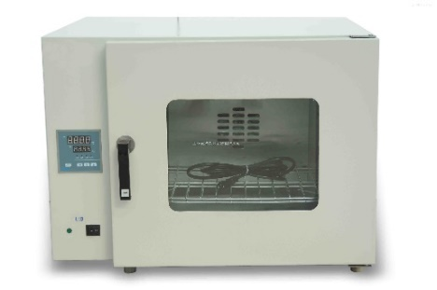 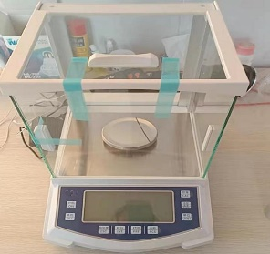

a) HG101-2A Drying box b) electronic balance  
Fig.1 Main test equipment

After cleaning, heating, and drying the cutting ring, weigh it using an electronic scale and note the mass as M1. Using a cutting ring to collect soil samples; the soil fills the ring knife naturally while it is being accumulated, and minimal pressure is applied to it during the sampling process. Re-weigh the dirt sample and the ring knife using the electronic balance, and then note their combined mass as M2. In the drying box, place the cutting ring and soil sample, set the temperature to 105 °C, and run the drying process for at least 24 hours. The weighing process is carried out when the drying is finished, the cutting ring is removed every hour, and it is repeated until the number of electronic days does not change for two consecutive times. According to the formula, the total weight M3 of the sample, the ring cutter, and the soil moisture content may all be calculated (5).



Where：ω indicates soil moisture content; M1 indicates the quality of the cutting ring; M2 indicates the total mass of the ring knife and soil before drying, M3 indicates the total mass of the ring knife and soil after drying

* + 1. Physical test of angle of repose

When soil is supposed to settle freely into a conical funnel, it assumes the shape of cones. The calibrated angle of repose is the interior angle created between the surface of the earth and the horizontal table top. In order to describe the flow, friction, and other properties of the material, the size of the angle of repose is frequently utilized. Such an angle of repose is connected to the density, surface area, and friction coefficient of the material to be calibrated. So, the majority of granular materials are expressed by the angle of repose in the discrete element modeling of granular materials. For measuring the angle of repose, follow these simple steps: Prepare heavy red clay with a moisture level of 12.5%±1%, and 18.3%±1% respectively. The physical experiment involves the test bench (Fig. 1), measuring the soil's accumulation angle with a protractor, repeating the process 10 times, and taking the red clay's average result, which comes out to 38.21°.

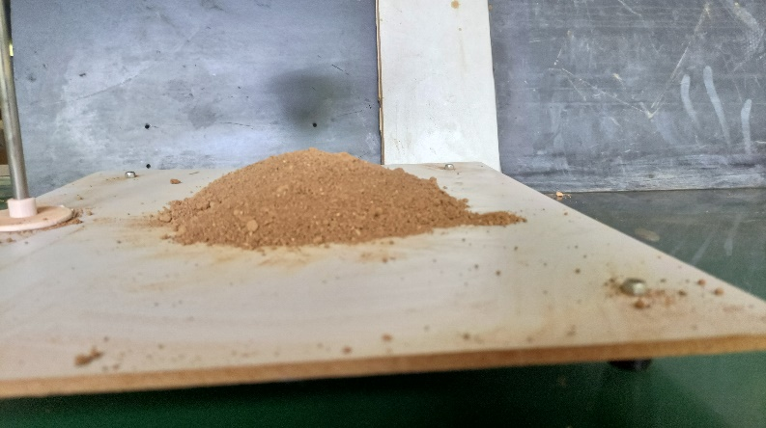

a. Moisture content 12.5%

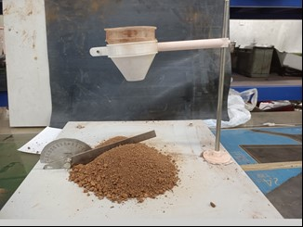

b. Moisture content 18.3%  
Fig.2 Physical test of repose angle of red clay soil

* 1. Simulation Investigation of Response Angle

The response surface optimization approach was applied, with the soil angle of repose being utilized as the response value, based on the reference value range of the soil model discussed above. Instead Box-Behnken technique was employed to carry out the calibration test based on the Design-Expert software. Table 2 shows each measurement factor's level range.

Table 2. Horizontal factor coding for simulation tests with angle of rest

|  |  |  |  |  |  |
| --- | --- | --- | --- | --- | --- |
| **Level** | | JKR surface energy  x1 | Restitution coefficient  x2 | Friction coefficient  x3 | Rolling friction coefficient  x4 |
| Low Level | 4 | 0.15- | 0.2 | 0.05 |
| Center Level | 8 | 0.35 | 0.56 | 0.125 |
| High Level | 12 | 0.35 | 0.92 | 0.2 |

In the simulation test, the angle of repose established using the same parameters was repeated five times. Images of the simulation model were intercepted in the X and Y directions of the accumulation angle simulation model produced by EDEM and imported into AutoCAD [21]. Table 3 displays the measurements' findings.

Table 3. Experimental design and results of soil rest angle simulation

|  |  |  |  |  |  |
| --- | --- | --- | --- | --- | --- |
| Test No. | x1 | x2 | x3 | x4 | Response angle /(°) |
| 1 | 4 | 0.35 | 0.56 | 0.2 | 30.45 |
| 2 | 8 | 0.35 | 0.56 | 0.125 | 38.52 |
| 3 | 4 | 0.35 | 0.56 | 0.05 | 16.35 |
| 4 | 12 | 0.55 | 0.56 | 0.125 | 26.82 |
| 5 | 8 | 0.55 | 0.92 | 0.125 | 24.56 |
| 6 | 12 | 0.35 | 0.56 | 0.2 | 54.48 |
| 7 | 8 | 0.15 | 0.56 | 0.05 | 43.86 |
| 8 | 12 | 0.15 | 0.56 | 0.125 | 42.56 |
| 9 | 8 | 0.35 | 0.56 | 0.125 | 37.45 |
| 10 | 8 | 0.35 | 0.56 | 0.125 | 39.51 |
| 11 | 4 | 0.15 | 0.56 | 0.125 | 46.21 |
| 12 | 4 | 0.35 | 0.2 | 0.125 | 25.48 |
| 13 | 8 | 0.55 | 0.56 | 0.05 | 12.25 |
| 14 | 4 | 0.35 | 0.92 | 0.125 | 25.16 |
| 15 | 8 | 0.35 | 0.92 | 0.05 | 33.84 |
| 16 | 12 | 0.35 | 0.92 | 0.125 | 51.47 |
| 17 | 8 | 0.35 | 0.92 | 0.2 | 40.23 |
| 18 | 8 | 0.55 | 0.2 | 0.125 | 16.45 |
| 19 | 8 | 0.35 | 0.2 | 0.05 | 31.20 |
| 20 | 12 | 0.35 | 0.2 | 0.05 | 40.26 |
| 21 | 8 | 0.35 | 0.56 | 0.05 | 47.25 |
| 22 | 4 | 0.55 | 0.56 | 0.125 | 11.78 |
| 23 | 12 | 0.35 | 0.2 | 0.125 | 48.89 |
| 24 | 8 | 0.55 | 0.56 | 0.2 | 25.53 |
| 25 | 8 | 0.15 | 0.56 | 0.2 | 46.72 |
| 26 | 8 | 0.35 | 0.56 | 0.125 | 36.21 |
| 27 | 8 | 0.15 | 0.2 | 0.125 | 46.56 |
| 28 | 8 | 0.35 | 0.56 | 0.125 | 35.48 |
| 29 | 8 | 0.15 | 0.92 | 0.125 | 43.14 |

1. Calibration of Simulation Parameters

Based on the above test values of the angle of repose, the slope rolling, the static friction, and the collision recovery experiments were used to acquire the reliable and precise simulation parameters of the red clay in the hilly and mountainous areas of the southwest, to maximize the drag reduction performance of agricultural machinery, and to give matching parameters for the design of bionic materials. Tests to confirm the range of parameters discovered using the test for the angle of repose. For 245 boron steel and three other drag-reducing materials, (UHMW-PE, PTFE, 65Mn) the soil-contacting material for agricultural machinery, a static friction test was conducted to determine the typical soil-contacting surface materials of red clay in hilly and mountainous places under four moisture contents. According to the results of the measured static friction coefficient, the slope rolling test was used to calibrate the discrete element parameters of red clay under high moisture content (18.3%±1%) on the surface of different soil-contacting materials.

* 1. Slope Experiments for Rolling Coefficient of Friction

As increasing water contents, the soil adhesion at various water contents (water contents below the soil liquid limit) steadily improves [31]. Using the physical test rig depicted in Figure 2, the static friction coefficients of two types of typical earth-contacting component materials under high moisture content were calculated. With a 10 mm radius, the 3D-printed spherical model was utilized to represent soil particles. A ruler is used to measure the ball's rolling distance S2 in the horizontal direction as it rolls down from its static position at the top of the inclined plane until it stops. This process is repeated five times, and the average value is taken as the rolling distance in the horizontal direction. Simultaneously, its simulation experiment was done in the EDEM software, and the parameter values match those of the actual test. Key parameters of the slope created by the experimental tests are provided in Table 4 under the results of the physical test.

The parameters in the experiment are designed for the calibration test using the Box-Behnken method in the Design-expert software, referring to the relevant parameters of plastic and steel in the EDEM material database, corresponding to the relevant literature and the results of the actual test, and exporting the soil. Table 5 shows the slope simulation test factors and levels between the 245 boron steel and the PTFE plate.

The parameters in the experiment are designed for the calibration test using the Box-Behnken method in the Design-expert software, referring to the relevant parameters of plastic and steel in the EDEM material database, corresponding to the relevant literature and the results of the actual test, and exporting the soil. Table 5 shows the slope simulation test factors and levels between the 245 boron steel and the PTFE plate.

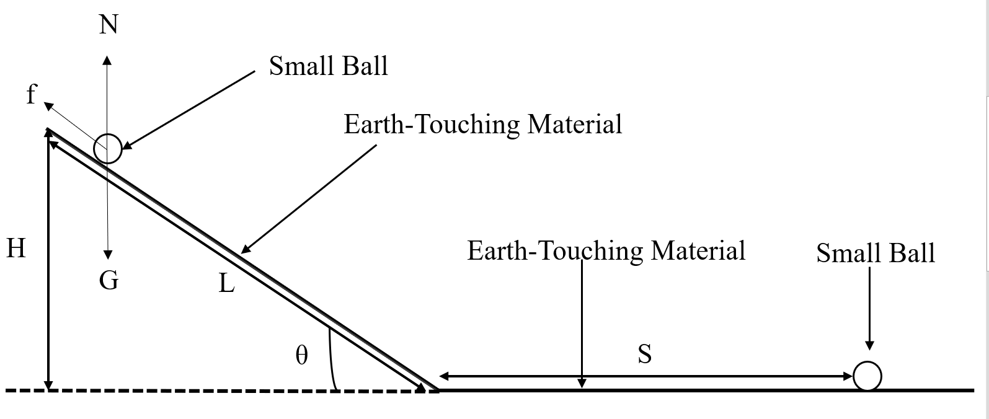

(a) Schematic of the rolling coefficient of friction

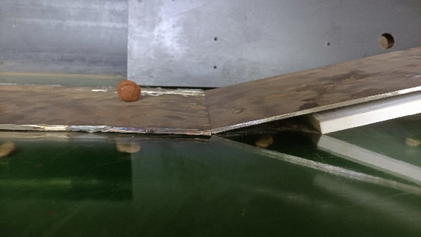

(b) Physical tests  
Fig.3 Measure the coefficient of friction of rolling

Table 4. Parameters related to inclined test benches

|  |  |  |
| --- | --- | --- |
| Material | Bevel length [mm] | Bevel height [mm] |
| 65Mn | 220 | 25 |
| PTFE | 180 | 25 |
| UHMW-PE | 140 | 25 |
| 245 Boron Steel | 100 | 25 |

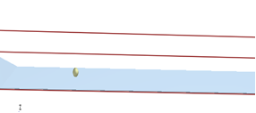

Fig. 4 Simulation test of soil and different soil-touching materials

Table 5. Factors and levels of slope simulation test

|  |  |  |  |  |  |
| --- | --- | --- | --- | --- | --- |
| **Level** | **Material** | JKR surface energy  **x1** | Restitution coefficient  **x2** | Friction coefficient  **x3** | Rolling friction coefficient  **x4** |
| Low Level | 245 boron steel  PTFE | 2.00  1.00 | 0.20  0.10 | 0.20  0.10 | 0.03  0.03 |
| Center Level | 245 boron steel  PTFE | 7.00  5.50 | 0.45  0.40 | 0.45  0.40 | 0.055  0.055 |
| High Level | 245 boron steel  PTFE | 12.00  10.00 | 0.70  0.70 | 0.70  0.70 | 0.08  0.08 |

1. Experimental Results and Analysis
   1. Angle of Rest Regression Model

The analysis of variance function of the Design-Expert software is used to examine the data in Table 2, and the results are shown in Table 3. Information in Table 6 is then subjected to multivariate regression analysis. The red clay regression model for the southwest hilly mountain region is shown below.

Table 6. Analysis of variance for soil angle of rest regression model

|  |  |  |  |  |
| --- | --- | --- | --- | --- |
| **Source** | **Squares** | **Degree of freedom** | **F Value** | **P Value** |
| Model | 3910.82 | 22 | 69.21 | < 0.0001** |
| x1 | 574.56 | 1 | 223.78 | < 0.0001** |
| x2 | 696.96 | 1 | 271.45 | < 0.0001** |
| x3 | 4.80 | 1 | 1.87 | 0.2207 |
| x4 | 125.89 | 1 | 49.03 | 0.0004** |
| x1x2 | 87.33 | 1 | 34.01 | 0.0011** |
| x1x3 | 2.10 | 1 | 0.8189 | 0.4004 |
| x1x4 | 0.0036 | 1 | 0.0014 | 0.9713 |
| x2x3 | 33.47 | 1 | 13.03 | 0.0112 * |
| x2x4 | 27.14 | 1 | 10.57 | 0.0174 * |
| x3x4 | 23.33 | 1 | 9.09 | 0.0236 * |
| x12 | 6.21 | 1 | 1.92 | 0.2149 |
| x22 | 122.93 | 1 | 64.71 | 0.0002** |
| x3² | 6.71 | 1 | 2.10 | 0.1971 |
| x42 | 0.8586 | 1 | 0.7885 | 0.4087 |
| x12x2 | 0.8646 | 1 | 0.3367 | 0.5828 |
| x12x3 | 5.51 | 1 | 2.15 | 0.1932 |
| x12x4 | 4.32 | 1 | 1.68 | 0.2421 |
| x1x22 | 166.99 | 1 | 65.04 | 0.0002** |
| x1x32 | 0.3961 | 1 | 0.1543 | 0.7081 |
| x22x3 | 10.19 | 1 | 3.97 | 0.0934 |
| x22x4 | 4.96 | 1 | 1.93 | 0.2139 |
| x2x32 | 2.15 | 1 | 0.8385 | 0.3951 |
| x12x22 | 1.40 | 1 | 0.5015 | 0.5015 |
| Residual | 14 | 6 |  |  |
| Lack of Fit | 3.20 | 2 | 0.8513 | 0.4920 |
| Pure Error | 10.81 | 4 |  |  |
| Total | 3924.83 | 28 |  |  |

Note: ** indicates extremely significant impact (P<0.01), and * indicates significant impact (0.01<P<0.05)

The variance analysis of the response values R1 is shown in Table 6. According to the data in the table, we can know the significance of factors and their interaction effect. P-value for R1 equation model is less than 0.0001. The determination coefficients R1 is 0.9964, and the adjusted determination coefficient Radj2 is 0.980, respectively. These results indicate a highly significant (P < 0.01) relationship between the model response value (angle of repose) and the independent variables. These data illustrate that the model has good reliability and accuracy. Therefore, Eq. 5 could truly and reliably reflect the variation law of the angle of repose was used to predict the accumulation angle under different water contents.

* + 1. Optimization and verification of red clay rest angle parameters with different moisture content

A group with an angle of repose that is most comparable to the angle of repose obtained in the physical test is obtained using the parameter optimization function in the Design-expert software, utilizing the angle of repose of 38.21° formed by the red clay with a moisture content of 12.5%±1% in the EDEM simulation test as the optimization target. The data, which are the size of the static friction coefficient, collision recovery coefficient, JKR surface energy, and sliding friction coefficient of the red clay particles, are 0.711, 0.301, 8.156 J/m2, and 0.113, respectively, and the angle of repose at this time is 38.982°; the error with the actual test results is 2.02 percent. Figure 3 displays the ratio of the actual test pile type to the optimized simulation test of the angle of repose. It is clear from comparing the simulation test and the actual measurement test that they are very similar. The collision restitution coefficient, followed by the kinetic friction coefficient and surface energy, is the most important of the four variables used to calibrate angle of repose.

The difference between the physical experimental data and EDEM simulation test results for the red clay used in the experiment, which had a moisture content of 12.5%±1%, is within 3%, and the parameter values of the simulation test's results within the error range are consistent with the results of the physical test, namely JKR. Moreover, static friction coefficient is 0.6~0.8, collision recovery coefficient is 0.2~0.5, and rolling friction coefficient is 0.125~0.19;  surface energy is 7~10 J/m2. Similar to the previous example, for the red clay with a moisture content of 18.3%±1%, applying angle of repose 42.21° as the optimization target of the simulation test, the JKR surface energy between soils can be calculated to be 8.964 J/m2, static friction coefficient is 0.889, and soil particle recovery can be achieved.The figure below, which is similar in angle and accumulation model. Also the coefficient is 0.348, and the coefficient of rolling friction is 0.162. Similar to the simulation test parameters, the red clay's moisture content ranges from 18.3% ± 1%, which means that the JKR surface energy is 8–11 J/m2, the static friction coefficient is 0.6–0.8, the collision recovery coefficient is 0.2–0.5, and the rolling friction coefficient is 0.135–0.19.

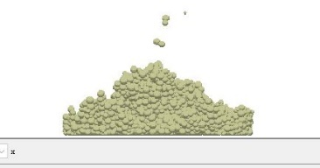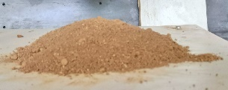

a. Moisture content 12.5%

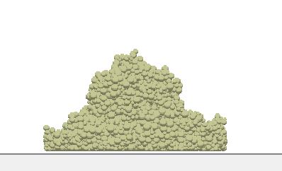 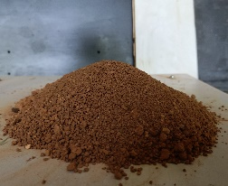

b. Moisture content 18.3%  
Fig.5 The moisture content is 12.5% and 18.3% soil rest angle

* 1. Regression Mode for Angle of Rest

Figure 4 displays the results of the static friction measurement test, which was used to determine the static friction coefficients for various water contents. The figure shows that the static friction coefficient is positively correlated with the soil moisture content for the material of typical soil-contacting parts in the plastic range of the soil, and the increase range is fairly obvious. Its coefficient of static friction and the rise in water content do not appear to be correlated in a linear fashion for plastic earth-contact parts. Red clay is still able to slide freely even when the water content is above the range that makes it plastic. Indeed the friction coefficient also does not significantly increase.

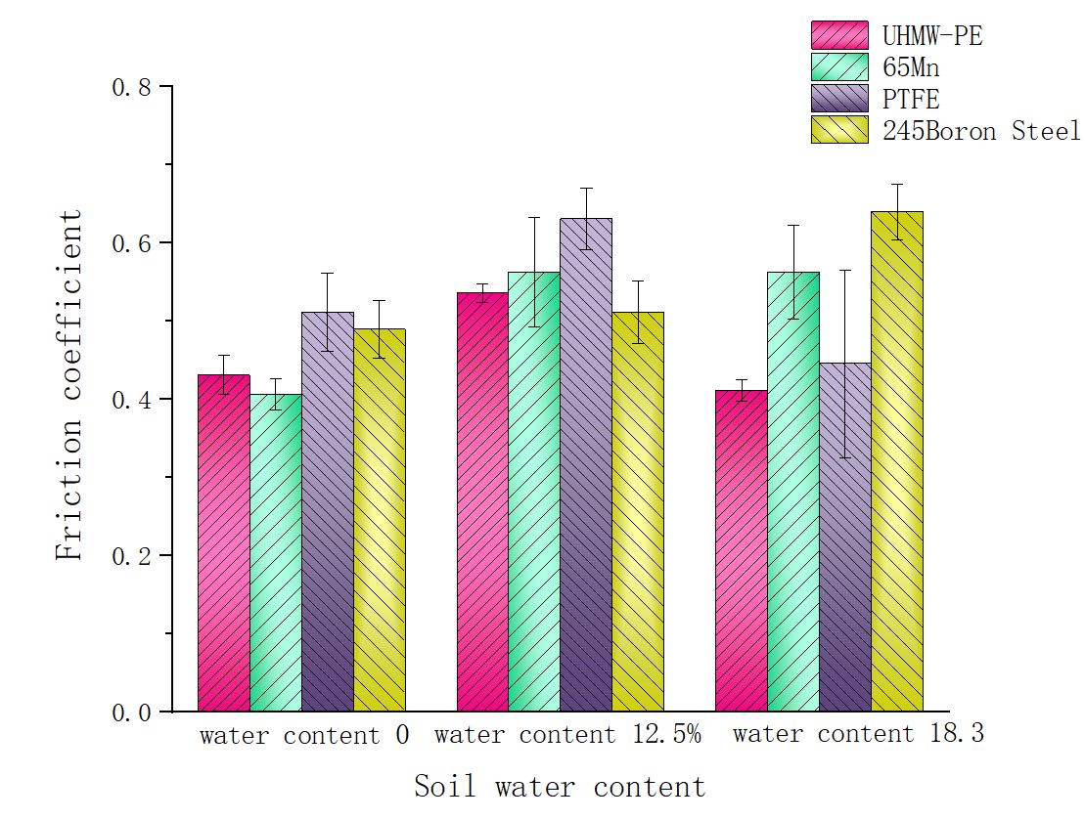

(a) The coefficient of static friction when the moisture content does not exceed 25%

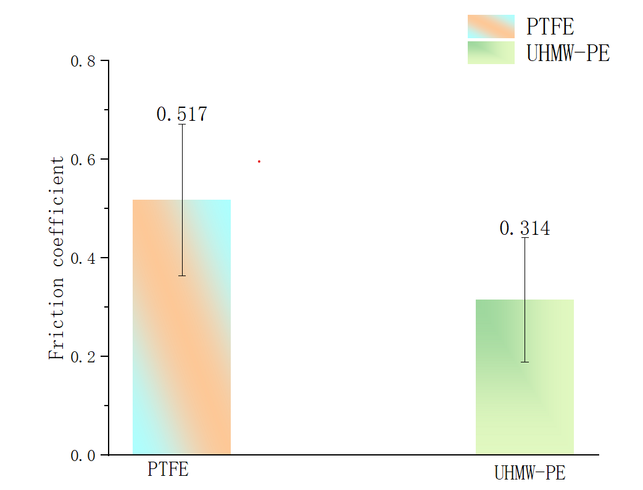

(b）Moisture content 25% ±1%  
Fig. 6 Static friction coefficient between red clay with different moisture content and different soil-touching materials

Figure 5 demonstrates how the vertical (90°) 245 boron steel adheres to the red clay with a moisture content of 25%. Figure 9 shows that the soil has completely adhered when the moisture content is 25% (less than the red clay's liquid limit). As well the soil ball remains stationary on the 245 boron steel plate even after the physical test bench's angle is increased by more than 90 degrees, proving that the soil ball's gravity is significantly lower than the force that holds it to the plate. For typical plastic soil-contacting parts with low surface energy, when the moisture content is 25%, they can still slide freely within a certain lifting angle range, indicating that tires or tracks with smaller surface energy have a certain effect of reducing adhesion and desorption. It can also provide some ideas for the design of biomimetic viscosity reduction and desorption.

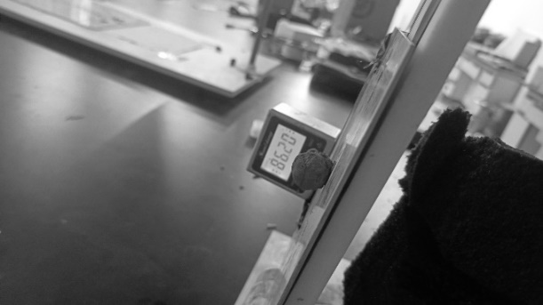

Fig. 7 Red clay with a moisture content of 25% adheres to a vertical 245 boron steel plate

1. Conclusions

The Hertz-Mindlin with JKR Cohesion contact model in EDEM was used in this study to calibrate the parameters of the red clay under the two moisture contents based on the actual operating soil moisture content of agricultural machinery in the hilly and mountainous parts of southwest China.Basic contact model parameters of the red clay beneath the two water contents were derived using the response surface optimization approach, and the regression equation of the angle of repose was obtained for comparison:12.5%±1%, the JKR surface energy was 8.156 J/m2, the rolling friction coefficient between soil particles was 0.113, the coefficient of restitution was 0.301, and the coefficient of static friction was 0.711; With a moisture content of 18.3%±1%, soil particles' JKR surface energy is 8.964 J/m2, their coefficient of restitution is 0.348, their coefficient of static friction is 0.889, and their rolling friction with other soils is 0.964 J/m2,its value is 0.162.The rolling friction coefficient between the red clay particles (or between the particles and the material of the soil-contacting parts) and the particles (or the contact between the particles) is determined through the regression model variance analysis of the angle of repose of the red clay in the southwest hilly and mountainous areas under two moisture contents. According to the physical test phenomenon, there is a strong correlation between the surface energy parameters of the soil component material and the contact model. It can be seen that the calibration results under the two different water contents are consistent with the actual situation. Therefore, for the red clay with a moisture content of 10% to 20%, when the relevant discrete element simulation test is carried out, the corresponding parameter values can take values between the upper and lower limits.

Under various moisture contents, the static friction coefficients of four typical soil-contacting part materials were measured. For 245 boron steel, which is used in more earth-contacting parts, the increase in static friction coefficient with increased moisture content is more noticeable. The adhesion between the 245 boron steel and the soil is already greater than its own gravity when the soil moisture content is higher than 25%, and the soil ball will not slide relatively. For two common types of plastic soil-contacting parts, the static friction coefficient gradually rises as soil moisture content rises, but the rise is gradual. When the soil moisture content is greater than 25%, the soil can still slide freely and its friction coefficient does not increase significantly. For PTFE sheet, due to its extremely low surface energy, it has good debonding and debonding properties. The adhesion reduction and desorption effect of low surface energy contact parts is also better.

1. Acknowledgements

This study was financially supported by a program of China’s National Natural Science Foundation Project (Grant No.52065031, 51605210). The authors declare no conflict of interest.

1. References

[1] Yan X L, Wang C, Li M, et al. 2019, Design and experiment on the chisel-shape deep-shovel in red loam. J. EI. Commun., 41(4):135－142.

[2] Mustafa U, John M Fielke. 2014, 3D DEM tillage simulation: Validation of a hysteretic spring (plastic) contact model for a sweep tool operating in a cohesionless soil. J. Sci. Commun., 220-227.

[3] Zhang R, Li J Q, Zhou C H, et al. 2007, Simulation of dynamic behavior of soil ahead of the bulldo zing plates with different surface configurations by discrete element method. J. EI. Commun. 13-19.

[4] Mustafa Ucgul, John M Fielke, Chris Saunders. 2015, Three dimensional discrete element modeling DEM of tillage accounting for soil cohesion and adhesion. J. SCI. Commun.,: 298-306.

[5] Wang X L, Hu H, Wang Q J, et al. 2017, Calibration method of soil contact characteristic parameters based on DEM theory. J. EI. Commun, , 48(12): 78-85.

[6] Ma Y H, Ma S S, Jia H L, et al. 2014, Measurement and analysis on reducing adhesion and resistance of bionic ripple opener. J. EI. Commun 30(5): 36-41.

[7] Zheng K, He J, Li H W, et al. 2016, Research on polyline soil-breaking blade subsoiler based on subsoiling soil model using discrete element method. J. EI. Commun, 47(9): 62-72.

[8] Deng J Y, Hu J, Li Q D, et al. 2016, Simulation and experimental study on the subsoiler based on EDEM discrete element method. J. EI. Commun, 37(4): 14-18.

[9] Lu F Y, Ma X, Tan S Y, et al.2017, Simulative calibration and experiment on main contact parameters of discrete elements for rice bud seeds. J. EI. Commun, 49(2): 94-99.

[10] Wang Y X, Liang Z J, Zhang D X, et al. 2016, Calibration method of contact characteristic parameters for corn seeds based on EDEM. J. EI. Commun, 32(22): 36-42.

[11] Liu F Y, Zhang J, Li B, et al. 2016, Calibration of parameters of wheat required in discrete element method simulation based on repose angle of particle heap. J. EI. Commun, 32(12): 247-253.

[12] Liu F Y Zhang J, Chen J. 2018, Construction of visco-elasto-plasticity contact model of vibratory screening and its parameters calibration for wheat. J. EI. Commun, 34(15): 37-43.

[13] Peng F, Wang H Y, Fang F, et al. 2018, Calibration of discrete element model parameters for pellet feed based on injected section method. J. EI. Commun, 49(4): 140-147.

[14] Zhang T, Liu F, Zhao M Q, et al. 2017, Measurement of physical parameters of contact between soybean seed and metering device and discrete element simulation calibration. J. EI. Commun, 22(9): 86-92.

[15] Xing J J, Zhang R, Wu P, etc. 2020, Parameter calibration of discrete element simulation model of brick red soil particles in Hainan thermal zone. J. EI. Commun, 36(05):158-166.

[16] Yu J Q, Fu H, Li H, et al. 2005, Application of discrete element method to research and design of working parts of agricultural machines. J. EI. Commun, 21(5): 1-6.

[17] Santos K G, Campos A V P, Oliveira O S, et al. 2015, Dem simulations of dynamic angle of repose of acerola residue: a parametric study using a response surface technique J. SCI. Commun, 1(2):11326-11333.

[18] Mohammad Almagzoub, Mohammad,Carlo Menon. 2010, DEM Numerical Simulation of Abrasive Wear Characteristics of a Bioinspired Ridged Surface J. SCI. Commun, 7(02):175-181.

[19] Shi L R, Zhao W Y, Sun W. 2017, Soil particle contact model and parameter calibration of farmland in arid areas of Northwest China based on discrete elements. J. EI. Commun, 33(21):181-187

[20] Wang X L, Zhong X K, et al. 2021, Calibration of no-till soil parameters based on discrete element nonlinear elastoplastic contact model. J. EI. Commun, 37(23):100-107.

[21] Li J W, Tong J, Hu B, et al. 2019, Discrete element simulation parameter calibration of interaction between clay-weight black soil and contact parts with different moisture content. J. EI. Commun, 35(06):130-140

[22] Wu T, Huang W F, Chen X S, et al. 2017, Calibration of discrete element model parameters for cohesive soil considering the cohesion between particles. J. EI. Commun, 38(3): 93-98.

[23] DEM 2.5 theory reference guide[R/OL]. 2014-12-05.[2015-06-07].http://www.docin.com/p-980174717. html.

[24] Xiong P Y, Yang Z, Sun Z Q, et al. 2018, Simulation analysis and experiment for three-axis working resistances of rotary blade based on discrete element method. J. EI. Commun, 34(18): 113-121.

[25] Shi M L. 2021. Preparation and structural properties of UHMWPE composites[D]. J. EI. Commun,

[26] Mustafa Ucgul, Chris Saunders, John M Fielke. 2017, Discrete element modelling of tillage forces and soil movement of a one-third scale mouldboard plough. J. SCI. Commun, (155): 44-54.

[27] J Y Sun, Y M Wang, Y H Ma, et al. 2018, DEM simulation of bionic subsoilers (tillage depth >40 cm) with drag reduction and lower soil disturbance characteristics. J. SCI. Commun, (119): 30-37.

[28] Teng B. Study on Face-on-Face Torsional Tribological Interfacial Behaviors[D]. J. EI. Commun, 2014.

[29] Hu C M, He H L, Hu S S. 2003, Study on the dynamic mechanical properties of No. 45 steel. J. EI. Commun t, (02):188-192.

[30] Ren L Q et.al.2011, Soil adhesion mechanics[M]. Beijing:

[31] Li H J. 2007, Application research on mechanized broad bean on-demand sowing technology[J]. J. EI. Commun, (09):187-188.

The effect of integrating a bio-inspired convex structure with a low-surface energy polymer on soil adhesion and friction8349

Abouelnadar El. Salema,b

abouelnadar@webmail.hzau.edu.cn

Guozhong Zhanga*

zhanggz@mail.hzau.edu.cn

Hongchang Wanga

wanghc84@mail.hzau.edu.cn

aCollege of Engineering, Huazhong Agricultural University, Wuhan, 430070, China

bSoil Conservation Department, Desert Research Center, Cairo 11753, Egypt

* Prof. GuoZhong Zhang

Abstract

The capacity of soil-burrowing animals to move freely in sticky soil is a motivational trait for developing soil-engaging tools with high operational efficiency. The hydrophobicity and morphological profiles of soil animals' skin were reported to be the key pillars in producing their anti-adhesive mechanisms. Ultra-high molecular weight polyethylene (UHMW-PE) possess outstanding corrosion resistance, hydrophobicity, and chemical stability, which qualify it as a potential choice in soil adhesion reduction. Hence, this study aimed to investigate the feasibility of integrating a domed surface inspired by the micro-convex structure of the dung beetle skin with the UHMW-PE as a surface coating for soil-engaging components in terms of soil adhesion reduction. The sliding resistance of three sliding plates (flat plate of carbon steel, flat plate of UHMW-PE, and domed plate of UHMW-PE), entirely identical in the projected area, was evaluated in two soil textures of silty clay and sandy clay loam, at four moisture levels of 18, 23, 28, and 33% and four drag speeds of 0.15, 0.2, 0.25, and 0.3 m s-1 using a completely randomized design. The dimensions of the embossed domes on the tested plate surface and their distribution pattern were established based on the previously published structural optimization of the bio-inspired convex surface. In each treatment, the tested plate was dragged for 0.7 m of the soil bin length, and the sliding resistance was recorded continuously using the distributed stress and strain test and analysis system (DH3820 N). The coefficients of adhesion and friction were calculated according to the Mohr-Coulomb failure criterion. The variance analysis revealed that all investigated parameters significantly affected coefficients of adhesion and friction. In addition, as compared to flat steel plates, UHMW-PE coated plates exhibited much lower adhesion in all treatments, paving the way for practical applications in soil adhesion reduction and soil-engaging component optimization.

Keywords: Soil adhesion, External friction coefficient, Ultra-high molecular weight polyethylene, Bio-inspired surface.

1. Introduction

Adhesion is considered a major issue when mechanizing agriculture production systems, especially in wet soils, where soil particles cling to soil-engaging components, increasing moving resistance. This naturally occurring phenomenon has several negative repercussions for farming operations, including reduced germination rates (Goshtasb, Fielke 2009), up to a 30% increase in energy consumption (Ren, Tong 2001), and a restriction on no-tillage planting in sticky soils (Khosravani, Desbiolles 2011). Another effect of soil adhesion is a 20-30% reduction in the operating efficiency of loading and excavation equipment (Ren, Han 2006).

The largest segment of the energy consumed in mechanizing agricultural production systems is squandered trying to overcome soil adhesion and friction at the soil-tool interface. Therefore, several approaches were proposed to address soil adhesion, including the continuous air or water injection into the contact interface (Li, Kou 2010, Zhang, Chen 2016), thermal desorption (Azadegan and Massah 2012), mechanical vibration (Liu, Xia 2022), mechanical detachment (Liu, Zhao 2018), electro-osmosis (Heuser, Spagnoli 2012), soil-engaging component coating (Barzegar, Hashemi 2016, Marani, Shahgholi 2019), and biomimetic concept of similarity (Guan, Fu 2022, Soni, Salokhe 2007).

In most soil-engaging components of farming machinery, soil slides tangentially over the tool surface. The shear stress at the soil-tool contact interface is a function of soil-tool friction, adhesion, and normal pressure applied to the contact interface (Barzegar, Hashemi 2016, Marani, Shahgholi 2019, Salem, Wang 2021). During dynamic equilibrium, the adhesion and external friction angle can be calculated simultaneously based on the numerical values of the tangent and vertical forces at the soil-tool contact interface using equation 1. The effect of surface structural optimization on soil-tool adhesion has been extensively studied (Guan, Fu 2022, Salem, Zhang 2022, Soni, Salokhe 2007, Zhang, Huang 2013). They concluded that adequately designed bio-inspired surfaces could significantly reduce the sliding resistance at soil-tool contact interface compared with ordinary surfaces.

$\text{τ = }C_{ a}+μ σ$ (1)

Here, *τ* is the shear stress at the soil-solid contact interface, N/m2, *Ca* is the coefficient of adhesion, N/m2, *µ* is the soil-solid coefficient friction, dimensionless, and σ is the normal stress on the soil-solid contact interface, N/m2.

Several studies have been reported on employing the low-surface energy polymers as a surface coating to combat soil adhesion (Barzegar, Hashemi 2016, Marani, Shahgholi 2019, Nalbant and Palali 2011). However, the practical utility of organic polymers as a surface coating for soil-engaging components to reduce soil adhesion remains limited due to their poor abrasion resistance against soil, particularly in harsh farming environments. Unlike many other organic polymers, ultra-high molecular weight polyethylene (UHMW-PE) has proved its operating efficiency and sustainability in many practical applications due to its intrinsic characteristics such as corrosion resistance, hydrophobicity, biocompatibility, and chemical stability. These exceptional properties qualified UHMW-PE as a potential choice in many engineering applications, including soil adhesion reduction and medicine as an artificial substitute for human joints (Chirende, Li 2010, McGloughlin and Kavanagh 2000).

Barzegar et al. examined the draught force of two thin tines that were identical in shape and size, one covered with a thick layer of UHMW-PE and the other made of polished steel. The performance evaluation was conducted in a soil bin under different moisture content and compaction conditions. The results revealed that the UHMWPE coated tine significantly reduced the draught force in all treatments. In the same context, Marani et al. used a simple slider system to evaluate the sliding resistance of nanocoated plates against the St37 steel plate under different operating and soil conditions. The results showed that, compared to St37 steel plates, the nanocoated plates reduced adhesion coefficient by up to 9 times while reducing external friction angle by up to 2.5 times.

Salem et al. conducted a structural optimization study on a bio-inspired domed surface inspired by the micro-convex structure of the dung beetle skin. They reported that a surface coverage ratio of 60%, dome height of 5 mm, and dome base diameter of 20 mm were the best bio-inspired domed surface geometries for minimizing shear stress at the soil-sample interface under paddy field conditions. This study aimed to validate the feasibility of combining the optimized geometries reported by Salem et al. with ultra-high molecular weight polyethylene as a surface coating for soil-engaging components. For this purpose, three sliding plates, equal in the projected area, were evaluated in terms of their coefficients of adhesion and friction under different operating and soil conditions.

1. Materials and methods
   1. Experiment design and fabrication of tested samples

Three sliding plates, equal in the projected area of 0.0805 m2 (*Fig. 1*), were evaluated in two different soil textures (Table 1), at four different moisture levels of 18, 23, 28, and 33% and four drag speeds of 0.15, 0.2, 0.25 and 0.3 m s-1. The domes were distributed on the plate surface using a parallelogram pattern. The dimensions of the domes on the tested plate surface were established based on the previously published structural optimization study of the bio-inspired domed surface (Salem, Wang 2021). A completely randomized design with three replications was adopted to conduct the current experiments, producing 288 data sets.

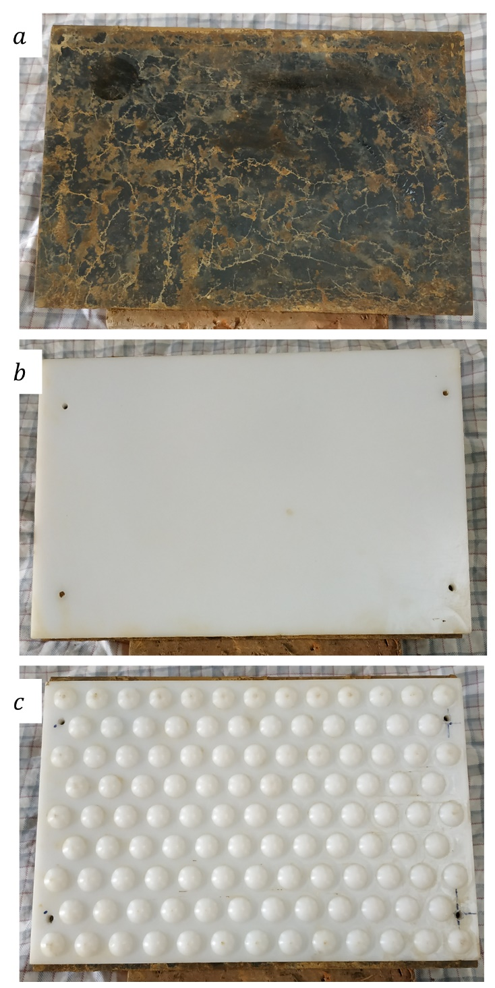

Figure 1. The tested samples: (a) flat plate of carbon steel; (b) flat plate of UHMW-PE; (c) domed plate of UHMW-PE

Table 1. Experimental soil consistency limits (%)

|  |  |  |
| --- | --- | --- |
| Soil texture | Liquid limit | Plastic limit |
| Silty clay | 42 | 17 |
| Sandy clay loam | 33 | 18 |

Soil liquid and plastic limits were determined using the liquid and plastic limits tester (LP-100D) following GB/T50123-2019 geotechnical test method standard. The test concept is based on the relationship between cone penetration and soil shear strength (Hansbo 1957). The liquid limit of a particular soil is the moisture content at which the undrained shear strength of that soil is 1.7 KPa, whereas the plastic limit is the moisture content corresponding to the undrained shear strength of 170 KPa (Wroth and Wood 1978).

$C_{u}=KQ/h^{2}$ (2)

Here, *Cu* is the undrained shear strength, *Q* is the cone's weight, *h* is the cone's penetration depth into the soil, and *K* is constant, which is wholly influenced by the cone angle. This study used the 0.59 N-60° cone assigned to soft soils, with a K value of 0.3 for remolded soil. The liquid and plastic limits were determined as the moisture content values corresponding to a 10.2 mm and 1 mm penetration distance on the best-fitted line, respectively (*Fig. 2*) for more details see (Sharma and Sridharan 2018).



Figure 2. The investigation of soil plastic and liquid limits

* 1. Measurement method and procedure

Each tested plate was placed in contact with the top surface of the soil paste and subjected to a specified normal load (*Fig. 3*). The tested plate was dragged at the specified speed for the desired displacement. This procedure is repeated using four normal loads of 65, 95, 125, and 155 N (this load includes the plate weight). At ultimate dynamic equilibrium, the corresponding traction force of each applied normal load is recorded.

The numerical values of soil adhesion and external friction coefficients were calculated according to the Mohr-Coulomb failure criterion (equation 1), which shows the relationship between tangential and normal stresses during ultimate dynamic equilibrium. According to the Mohr-Coulomb failure criterion, the adhesion value is determined by intersecting the failure line created by linear fitting of the obtained points with the y-axis, and the slope of the failure line represents the external friction angle (*Fig. 4*). Many researchers have utilized the above technique to measure soil adhesion and friction with other materials (Abbaspour-Gilandeh, Hasankhani-Ghavam 2018, Marani, Shahgholi 2019).



Figure 3. A simple slider technique for measuring soil adhesion and friction coefficients



Figure 4. Schematic representation of a failure line at the soil-plate contact interface

* 1. Soil preparation and implementation of the experiment

Initially, the tested soil was soaked in water for two days, and then the moisture content of the soil was measured and tracked twice daily until it reached the highest desired moisture content in the current study (33% d.b.). The relevant tests were then carried out, and so on until the lowest studied moisture content (18% d.b.) was achieved. A precise test bench was used to assess soil adhesion and friction coefficients at various combinations of the investigated parameters (*Fig. 5*).

An S-shaped load cell (Kyowa, 50 kg) was used to measure the sliding resistance of the different sliding plates. Each sliding plate was tested individually using a 0.4 kW electric motor with an inverter controlling the motor speed. The plate was pulled for 0.7 m, and the sliding resistance was continuously acquired by the distributed stress and strain test and analysis system (DH3820 N) (see the supplementary figure).

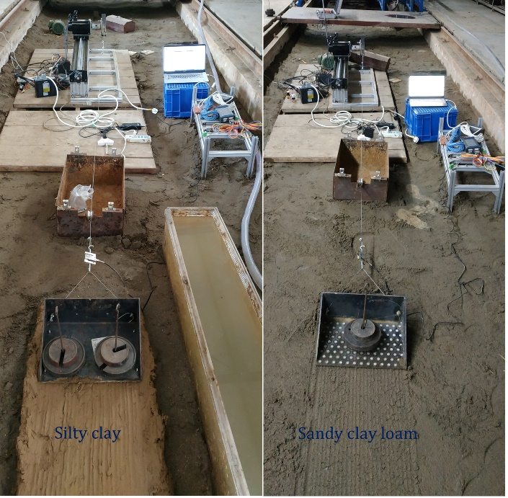

Figure 5. The experimental setup for determining soil adhesion and friction coefficients.

1. Results and discussion

The average of the calculated coefficients of adhesion and friction for all combinations of investigated parameter levels are presented in a spreadsheet (see the supplementary tables). The standard deviations of replicate measurements were computed and shown on charts in the form of error bars to evaluate the variation of repeated data from mean values.

The IBM SPSS 25 statistical software package was used to analyze the data based on a complete randomized design. According to the results of the variance analysis (Table 2), all investigated parameters and binary interaction effects were statistically significant at the 5% probability level, except for the binary interaction effect between soil moisture content and sliding speed on the coefficient of friction.

Table 2. The effects of the studied parameters on external friction and soil adhesion

|  |  |  |  |  |  |  |
| --- | --- | --- | --- | --- | --- | --- |
| Source of variation | df | Mean squares | |  | F-value | |
| Adhesion | Friction | Adhesion | Friction |
| Soil texture (A) | 1 | 2898909.34 | 0.646 |  | 1482.95* | 413.92* |
| Material and structure (B) | 3 | 2201778.56 | 4.82 |  | 1126.33* | 3088.56* |
| Soil moisture content (C) | 3 | 519582.47 | 1.237 |  | 265.8* | 792.65* |
| Sliding speed (D) | 3 | 992319.95 | 0.681 |  | 507.63* | 436.22* |
| A × B | 3 | 244593.88 | 0.02 |  | 125.12* | 12.55* |
| A × C | 3 | 663398.89 | 1.773 |  | 339.37* | 1136.13* |
| A × D | 3 | 10732.32 | 0.058 |  | 5.49* | 37.15* |
| B × C | 9 | 74768.28 | 0.055 |  | 38.25* | 35.12* |
| B × D | 9 | 28123.4 | 0.01 |  | 14.39* | 6.52* |
| C × D | 9 | 4885.46 | 0.003 |  | 2.5* | 1.73ns |
| Error | 256 | 1954.83 | 0.002 |  |  |  |
| Total | 383 |  |  |  |  |  |

* 1. The interactive impacts of soil texture, test-plate material, and moisture content on soil adhesion

As shown in *Fig. 6*, an increase in moisture content in silty clay soil increased soil adhesion for all tested plates. In contrast, soil adhesion values in sandy clay loam soil were increased by increasing its moisture content up to 28%. When the moisture content in the sandy clay loam soil was exceeded 28%, the values of adhesion coefficients rapidly decreased for all tested plates, which may be attributed to the low water-holding capabilities of light soils. As a result, when the moisture level of the sandy clay loam soil exceeds 28%, it behaves like a fluid; similar behaviour has been observed by other researchers in light soils with a high sand percentage (Burbaum and Sass 2017, Hasankhani-Ghavam, Abbaspour-Gilandeh 2015, Manuwa 2012).

Due to its high surface energy, the flat steel plate had the highest adhesion coefficient in both soil textures and all moisture contents. In comparison, the UHMW-PE plate with domed protrusions exhibited the lowest adhesion coefficient due to its lower wettability (Nalbant and Palali 2011). Furthermore, the capacity of an adequately designed non-smooth surface to interrupt the continuity of the interfacial water film enhances soil adhesion reduction (Chirende, Li 2010, Wang, Xue 2019). In general, the hydrophobic effect of UHMW-PE plates is due to the high water contact angle of Ultra-high molecular weight polyethylene (94°), which hinders a continuous interfacial water film from developing at the contacting interface, thereby reducing the attraction forces between soil particles and the plate surface (Tong, Ren 1999).



Figure 6. The variation in adhesion coefficients between both soil textures according to test-plate material and soil moisture content

As observed from *Fig. 6*, silty clay soil is more adhesive due to fine particles with a large surface area (clay and fine silt). Furthermore, increasing the moisture content value increased adhesion, implying that a high moisture content creates a suitable environment for ionic bond formation. Consequently, increased adhesion is predicted in clay and moisture-rich soils (Chen, Tong 1994). The maximum soil-plate adhesion value for steel plate was 1199.55 N/m2 in silty clay soil with a moisture content of 33% and a sliding speed of 0.3 m s-1, while the maximum soil-plate adhesion value for sandy clay loam soil was 842.29 N/m2 with a moisture content of 28% at the same sliding speed of 0.3 m s-1. Generally, UHMWPE-coated plates (i.e., the flat UHMWPE plate and domed UHMWPE plate) exhibited much lower adhesive force than the flat steel plate.

* 1. The interactive impacts of soil texture, test-plate material, and moisture content on external soil friction

*Figure 7* displays the variation in soil external friction angle coefficient for the investigated plates at all studied moisture contents in both soil textures. Among all treatments, the largest friction coefficient values were obtained at a moisture content of 28% in sandy clay loam soil at a sliding speed of 0.3 m s-1, with values of 1.03, 0.71, and 0.78 for flat steel plate, flat UHMWPE plate, and domed UHMWPE plate, respectively. In contrast, the lowest values in the sandy clay loam soil were obtained at a moisture content of 33% and a sliding speed of 0.15 m s-1 with values of 0.27, 0.21, and 0.21 for flat steel plate, flat UHMWPE plate, and domed UHMWPE plate, respectively. Gill and Vanden Berg stated that there is a direct relationship between soil sand percentage and friction coefficient; hence increasing the proportion of coarse particles in sandy clay loam soil compared to silty clay soil might be one of the causes (Gill and Vanden Berg 1967).

In sandy clay loam soil, the friction coefficients for all studied plates decreased rapidly when the soil moisture content exceeded 28%. This reduction may be attributed to the lubricating effect provided by forming a thick interfacial water layer at the contacting surface, which is related to the low water-holding capacity of such light soil (Ren, Han 2006). The results revealed that the plates with a surface coating of UHMWPE polymer had a lower coefficient of friction than steel plates. It may be inferred that plates with a surface coating of UHMWPE polymer due to their inherent properties produce more favorable conditions for the soil particles to slide over the plate surface.

* 1. The interactive impacts of soil texture, test-plate material, and sliding speed on coefficients of adhesion and friction

As can be seen in *Fig. 8* in both types of soil texture and for all sliding plates, the external friction coefficient, and soil adhesion increased with increasing sliding speed. Generally, the increased adhesion and external friction coefficients of all studied plates with increasing sliding speed may be attributed to the increased shear rate at the contacting interface (Swick and Perumpral 1988, Yang, Tong 2019). Among the studied plates engaged with two soil textures at all investigated sliding speeds, the maximum adhesion was 1199.55 N/m2, related to a flat steel plate in silty clay soil at a speed of 0.3 m s-1. The flat UHMWPE plate and domed UHMWPE plate had corresponding values of 815.37 and 719.32 N/m2, respectively. While the smallest adhesion values were obtained in sandy clay loam soil at a speed of 0.15 m s-1 for flat steel plate, flat UHMWPE plate, and domed UHMWPE plate with values of 405.22, 362.48, and 289.5 N/m2, respectively.



Figure 7. The variation in external friction coefficients between both soil textures according to test-plate material and soil moisture content



Figure 8. The variation in adhesion and external friction coefficients between both soil textures according to test-plate material and sliding speed

Another interesting aspect to notice is that the soil adhesion reduction of the plates with a surface coating of UHMWPE polymer increased compared to the steel plate at the high moisture content levels. This result demonstrates that increasing soil moisture content increased soil adhesion to steel plates more effectively than to plates with a UHMWPE polymer surface coating. It was concluded that the plates with a surface coating of UHMWPE polymer preserved their ability to minimize soil adhesion in moist and sticky soils due to their inherent hydrophobic properties. Other researchers have reported similar behavior for nano-coated and polymer-coated materials in other experiments (Barzegar, Hashemi 2016, Marani, Shahgholi 2019, Ren, Deng 2004, Salokhe, Chuenpakaranant 1999, Salokhe, Gee-Clough 1990).

It can be observed that the optimized bio-inspired surface generated a lower adhesion coefficient and a higher friction coefficient compared to a flat surface made of the same material. However, because the resultant decrease in adhesion coefficient was more pronounced than the resultant increase in friction coefficient, the overall impact was a reduction in the optimized bio-inspired surface sliding resistance compared to flat surface sliding resistance. This demonstrates the viability of coupling the optimized bio-inspired surface structure with a low surface energy polymer, which opens up many opportunities for developing anti-adhesive soil-contacting tools.

* 1. The tendency of the test-plate material to adhere to soil

The soil tendency for adhering to the test-plate material was evaluated by collecting, drying, and weighing the mass of soil clinging to each plate after sliding across the surface of silty clay soil with a moisture content of 33% for 0.7 m under an applied load of 155 N (Fig. 10). Although this simple measure doesn't fully reflect the complicated process of soil adhesion during paddock preparation, it may be used to compare and identify how different materials impact soil adhesion (Zumsteg and Puzrin 2012). After three replications, the average dried mass of soil clinging to the ultra-high molecular weight polyethylene plate was 427 gm with a standard deviation of 95 gm, compared to 767 gm with a standard deviation of 217 gm for the carbon steel plate. These results indicate that the ultra-high molecular weight polyethylene polymer has a significantly lower tendency to adhere to the soil than carbon steel plate.



Figure 9. The effect of test-plate material on the adhered soil mass to each plate under identical experimental settings

1. Conclusion

The effects of test-plate material, soil moisture content, soil texture, and sliding speed on coefficients of adhesion and friction were investigated. It was observed that the binary interaction effect of soil texture and soil moisture content on coefficients of adhesion and friction is highly significant. Furthermore, the results revealed a significant difference in soil adhesion between light and heavy soil at the same moisture content. Combining a bio-inspired convex shape with a surface coating of UHMWPE polymer significantly reduced the adhesion coefficients compared to carbon steel, especially in moist and sticky soils. The effect of tested-plate material on soil adhesion levels was investigated by collecting, drying, weighing, and comparing the amount of soil sticking to each plate. According to the results, ultra-high molecular weight polyethylene polymer has a significantly lower tendency to stick to soil than carbon steel. The lower adhesion coefficients of bio-inspired polymer-coated surfaces pave the way for practical applications in soil adhesion reduction and soil-engaging component optimization.

1. Acknowledgements

This study was financially supported by the National Natural Science Foundation of China; (Grant No. 51775220) titled “Contract–Rheology-Resistance coupling mechanism between the flat plate type soil working parts and disturbed paddy soil”. The authors would like to express their gratitude to the Huazhong Agricultural University soil physics laboratory staff for their assistance with the soil bin experiments.

1. References

Abbaspour-Gilandeh, Y., Hasankhani-Ghavam, F., Shahgoli, G., Shrabian, V. R., Abbaspour-Gilandeh, M., 2018. Investigation of the effect of soil moisture content, contact surface material and soil texture on soil friction and soil adhesion coefficients. Acta technologica agriculturae. 21, 44-50

Azadegan, B., Massah, J., 2012. Effect of temperature on adhesion of clay soil to steel. Agronomic Research in Moldavia. 45, 21–7

Barzegar, M., Hashemi, S., Nazokdast, H., Karimi, R., 2016. Evaluating the draft force and soil-tool adhesion of a UHMW-PE coated furrower. Soil and Tillage Research. 163, 160-7

Burbaum, U., Sass, I., 2017. Physics of adhesion of soils to solid surfaces. Bulletin of Engineering Geology and the Environment. 76, 1097-105

Chen, Y., Tong, J., Ren, L., Chen, B., Ge, L., 1994. Abrasive wear behavior of several soil adhesion-reducing materials. Transactions of the Chinese Society of Agricultural Engineering. 10, 91-5

Chirende, B., Li, J., Wen, L., Simalenga, T. E., 2010. Effects of bionic non-smooth surface on reducing soil resistance to disc ploughing. Science China Technological Sciences. 53, 2960-5

Gill, W. R., Vanden Berg, G. E. Soil Dynamics in Tillage and Traction US Department of Agriculture: Agricultural Research Service; 1967.

Goshtasb, A. K., Fielke, J., Desbiolles, J. A review of soil/tool adhesion principles and approaches to reducing limitations of disc seeders. In: Climate ATIaC, editor. The 2009 CIGR International Symposium of the Australian Society for Engineering in Agriculture. Brisbane, Queensland: Engineers Australia; 2009. p. 208-15.

Guan, C., Fu, J., Xu, L., Jiang, X., Wang, S., Cui, Z., 2022. Study on the reduction of soil adhesion and tillage force of bionic cutter teeth in secondary soil crushing. Biosystems Engineering. 213, 133-47. https://doi.org/https://doi.org/10.1016/j.biosystemseng.2021.11.018

Hansbo, S. A new approach to the determination of the shear strength of clay by the fall-cone test. Stockholm, Sweden: Royal Swedish Geotechnical Institute 1957.

Hasankhani-Ghavam, F., Abbaspour-Gilandeh, Y., Shahgoli, G., Rahmanzadeh-bahram, H., 2015. Design, manufacture and evaluation of the new instrument to measure the friction coefficient of soil. International Commission of Agricultural Engineering. 17, 101–9

Heuser, M., Spagnoli, G., Leroy, P., Klitzsch, N., Stanjek, H., 2012. Electro-osmotic flow in clays and its potential for reducing clogging in mechanical tunnel driving. Bulletin of Engineering Geology and the Environment. 71, 721-33

Khosravani, A., Desbiolles, J., Fielke, J. Opportunities for improving the performance of single disc seeders in sticky soil conditions. In: Hegarty R, Banhazi T, Saunders C, editors. 2011 Society for Engineering in Agriculture Conference: Diverse Challenges, Innovative Solutions. Barton, A.C.T.: Engineers Australia; 2011. p. 256-65.

Li, J., Kou, B., Liu, G., Fan, W., Liu, L., 2010. Resistance reduction by bionic coupling of the earthworm lubrication function. Science China Technological Sciences. 53, 2989-95

Liu, G., Xia, J., Zheng, K., Cheng, J., Wang, K., Zeng, R., et al., 2022. Effects of vibration parameters on the interfacial adhesion system between soil and metal surface. Soil and Tillage Research. 218, 105294-304

Liu, H., Zhao, S., Tan, H., Yang, Y., Zhang, X., 2018. Investigation on press device in reducing adhesion and resistance based on scrape and vibration principle. Transactions of the Chinese Society of Agricultural Machinery. 49, 86-92

Manuwa, S., 2012. Evaluation of soil/material interface friction and adhesion of Akure sandy clay loam soils in southwestern Nigeria. Advances in Natural Science. 5, 41-6

Marani, S. M., Shahgholi, G., Moinfar, A., 2019. Effect of nano coating materials on reduction of soil adhesion and external friction. Soil and Tillage Research. 193, 42-9

McGloughlin, T. M., Kavanagh, A., 2000. Wear of ultra-high molecular weight polyethylene (UHMWPE) in total knee prostheses: a review of key influences. Journal of Engineering in Medicine. 214, 349-59

Nalbant, M., Palali, A. T., 2011. Effects of different material coatings on the wearing of plowshares in soil tillage. Turkish journal of agriculture and forestry. 35, 215-23

Ren, L.-Q., Tong, J., Li, J.-Q., Chen, B.-C., 2001. SW—soil and water: soil adhesion and biomimetics of soil-engaging components: a review. Journal of Agricultural Engineering Research. 79, 239-63

Ren, L., Deng, S., Wang, J., Han, Z., 2004. Design principles of the non-smooth surface of bionic plow moldboard. Journal of Bionic Engineering. 1, 9-19

Ren, L., Han, Z., Li, J., Tong, J., 2006. Experimental investigation of bionic rough curved soil cutting blade surface to reduce soil adhesion and friction. Soil and Tillage Research. 85, 1-12

Salem, A. E., Wang, H., Gao, Y., Zha, X., Abdeen, M. A., Zhang, G., 2021. Effect of Biomimetic Surface Geometry, Soil Texture, and Soil Moisture Content on the Drag Force of Soil-Touching Parts. Applied Sciences. 11, 8927-38. https://doi.org/10.3390/app11198927

Salem, A. E., Zhang, G. Z., Abdeen, M. A. M., Wang, H., Gao, Y., 2022. Optimizing the adhesion of soil-touching parts based on biomimetic concepts using the Taguchi method. International Journal of Agricultural and Biological Engineering. 15, 147-54

Salokhe, V., Chuenpakaranant, W., Niyampa, T., 1999. Effect of enamel coating on the performance of a tractor drawn rotavator. Journal of terramechanics. 36, 127-38

Salokhe, V., Gee-Clough, D., Manzoor, S., Singh, K., 1990. Improvement of the tractive performance of cage wheel lugs by enamel coating. Journal of Agricultural Engineering Research. 45, 209-24

Sharma, B., Sridharan, A., 2018. Liquid and plastic limits of clays by cone method. International Journal of Geo-Engineering. 9, 22. https://doi.org/10.1186/s40703-018-0092-0

Soni, P., Salokhe, V., Nakashima, H., 2007. Modification of a mouldboard plough surface using arrays of polyethylene protuberances. Journal of Terramechanics. 44, 411-22

Swick, W., Perumpral, J., 1988. A model for predicting soil-tool interaction. Journal of Terramechanics. 25, 43-56

Tong, J., Ren, L.-Q., Yan, J.-L., Ma, Y.-H., Chen, B. C., 1999. Adhesion and abrasion of several materials against soil. International Agricultural Engineering Journal. 8, 1-22

Wang, Y., Xue, W., Ma, Y., Tong, J., Liu, X., Sun, J., 2019. DEM and soil bin study on a biomimetic disc furrow opener. Computers and Electronics in Agriculture. 156, 209-16

Wroth, C. P., Wood, D. M., 1978. The correlation of index properties with some basic engineering properties of soils. Canadian Geotechnical Journal. 15, 137-45. https://doi.org/10.1139/t78-014

Yang, Y., Tong, J., Ma, Y., Jiang, X., Li, J., 2019. Design and experiment of biomimetic rotary tillage blade based on multiple claws characteristics of mole rats. Transactions of the Chinese Society for Agricultural Engineering. 35, 37-45 (in Chinese)

Zhang, D., Chen, Y., Ma, Y., Guo, L., Sun, J., Tong, J., 2016. Earthworm epidermal mucus: Rheological behavior reveals drag-reducing characteristics in soil. Soil and Tillage Research. 158, 57-66

Zhang, Y., Huang, H., Ren, L., 2013. Experiment and drag reduction mechanism of bionic excavator tooth during soil cutting. Nongye Jixie Xuebao= Transactions of the Chinese Society for Agricultural Machinery. 44, 258-61

Zumsteg, R., Puzrin, A. M., 2012. Stickiness and adhesion of conditioned clay pastes. Tunnelling and Underground Space Technology. 31, 86-96

Construction of a Soil Clods Recognition Bench-Scale Experiment for Discrete Element Method Modeling of Tilling Phenomena8654

Shuto Ishiia*

ishii.s@hnl.t.u-tokyo.ac.jp

Isami Sutoa

suto@hnl.t.u-tokyo.ac.jp

Hiroaki Tabea

tabe@hnl.t.u-tokyo.ac.jp

Keisuke Nagatoa*

nagato@hnl.t.u-tokyo.ac.jp

Moju Zhaoa*

chou@hnl.t.u-tokyo.ac.jp

Yoshifumi Ueshigeb

yoshifumi.ueshige@kubota.com

Takashi Iritanib

takashi.iritani@kubota.com

Masayuki Nakaoa

nakao@hnl.t.u-tokyo.ac.jp

aDepartment of Mechanical Engineering, The University of Tokyo, Bunkyo-ku, Tokyo, Japan 113-8656

bAnalysis Center, Technology Innovation Research and Development Unit, Research and Development Headquarters, Kubota Corporation, Sakai-City, Osaka, Japan 590-0823

*Corresponding author

Abstract

The development of rotary claws in tiller machines has been evaluated using actual equipment and analysis based on the discrete element method (DEM), which is an effective method for modeling the movement of granular materials. The required functions of the rotary claw are to break the soil into small pieces and plow the soil flat. However, evaluation by testing using actual equipment is difficult for precise measurements, and a considerable amount of time is required for one test. Additionally, DEM simulations have difficulty reproducing the soil behavior owing to the large number of parameters that determine their accuracy. Therefore, a comparison with the experimental results is necessary when determining DEM parameters. This research aims to develop a soil clod recognition method and an evaluation system for evaluating tractor performance.

The evaluation system was designed to measure the soil shape before and after tilling with a 1/4-scale tillage claw. To capture the changes in the soil shape and distribution and size of the soil clods, we developed an image processing method. This method uses pointcloud data obtained from a depth camera to calculate the difference before and after tilling. The experimental parameters were the soil moisture content and claw rotation speed. Their effects on the formation and decomposition of the soil clods were evaluated. To confirm the feasibility of the results obtained from the proposed evaluation system, DEM simulations were performed under identical conditions to compare the distribution and size of the soil clods and changes in soil shape.

The experimental results showed that the location, number, and size of scattered soil clods varied with the moisture content of the soil, and rotational speed of the claw. Based on the experimental results, a comparison was made with the results of the DEM analysis to clarify the differences between the two. The developed model experiment system for soil clods and the image processing method made it possible to quantitatively compare soil dispersal between the experiment and the DEM, which may accelerate the search for parameters for the DEM to reproduce the tilling.

Keywords: Discrete Element Method (DEM), Recognition of Soil Clods, Tillage Claw, Moisture Content Ratio, Rotation Speed.

*Editor’s note: see end of paper for wide-format figures.*

1. Introduction

In recent years, design evaluation of rotary development has been conducted through tests using actual tractor. Tests have been conducted in many fields. Usaborisut et al. (2020) conducted field tillage trials using a rotary tiller and power harrow with and without pre-applied subsoil and compared the characteristics of both. In these tests, the soil quality and moisture content ratio were controlled. Therefore, a single experimental trial takes a significant amount of time to complete. It is also difficult to collect accurate data from large-scale environments.

In previous studies, an experimental-scale model was created to reduce the time and effort required to use a machine. It also evaluated the shape of the claw with greater precision. For example, Chertkiattipol and Niyamapa (2010) analyzed the torque characteristics of a single claw with different shapes. They found that the position of the cutting edge and shape of the rotating blade affected the torque characteristics. Matin et al. (2015, 2016) analyzed the motion of four blades using a high-speed camera. They discovered that the blade penetration depth increased with increasing rotational speed, and peak torque was generated. Matin et al. (2021) conducted experiments with various blades, tilling widths, geometries, and tilling depths. They found that straight blades produced the most optimal soil clods and uniform grooves.

In addition, many studies have used the DEM as a method other than testing in actual equipment for design evaluation of tillage claw. DEM is an effective method for modeling the flow of granular materials. Cheng et al. (2021) conducted a simulation test based on DEM to analyze the wet clay soil adhering to the rotary-tillage during rotary-tillage in paddy fields. Li et al. (2018) conducted a soil-cutting simulation to optimize the rotary blade and save energy for the tilling operation. Zhao et al. (2020) analyzed the torque applied to claws and soil dispersal when the shape of claw was changed. However, the mechanism is complex and difficult to test in practice since the adhesive forces between soil particles vary with changes in conditions, such as moisture content. In addition, the number of parameters that determine the accuracy of the model is large and difficult to identify. This makes it difficult to perfectly reproduce the rotary-tillage process.

To improve the accuracy of the DEM simulations, it is necessary to compare them with real phenomena. Studies to improve the accuracy of DEM simulations include comparisons of DEM simulations with experiments on actual equipment and comparisons of DEM simulations with experiments using bench-scale test equipment. Hirasawa et al. (2013, 2014) compared the experimental and DEM simulation results for soil leveling, soil-particle dispersion velocity, and torque applied to the claw.

In this study, we evaluated the important functions of a tractor as a novel subject for a comparison between experiments and DEM. The purposes of tillage are to level the soil for efficient seeding after tilling and break the soil into small pieces to aerate the soil for plant growth. For both purposes we focused on changes in soil conditions before and after tillage.

Vision and force sense are important tools in measuring soil conditions. In this system, we focused on visual methods of measurement to focus on the number, size, and location of soil clods when observing their decomposition before and after tilling. As a future prospect, we plan to combine sensing other than visual information, for example, with information on torque applied to the claws during tilling. To recognize soil conditions, Grundy et al. (2020) used a depth camera to measure soil-surface roughness and introduced it as an alternative to existing measurement techniques. Although it recognizes the soil shape, it cannot detect soil clods on the top of the soil. Therefore, this study aimed to develop a system that recognizes soil conditions before and after tillage and detects soil clods. The developed system was verified in a 1/4-scale bench experiment. The size and position data obtained from the recognition results were used to confirm the dispersal of soil clods.

1. Method
   1. Experimental equipment and systems

In this study, a scale model of a rotary experiment was developed. Figure 1(a) shows a diagram of the experimental apparatus. The experimental apparatus consisted of a motor and 1/4-scale tilling claw. The motor drives the tilling claw, which is attached to the shaft for rotation. Rotation of the claw cultivated the soil bed. An area around the soil bed was used for the detection.

Figures 1(b) and 1(c) show the apparatus used in this experiment. A scale model was created using a 1/4-scale tilling claw.

An Intel RealSense LiDAR Camera L515 was used to capture the changes in soil shape and distribution and size of soil clods before and after tilling. This camera is equipped with both an RGB camera and LiDAR and can acquire colored pointcloud data with a single device. Figure 1(d) shows the location of the depth camera. A depth camera was mounted directly above the soil bed. The minimum depth distance of the depth camera was 0.25 m. In addition, the accuracy of the depth measurements was less than 2 cm at 1 m.

Figure 1(e) shows the soil bed used in this study. Soil beds and floor surfaces were created to observe soil dispersal. The soil bed had the smallest size that would be unaffected by the wall surface.

The bench-scale experiment was conducted using the following procedure. First, the dry soil was weighed and mixed with a calculated weight of water to reach the moisture content suitable for the experiment. The soil was then compacted into a container to achieve an appropriate soil volume fraction under experimental conditions. The soil bed was recorded using a depth camera as the pre-tillage data. The motor was then driven to rotate the tilling claw. A tilling test was conducted. Finally, the data were recorded as post-tillage data.

* 1. Experimental conditions

The experimental conditions are presented in Table 1. To investigate the mechanism of soil clod breakdown, experiments were conducted by varying two parameters: moisture content ratio of the soil and rotational speed of the claw. Three conditions were used for moisture contents of 8 %, 10 %, and 12 %. These moisture contents were common during tilling and is most likely to generate clods. If the moisture content is too small (less than 4%), clods are not produced because adhesion between soil particles does not occur easily. Conversely, if the moisture content is too high (more than 16%), the soil is clayey, and in the case of a one-jaw, one-rotation cultivation, soil clod breakdown does not occur, and a single soil clod is generated according to the trajectory of the rotating claw. Therefore, the observation of soil breakdown in these cases is considered unnecessary. Therefore, we set an intermediate moisture content ratio that facilitates the observation of the decomposition of soil clods. The moisture content ratio ($w$) can be derived from Equation (1) using the weight of soil ($M_{s}$) and weight of water ($M_{w}$).

$w=\frac{M_{w}}{M_{s}}×100$ (1)

The rotation speeds during the experiment were 100, 200, and 300 rpm, which are common rotation speeds for tractor tilling.

Next, the fixed parameters are described. The volume fraction of soil was set to 44 %. It ensured that the soil was sufficiently soft, and the decomposition of the soil clod was easily observed. The soil volume fraction of 44 % used in this study corresponded to approximately 1200 kg/m3 in terms of soil bulk density. The soil volume fraction ($P$) can be derived from Equation (2) using the volume of air ($V_{a}$), water ($V_{w}$), and soil ($V_{s}$). The tilling depth was set to 35 mm, which is approximately 1/4 times that of the actual machine.

$P=\frac{V_{s}}{V_{a}+V_{w}+V_{s}}×100$ (2)

The soil properties used in the experiments are listed in Table 2. The experiment was repeated five times for each condition.

Table 1. Operating conditions during the experiments

|  |  |  |
| --- | --- | --- |
| Variable parameters | Rotational speed [rpm] | 100, 200, 300 |
| Moisture content ratio [%] | 8, 10, 12 |
| Fixed parameters | Soil volume fraction [%] | 44 |
| Tilling depth [mm] | 35 |

Table 2. Soil properties in the experiments

|  |  |  |  |  |  |
| --- | --- | --- | --- | --- | --- |
| **Soil type** | **Particle size distribution**  **(mass percentage [%])** | | | | |
| **Sand**  **(2–0.42 mm)** |  | **Silt**  **(0.42–0.002 mm)** |  | **Clay**  **(< 0.002 mm)** |
| Clay  Loam  (CL) | 46.0 |  | 38.4 |  | 15.6 |

* 1. Soil clod recognition method

In this section, we describe a method for recognizing the soil clods. To recognize the soil clods after tilling, it is necessary to recognize randomly distributed clods in the soil. Therefore, methods such as ordinary RGB image recognition cannot distinguish between clods and soil, and the recognition is unsuccessful.

To classify clods and mountains, we used the geometrical characteristics of the soil clods in the recognition method. If there is a soil clod, it is assumed that the height will increase rapidly compared to the height of the surrounding area. In contrast, the mountainous shape varied continuously with the surrounding height. Therefore, when photographed from above, there was an occlusion area at the bottom of the soil clods.

Figure 2(a) shows a conceptual diagram of soil clod detection. First, a contour was obtained for each clod and mountain height. The areas of the contours were then calculated. The difference between the two is that the area reduction rate is small for clods and large for mountains.

Figure 2(b) shows the details of the proposed algorithm. First, a depth image is prepared before and after tilling. Each pixel contains a depth value expressed as a value from 0 to 255.

A difference in the depth image before and after tilling was created. The differences in images were binarized by varying the threshold values. The difference between images implies the difference in depth values for each pixel. Furthermore, by changing the threshold value and binarizing it, an image that resembles a surface cut can be created at a certain height.

Contours were extracted for each image. In conventional contour extraction, contours are merged when clods are adjacent to each other. Therefore, we used a watershed algorithm (Beucher, 1992). This algorithm is a classical region segmentation method widely used for the image segmentation of rock particles (Guo et al., 2022). It separates and recognizes objects in contact with each other. This method can distinguish between adjacent clods and extract them as separate contours.

Next, each contour from the first different image was registered as a group. The first difference image appeared to be cut at the lowest height.

Then, by gradually changing the threshold value, the contours of the image with a slightly higher cut surface were obtained. For each contour, the position of the geometric center was compared to that of the contour group previously registered to determine whether it was included in the contour group. If included, the contour is added to the contour group. Otherwise, a new contour group was created.

For each contour group, we determined the rate of decrease in the contour area. If the rate of decrease in the contour area was large, the contour group was considered to be a mountain. If the rate of decrease was small, the contour group was considered to be a clod. Based on these classifications, the contour groups were labeled as clods or mountains.

The largest contour in a group of contours labeled as a clod is the clod contour. The area and center of geometry of the largest contour can be determined.

* 1. DEM simulation

To compare the experimental results obtained using the soil clod recognition system proposed in this study with the simulation results of the DEM, the DEM was used to simulate tilling. Figure 3 shows a schematic of the simulation model. A 1/4-scale model of an actual machine was used for the simulation.

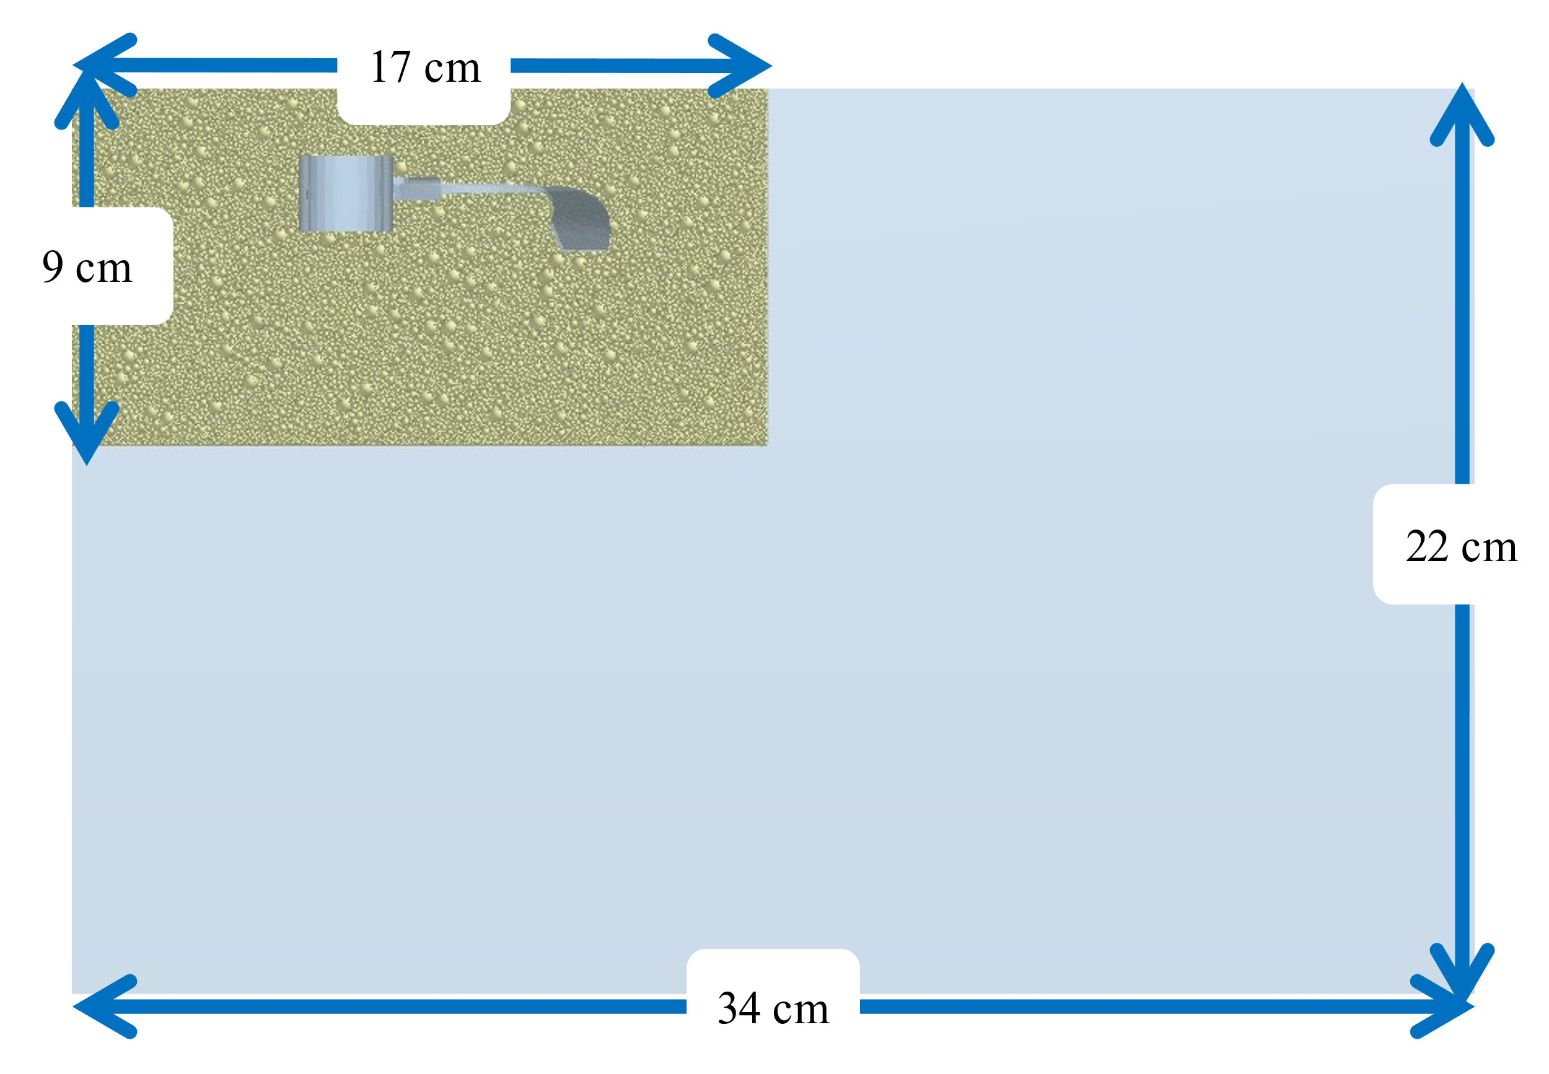

Figure 3. Schematic of the simulation model

The simulation was performed using the following procedure: First, the particle size distribution for the particles to be filled was created based on the particle size distribution of the particles used in the experiment. A container simulating the field was filled with particles. The pressure was applied from the top of the container to simulate the compacted soil. The simulation was performed by rotating the tilling claw at the same rotational speed as that in the experiment. Finally, the behavior of the particles during tilling and their distribution after tilling were compared.

Table 3 shows the properties of the soil in the DEM simulation. Additional parameters called Edinburgh-Elasto-Plastic-Adhesion (EEPA) were used in this analysis to analyze the behavior of the soil clods. The EEPA parameters are the parameters of tensile force generation and nonlinear force-displacement behavior. This parameter makes it possible to represent particle adhesion. Therefore, it was considered to be a necessary parameter for representing the soil clods in this study.

Table 3. Properties of the soil in DEM simulation

|  |  |
| --- | --- |
| Parameter Type | Value |
| Constant pull-off force [$N$] | 0 |
| Surface Energy [$J/m^{2}$] | 10 |
| Constant Plasticity Ratio | 0.9 |
| Slope Exp. | 1.5 |
| Tensile Exp. | 20 |
| Tangential Stiff Multiplier | 0.28571 |
| Coefficient of Restitution | 0.5 |
| Coefficient of Static Friction | 0.5 |
| Coefficient of Rolling Friction | 0.01 |
| Poisson’s Ratio | 0.25 |
| Solids Density [$kg/m^{3}$] | 2500 |

1. Results and Discussion
   1. Accuracy of soil clod recognition method

To confirm the accuracy of the proposed soil clod recognition method, soil clod samples were created and recognized. Figure 3 shows the location of the sample soil clod. The size of the soil clod is defined by its length along the two axes. As shown in the figure, the x- and y-axis were set up, and their respective axial lengths were measured. The scattering position of the clod was determined by comparing the center of geometry of the clod with that of the tilling claw. The scattering distance was determined for both the x- and y-axis. First, the soil clod was measured with a ruler. Its lengths in the x-axis and y-axis directions were 53 mm and 45 mm, respectively. The distance from the center of the claw was 120 and 90 mm in the x-axis and y-axis directions, respectively.

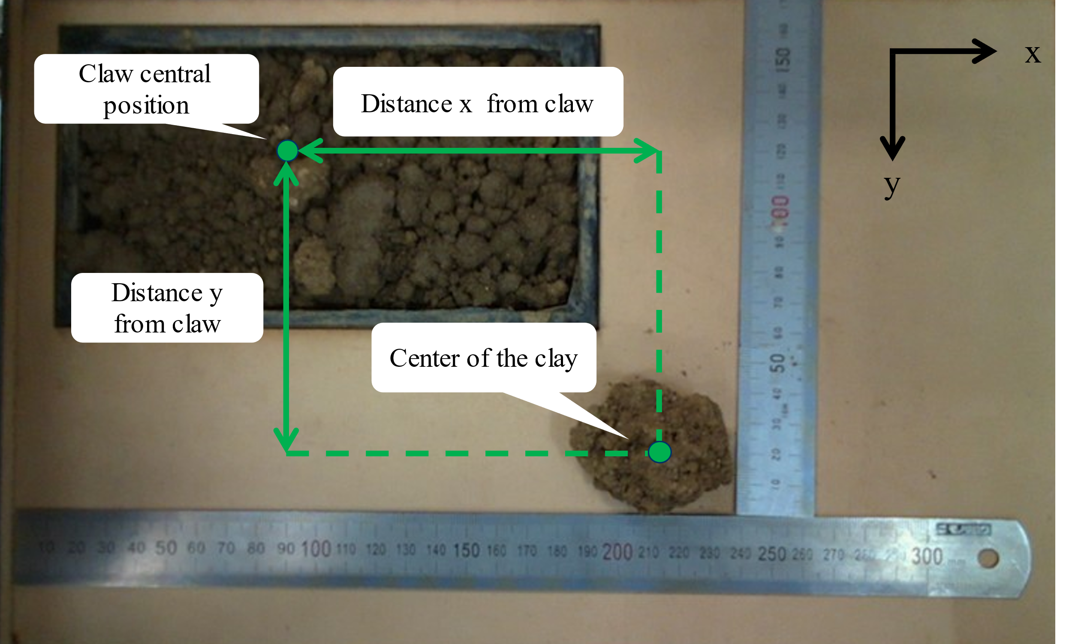

*Figure 3. Sample soil clod location*

Figure 4 and Table 4 show the measurement results for the soil clods recognized by the system. The lengths of the clods in the x- and y-axes were 55 and 44 mm, respectively. The distance from the center of the claw was 124 mm in the x-axis direction and 94 mm in the y-axis direction. Compared to the values measured with a ruler, the system accurately measured the size of the soil clods and detected their dispersal position and shape. Therefore, this system can accurately recognize the size and dispersal location of soil clods.

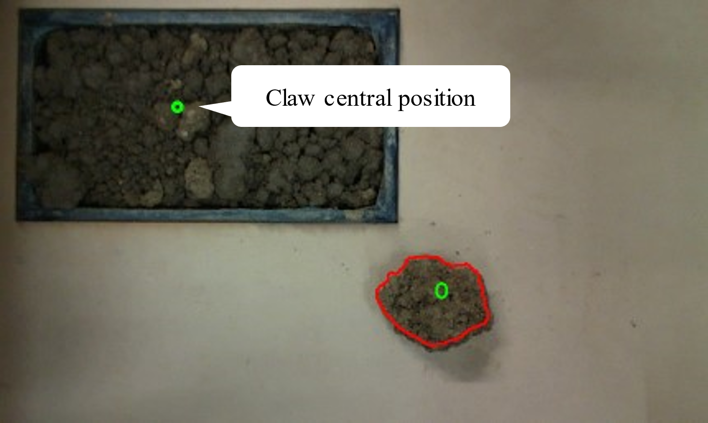

Figure 4. Recognition results of sample soil clods

Table 4. Comparison of measurement methods

|  |  |  |  |  |  |
| --- | --- | --- | --- | --- | --- |
| **Measurement method** | **Length (mm)** | |  | **Distance (mm)** | |
| **x** | **y** |  | **x** | **y** | |
| Measured with ruler | 53 | 45 |  | 120 | 90 | |
| Proposed system | 55 | 44 |  | 124 | 94 | |

* 1. Results overview

Figure 5 shows the results of the soil clod recognition for each experimental condition. Soil clods were recognized within the recognition area on the board, except inside the container. The recognized clods are shown as red contours. As shown in the Figure 5, the soil clods were correctly recognized under almost all conditions. The soil clods were not well recognized when the rotational speed was 300 rpm, and moisture content was 8 %. The small clods scattered on top of the sediment, lining next to each other. The results indicate that sediment and small clods are more likely to occur when the moisture content is low, and the rotation speed is high.

In addition, when the rotational speed was slow, the clods were larger. When the rotation speed was high, the clods broke into small pieces. The scattering area of the clods was distributed around the container at 100 rpm. However, as the rotational speed increased, the scattering area expanded. When the moisture content is low, many fine clods and sediments are distributed. Whereas when the moisture content is high, the size of the clods is larger, and the proportion of sediment and fine clods decreases.

Figure 6 shows the distribution of the average number of pieces per soil clod size for each of the nine conditions. The figure shows that the proportion of the small clods decreased, and that of the large clods increased as the moisture content increased. Comparing the rotational speed of 200 rpm, at a moisture content of 10%, the number of clods larger than 400 ${mm}^{2}$ accounted for 3.0 compared to 17.2 for the total (17%). On the other hand, when the moisture content is 12%, the number of clods is 1.4 compared to 6.0 (23%), indicating that the proportion of large clods increases as the moisture content increases. As the moisture content increases, the soil clods become more adhesive, thus their ability to break the soil into smaller pieces during tilling is decreased.

In addition, it can also be seen that both the percentage and the number of small soil clods increase as the speed of rotations increases. At a moisture content of 10%, at 100 rpm, the number of soil clods larger than 400 ${mm}^{2}$ accounted for 1.4 out of 5.6 overall (25%), while at 200 and 300 rpm, the percentages steadily decreased to 17% and 5%, respectively. As for the number of small clods, at a water content of 10%, the number of clods smaller than 100 ${mm}^{2}$ increased to 2.0, 9.0, and 12.8, respectively. This could be because the increased number of rotations increased the energy given to the soil by the tilling claw.

These results are consistent with those shown in Figure 5. The results were measured and quantitatively analyzed using the recognition system proposed in this study. In the future, it will be important to improve the accuracy of soil clod recognition in sediments. Since clods are also distributed in the container, it is necessary to examine the clods around the tilled area.

* 1. Size and dispersal distribution of soil clods

The distribution of the number of clods per size at 10 % and 12 % moisture content, where soil clod recognition was accurate, was determined. The detection area was divided into three parts, as shown in Figure 7. The distribution of the number of clods per size in each area was determined. Each area is assumed to have a significant contribution from the following mechanisms during tilling.

Area 1: The effect of scattering backward is large.

Area 2: The effect of scattering by sliding in the direction of the axis of rotation is large.

Area 3: Both effects are large.

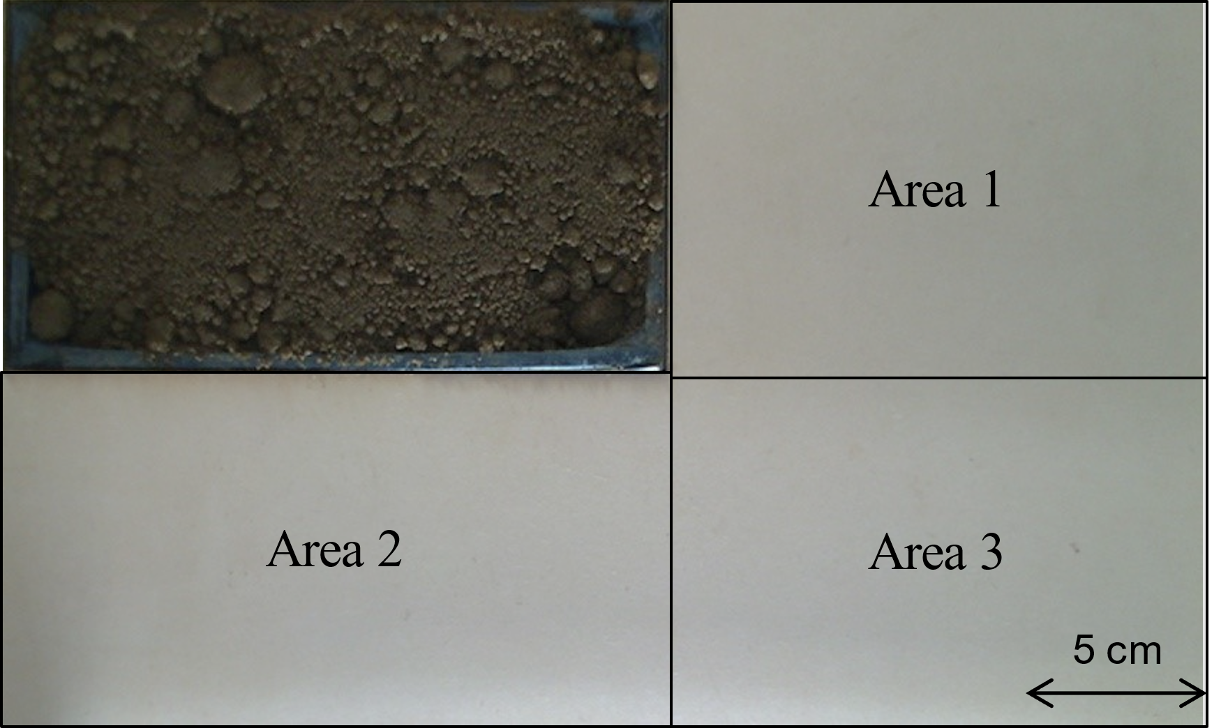

Figure 7. Detection area classification

Figure 8 shows the distribution of the size and number of clods in each area. As the rotation speed increases, the ratio of area 2 tends to decrease, and it can be confirmed that the distribution is biased in the direction of 1 and 3. When the water content ratio is 10%, area 3 accounts for 0.6 of the total 4.6 at 100 rpm (13%), and 24% and 25% at 200 rpm and 300 rpm, respectively, showing an increasing trend in the ratio to area 3. This is thought to be that at low rotational speeds, there was not enough torque to send the soil backward, causing it to slide sideways, while at high rotational speeds, the amount of soil sent to areas 1 and 3 increased because of the increased torque to send the soil in the direction of rotation. This result also agrees with the result of 3.2, confirming that the recognition system in this study can accurately quantify the amount of soil.

The difference between areas is small under all conditions, but it can also be confirmed that there is more scattering in area 2 only at 100 rpm. When the moisture content ratio was 10%, Area 2 accounted for 3.2 compared to 4.6 for the total (70%). When the moisture content was 12%, Area 2 accounted for 2.2 compared to 2.8 for the total (79%). These results clearly indicate that the amount of scatter in Area 2 is larger than that in the other areas. This indicates that at low rotational speeds, the lateral scattering effect is greater than the backward scattering effect.

* 1. Result of DEM simulation and comparison with scale-model experiment

To confirm the distribution of the location, number, and size of the scattered soil clods after tilling, we divided the area as described in section 3.3 and examined the clod distribution. Figure 9 shows the divisions of the areas in the simulation.

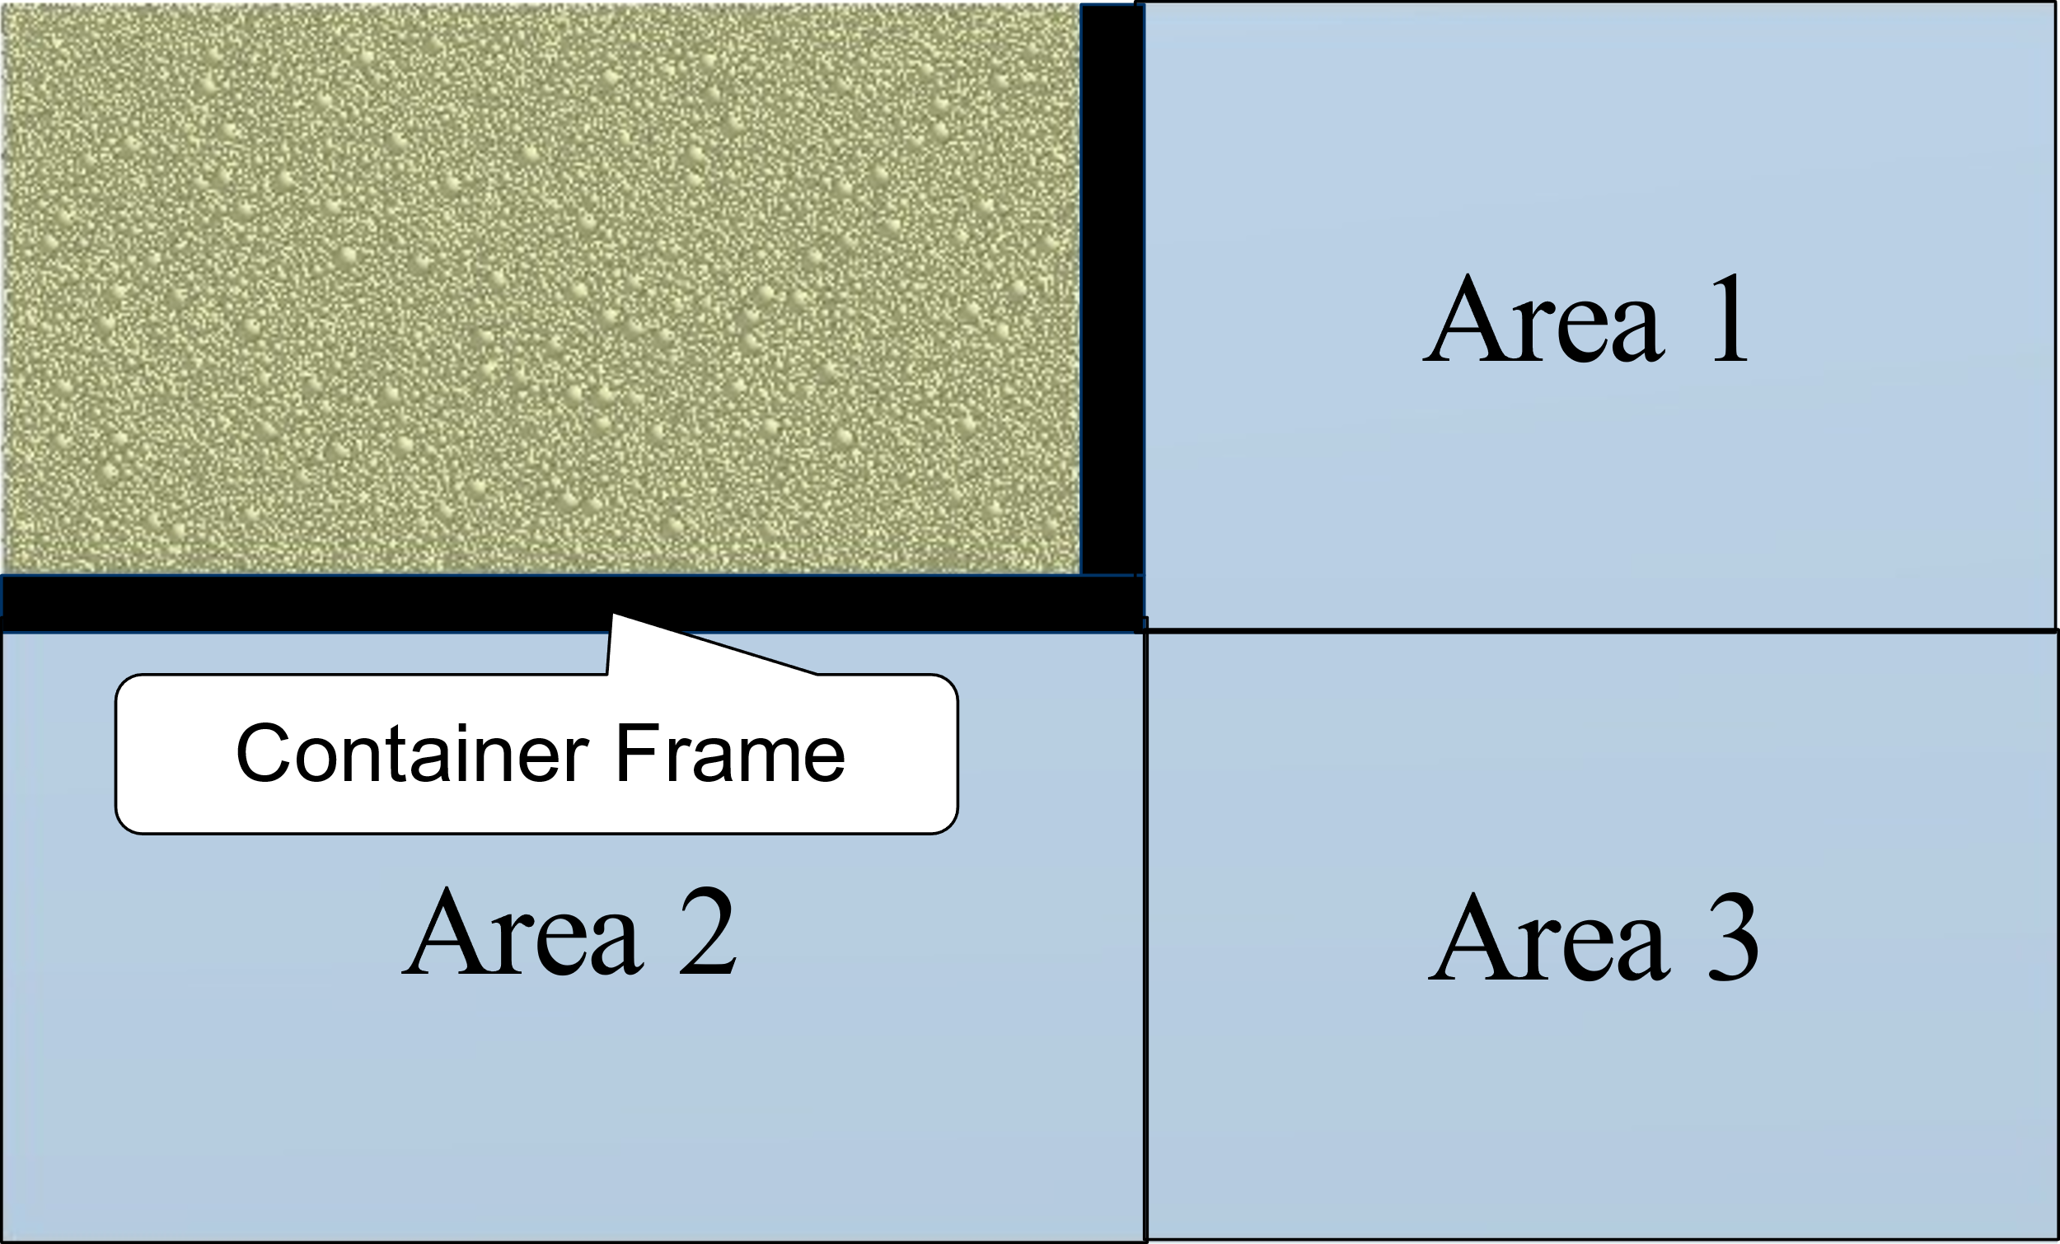

Figure 9. Detection area classification in DEM

A model simulating the soil with water content and adhesion was created using a DEM. Soil dispersal was evaluated by changing the rotational speed of the model. Figure 10(a) shows the scattering of the soil clods in the DEM. The soil clods are colored red.

Figure 10(b) shows the distribution of the size and number of soil clods per area. The number of soil clods increased as the rotational speed increased, and the dispersal area changed from area 2 to areas 1 and 3. The total number of clods at 200 rpm was 14, while area 3 accounted for only one clod (7%). On the other hand, at 300 rpm, area 3 accounts for 10 (42%) of the total number of dispersal areas, compared to 24 for the total. This indicates that the total number of clods increased, and the direction of scattering was biased toward Area 3. This trend is consistent with the results presented in section 3.3.

However, the average size of the soil clods was smaller than that observed in the experiment. The average size of the experimental soil clods at 200 rpm was 267 ${mm}^{2}$ at 10% water content and 488 ${mm}^{2}$ at 12% water content, compared to 29 ${mm}^{2}$ in the DEM analysis. The number of soil clods was extremely low at 100 rpm and extremely high at 300 rpm compared to the experiment. At 100 rpm, the number of soil clods was 4.6 and 2.8 for moisture content of 10% and 12%, respectively, while it was 0 in the simulation. At 300 rpm, the number of clods was 13.0 and 7.2 for moisture content of 10% and 12%, respectively, compared to 24 in the simulation. Therefore, the parameters of Edinburgh-Elasto-Plastic-Adhesion (EEPA) need to be modified. The adhesion force between particles needs to be increased to represent the scattering of soil clods during tiling obtained in this experiment.

Overall, the scattering distance of soil clods was short. The proportion of soil clods distributed in area 3 was small at a rotational speed of 200 rpm. In the experiment, this ratio is 24% at a moisture content ratio of 10% and 30% at a moisture content ratio of 12%, compared to 7% in the simulation. To resolve the difference between simulation and experiment, a model that increases particle-to-particle adhesion should be able to approximate experimental results. The energy used to destroy the soil clods could be used for dispersal.

1. Conclusion

In this study, we developed a system that can detect the presence or absence of soil clods based on depth images, which is important for the development of rotaries. A scale model of a tilling test was created. Experiments confirmed that the proposed method can accurately recognize soil clods. We also analyzed the mechanism of the proposed method when the rotation speed and moisture content changed and were able to compare the results with the DEM simulations.

As a prospect, we would like to improve recognition accuracy in situations where soil clods are difficult to recognize, such as the top of the sediment. In addition, by applying the soil cold recognition system to real-world environments, we would use the system in the evaluation of actual equipment.

1. References

Beucher, S. (1992) The Watershed Transformation Applied to Image Segmentation, Scanning Microscopy: Vol. 1992 : No. 6 , 28.

Cheng, J., Zheng, K., Xia, J., Liu, G., Jiang, L., & Li, D. (2021). Analysis of adhesion between wet clay soil and rotary tillage part in paddy field based on discrete element method. Processes, 9(5):845.

Chertkiattipol, S., & Niyamapa, T. (2010). Variations of torque and specific tilling energy for different rotary blades. International Agricultural Engineering Journal, 19(3), 1–14.

Grundy, L., Ghimire, C., & Snow, V. (2020). Characterisation of soil micro-topography using a depth camera. MethodsX, 7(September), 101144.

Guo, Q., Wang, Y., Yang, S., & Xiang, Z. (2022). A method of blasted rock image segmentation based on improved watershed algorithm. Scientific Reports, 12(1) :7143.

Hirasawa, K., Kataoka, T., Niu, H., Kubo, T. (2014). Analysis of Dynamic Phenomenon in Rotary Tilling (Part 2). Journal of the Japanese Society of Agricultural Machinery and Food Engineers, 76(1), 55–61.

Hirasawa, K., Kataoka, T., & Kubo, T. (2013). Prediction and evaluation for leveling performance in rotary tiller. In IFAC Proceedings Volumes (IFAC-Papers Online) (Vol. 4, Issue PART 1). IFAC.

Li, S., Chen, X., Chen, W., Zhu, S., Li, Y., Yang, L., Xie, S., & Yang, M. (2018). Soil-cutting simulation and parameter optimization of handheld tiller’s rotary blade by Smoothed Particle Hydrodynamics modelling and Taguchi method. Journal of Cleaner Production, 179, 55–62.

Matin, M. A., Desbiolles, J. M. A., & Fielke, J. M. (2016). Strip-tillage using rotating straight blades: Effect of cutting edge geometry on furrow parameters. Soil and Tillage Research, 155, 271–279.

Matin, M. A., Fielke, J. M., & Desbiolles, J. M. A. (2015). Torque and energy characteristics for strip-tillage cultivation when cutting furrows using three designs of rotary blade. Biosystems Engineering, 129, 329–340.

Matin, Md A., Hossain, M. I., Gathala, M. K., Timsina, J., & Krupnik, T. J. (2021). Optimal design and setting of rotary strip-tiller blades to intensify dry season cropping in Asian wet clay soil conditions. Soil and Tillage Research, 207(May 2020), 104854.

Morrisey, J. P., Thakur, S. C., & Ooi, J. Y. (2014). EDEM Contact Model : Adhesive Elasto-Plastic Model. Granul. Matter, 16(3), 383–400.

Usaborisut, P., Sukcharoenvipharat, W., & Choedkiatphon, S. (2020). Tilling tests of rotary tiller and power harrow after subsoiling. Journal of the Saudi Society of Agricultural Sciences, 19(6), 391–400.

Zhao, H., Li, H., Ma, S., He, J., Wang, Q., Lu, C., Zheng, Z., & Zhang, Chao. (2020). The effect of various edge-curve types of plain-straight blades for strip tillage seeding on torque and soil disturbance using DEM. Soil and Tillage Research, 202(17), 104674.

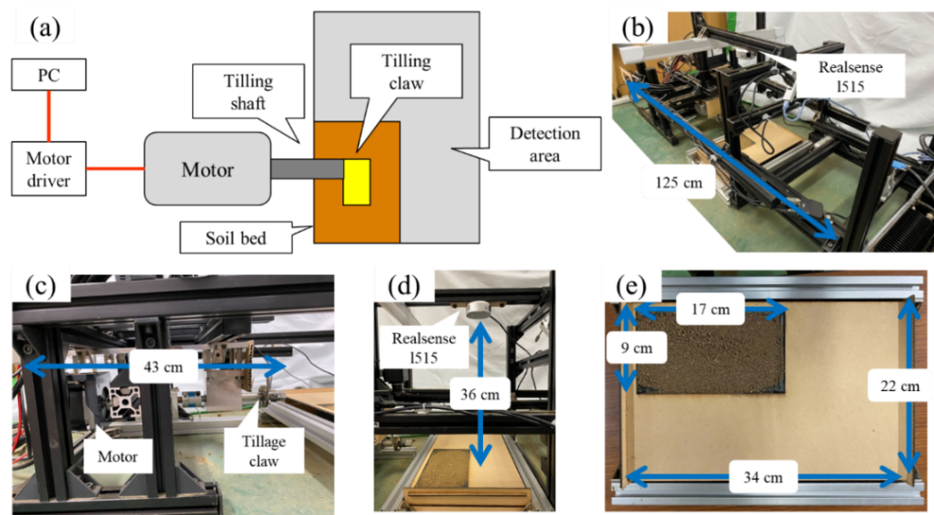

Figure 1. Experimental apparatus: (top-left view) (a)System diagram, (top-right view) (b)Overall appearance, (bottom-left view) (c)Appearance around tilling shaft, (bottom-center view) (d)View of soil profile recording, and (bottom-right view) (e)Soil bed for the experiment

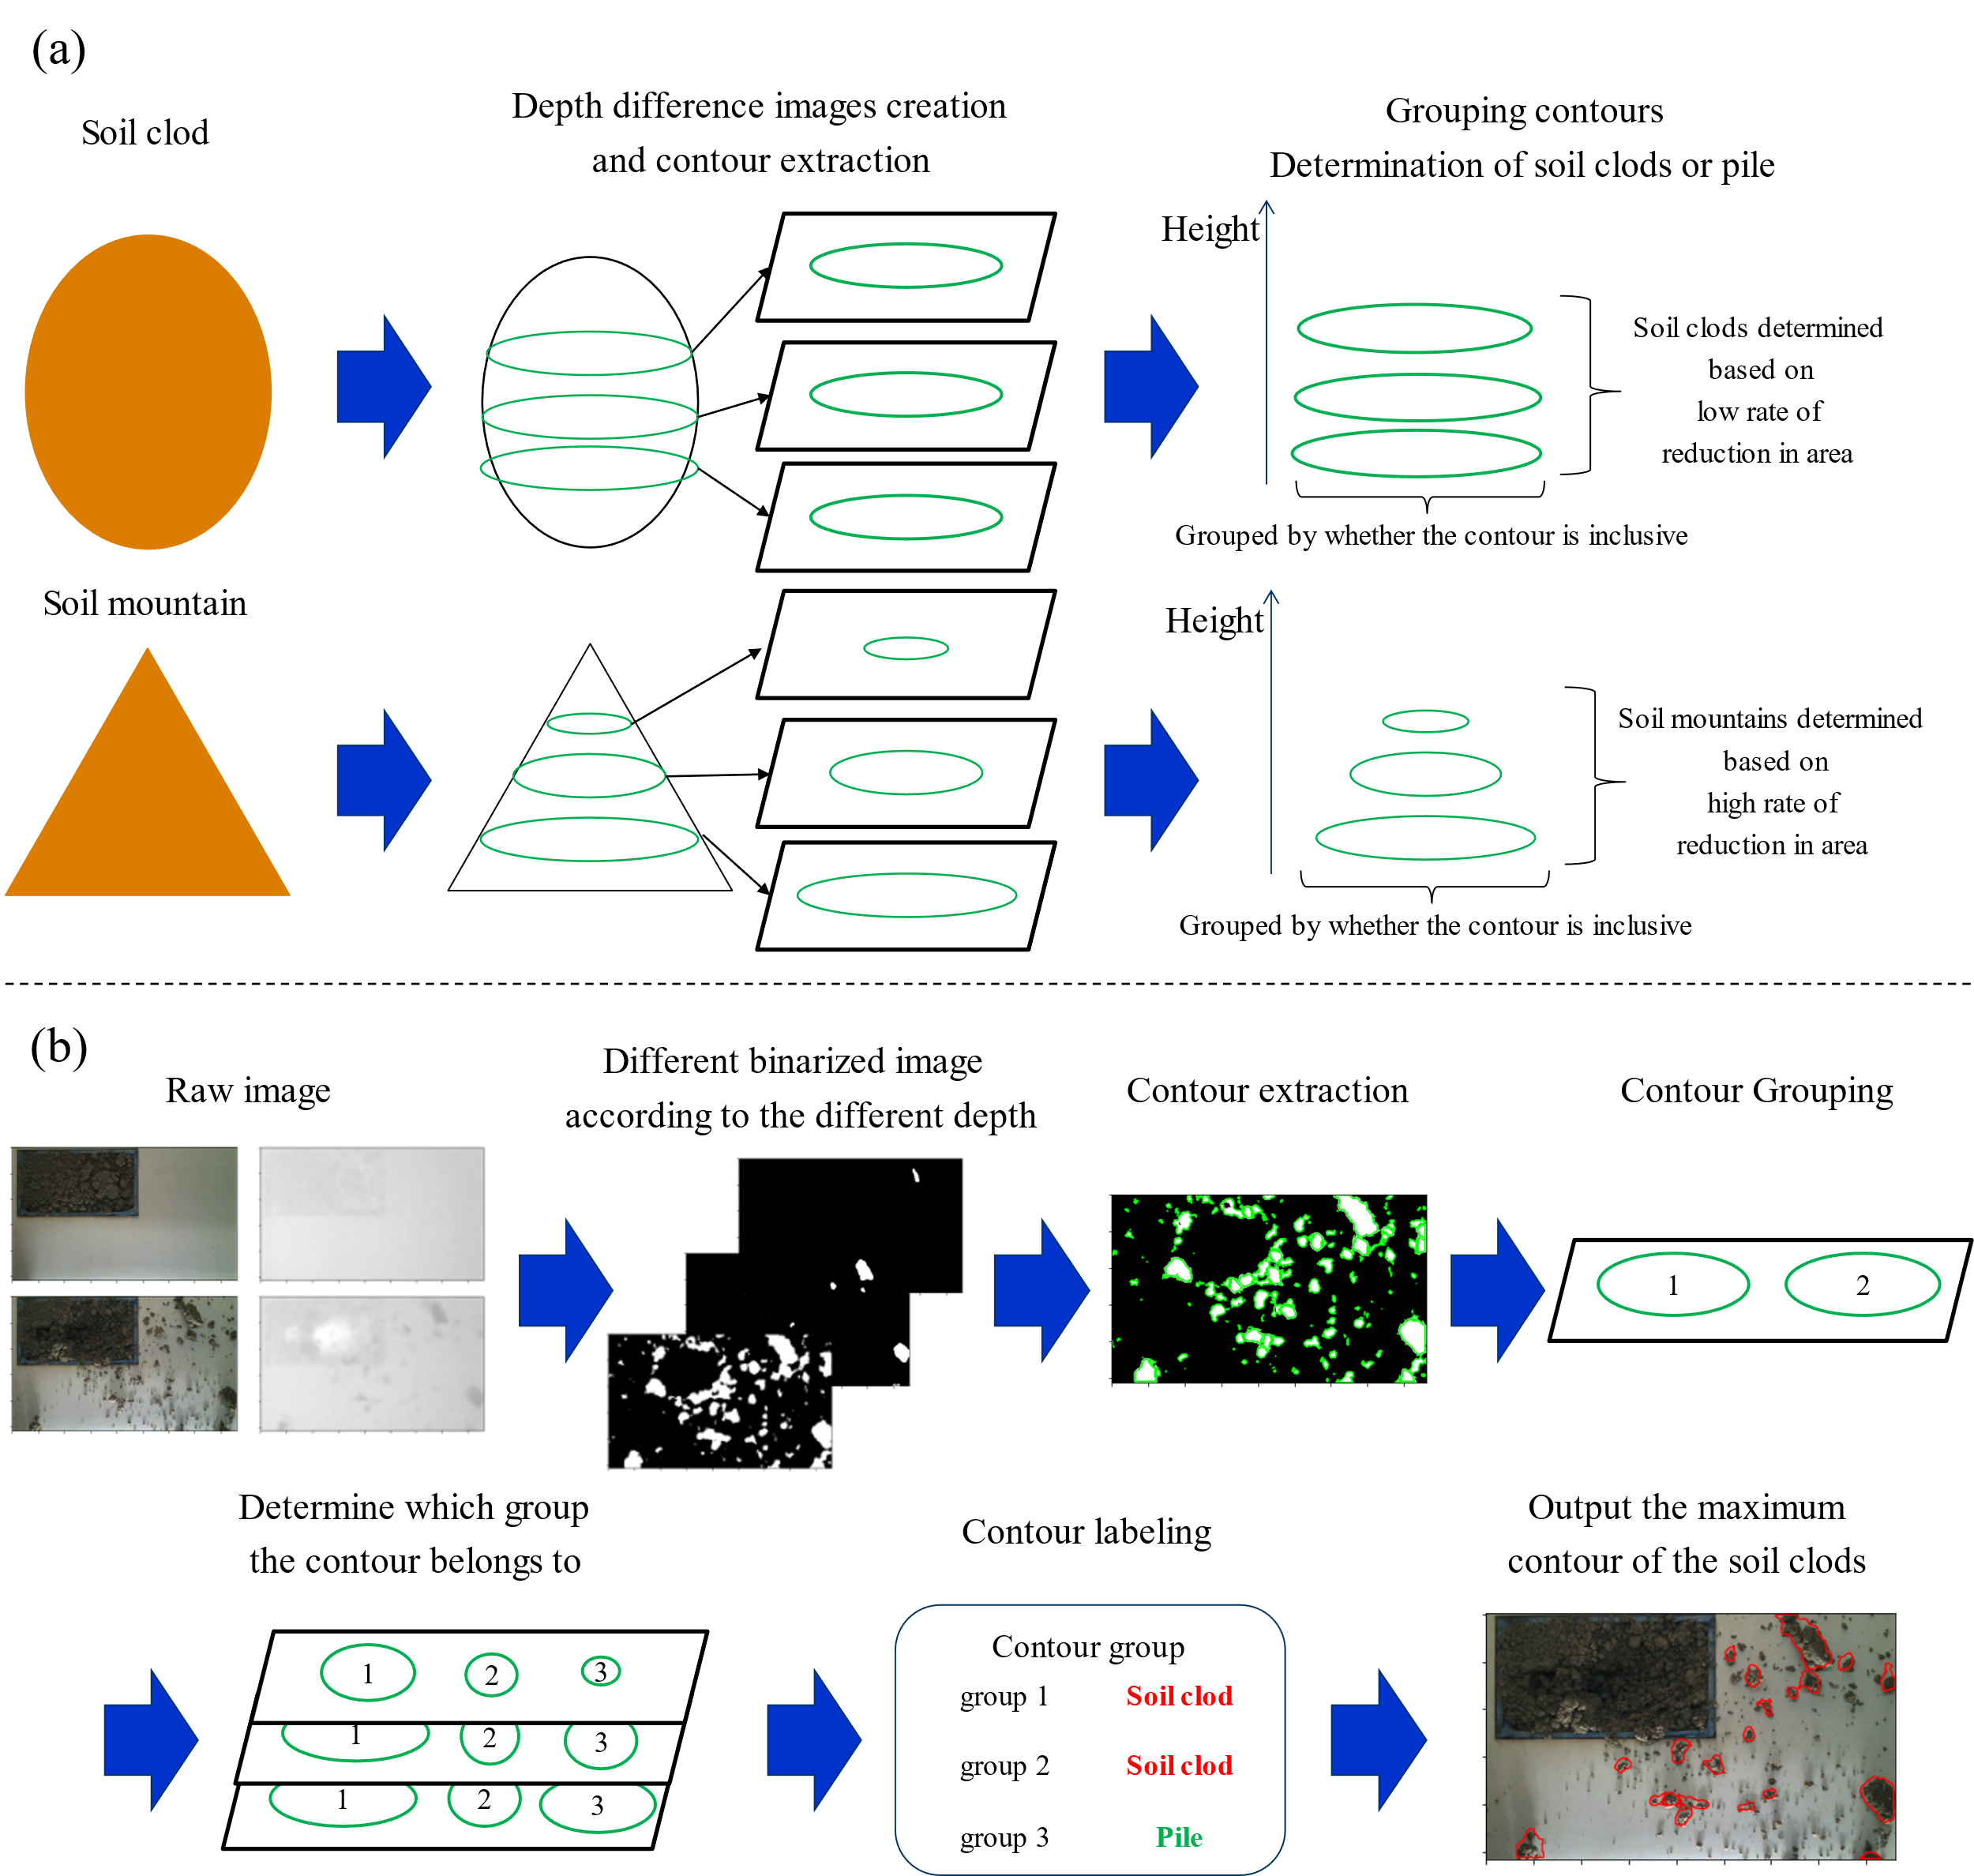

Figure 2. Soil clods recognition: (a) conceptual diagram and (b) flowchart of the algorithm

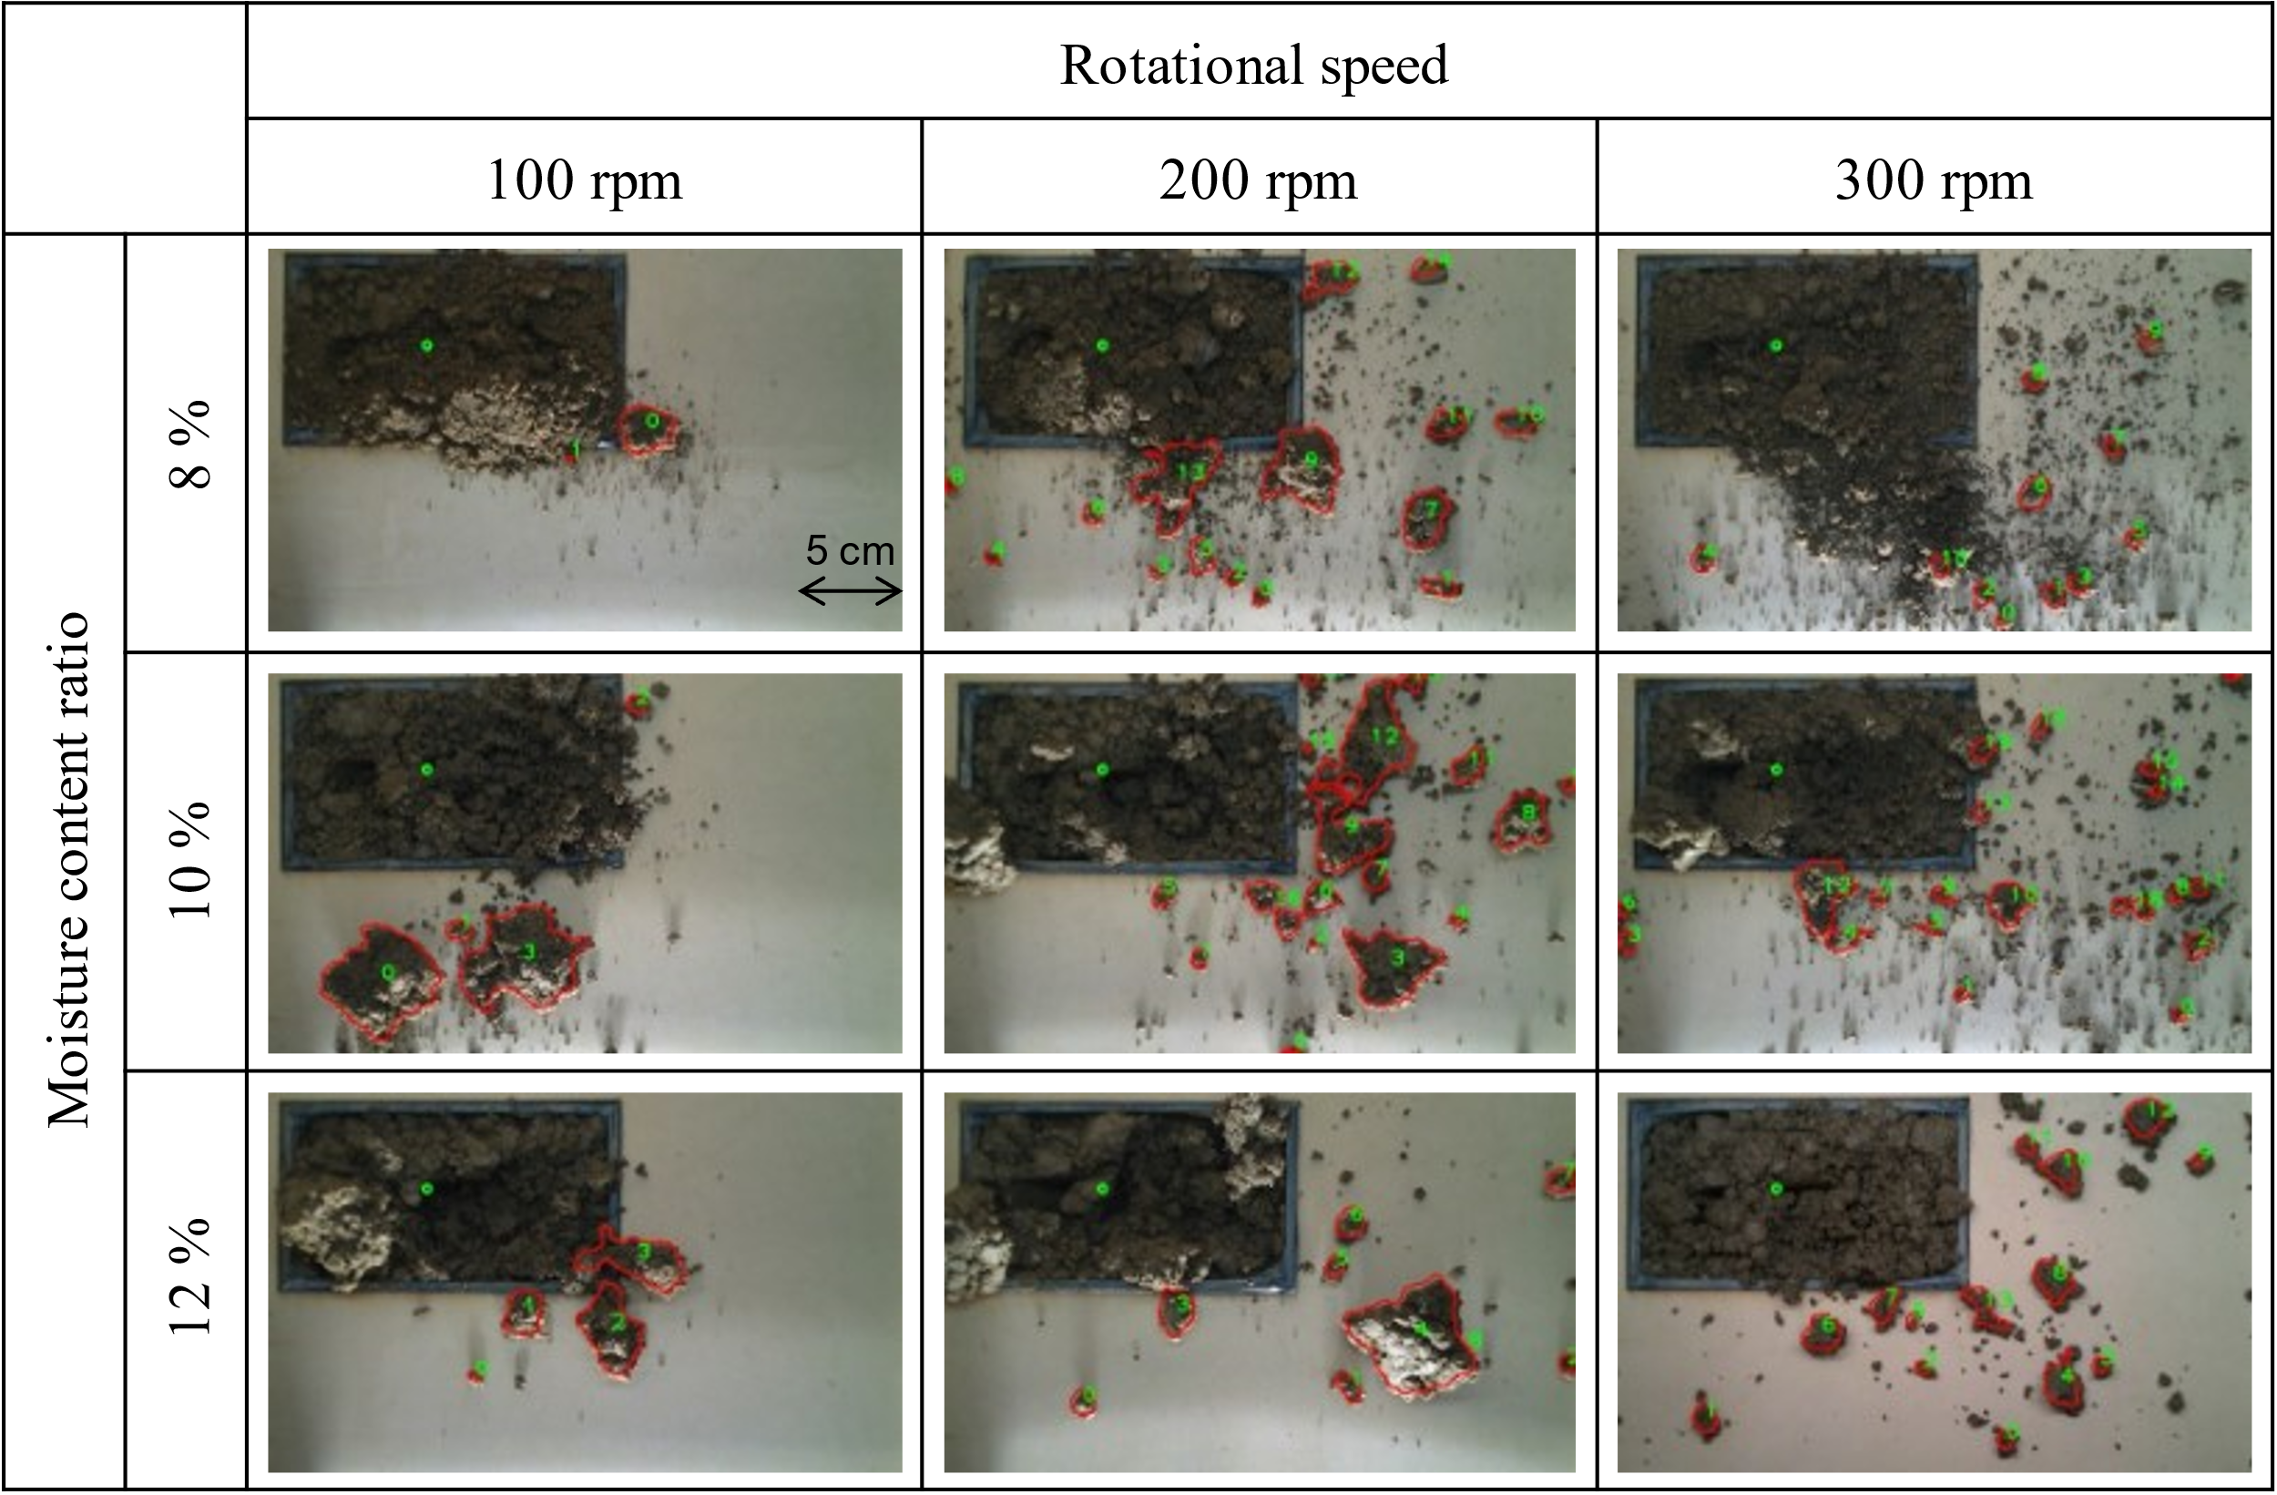

Figure 5. Soil clods recognition results for each condition

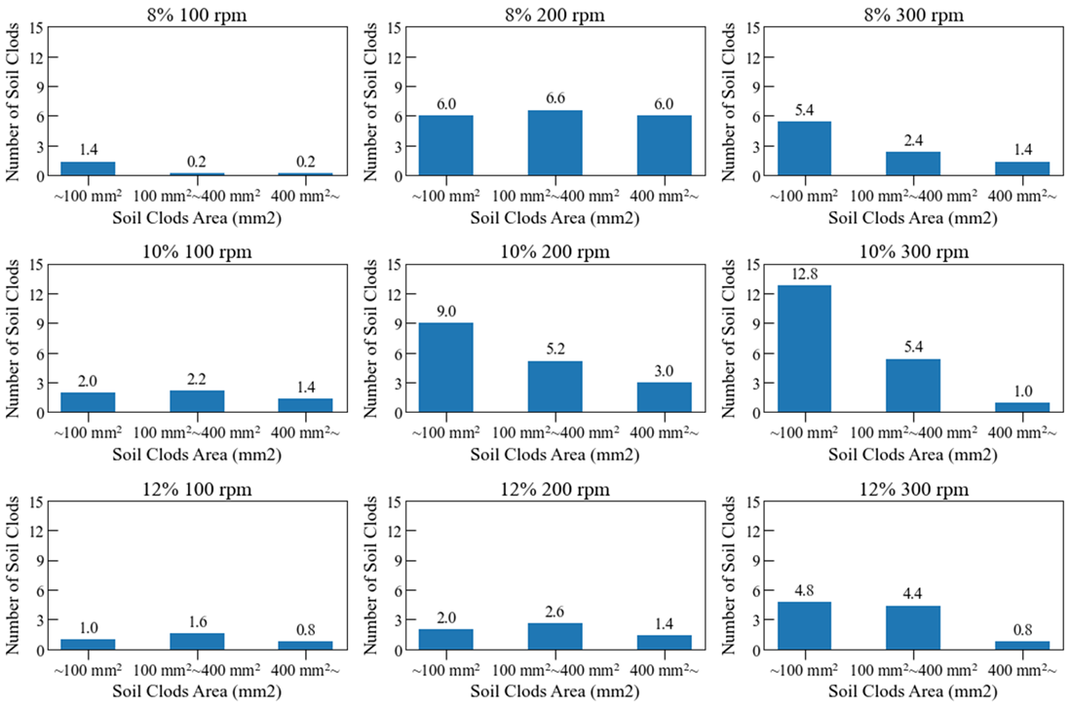

Figure 6. Size distribution of soil clods

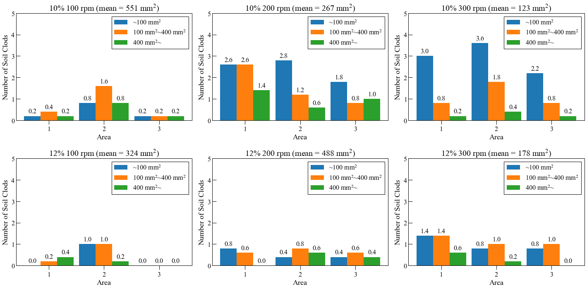

Figure 8. Size distribution of soil clods per area

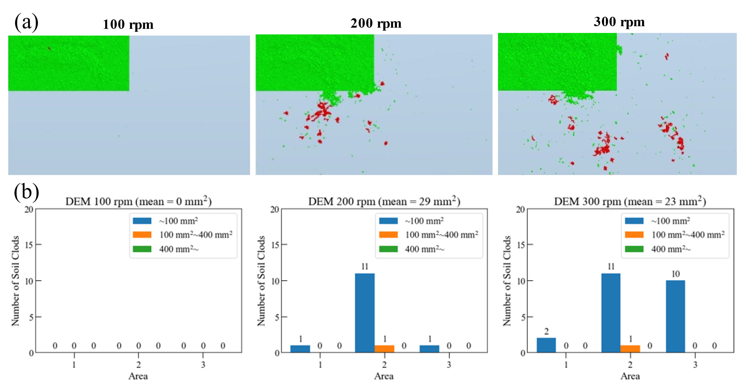

Figure 10. Soil clod dispersal: (a) appearance and (b) size distribution per area

Investigation of the relationship between the cone index and the physical and mechanical parameters of the soil of typical surfaces of the movement of agricultural tractors and machines8658

Sergey Zhukova*

ser-9.02.94@yandex.ru

Alexander Belyaevb

myhome2010@mail.ru

VladimirBelyakovb

belyakov@nntu.ru

VladimirMakarov b

makvl2010@gmail.com

a Nizhny Novgorod State Engineering and Economic University, Knyaginino, Nizhny Novgorod region, Russia

b Nizhny Novgorod State Technical University n.a. R.E.Alekseev, Nizhny Novgorod, Russia

Abstract

The development of high-performance mobile transport complexes for agricultural purposes is largely based on the results of scientific research. The main direction is to study the mobility properties of robotic complexes in specific natural and climatic conditions of the area. The purpose of this work is to determine the cone index CI for typical surfaces of agricultural machinery movement, based on the physical and mechanical characteristics of agricultural soils. In 2020 year, a large-scale experimental and theoretical study of agricultural soils was conducted for 7 months using a soil penetrometer and equipment for measuring soil density and humidity. The peculiarity of this work is that the study has a spatio-temporal character of changes in the mechanical parameters of soils. Thus, the cone index CI is determined during the agricultural season for five typical plots: the first plot is fallow land located on a slope; the second plot is virgin land; the third section is a plowed field; the fourth section is a dirt road and the fifth section is a dirt road covered with broken bricks. Thus, the study showed a change in the cone index for each site during the year: the first site – 4.8-10.93 kPa; the second site – 5.13-5.32 kPa; the third site – 4.14-4.57 kPa; the fourth site - 4.43 – 11.20 kPa; the fifth site – 5.57 – 5.81 kPa. The data were also approximated and a mathematical model for calculating the cone index from the deformation modulus E, (MPa) was obtained. The obtained mathematical dependencies can be used in the future as the basis for mapping the mobility of any region of the world, as well as in the compilation of the algorithm of the mobile robotic complex.

Keywords: Terrain Mobility, Tracked Vehicle, Inverse Approach.

1. Introduction

The effectiveness of the technological agricultural operation largely depends on the conditions of movement of the terrain. The driving conditions of agricultural machines are determined from the following components: 1) weather and climatic characteristics; 2) terrain; 3) physical and mechanical parameters of the soil base. The first and second components directly affect the mechanics of the interaction of the soil and the engine of the machine. Currently, Industry 4.0 is taking place in agricultural production and digital and robotic technologies are being integrated into the production processes. Accordingly, the introduction of autonomous robotic mobile complexes is required, for which it is necessary to develop and implement algorithms that will predict the mechanics of the interaction of the engine of the machine with the roadbed.

The mathematical model should be based on previously obtained data on the physical and mechanical state of soils. In 2020, an experimental and theoretical study was conducted and the following parameters were obtained: deformation modulus, soil specific adhesion, internal friction angle, shear modulus as soil characteristics. But these values represent an extremely large array of data, which is quite difficult to implement into the algorithm. Therefore, it was decided to identify the relationship between the known data and obtain an indicator of the resistance of the soil to the indentation of the conical indenter, which is part of the general "WES-model" and more simply and fully describes the mechanical state of the roadbed. This work is a continuation of the study [1], where the main soil base is loam, and the roadbed is represented by several main routes for moving agricultural machinery.

1. Purpose and objectives of the study

This work is part of a general study aimed at increasing the productivity of the agricultural sector by introducing automatic robotic mobile complexes into the chain of technological processes of production while minimizing the risks of the human factor. Since the role of man in mobile agricultural complexes is quite high, it is necessary to achieve its reduction. By integrating intelligent systems into the movement of transport and technological machines, the role of the human operator is significantly reduced. The high performance of intelligent systems is justified by the perfection of the algorithm, which takes into account all aspects of the TTM operation within the area of operation. The purpose of our work is to determine and study the relationship between physical and mechanical parameters and to supplement the scientific description of connected soils using a cone indenter as the most practically applicable indicator for basic soils and typical routes of agricultural machinery. To achieve the goal, it is necessary to solve the following tasks:

1. Determination of physical and mechanical parameters of agricultural soils and dynamics of their changes during the agricultural season;
2. Identification of the mathematical relationship of physical and mechanical parameters through the modulus of deformation as the main value;
3. Investigation of the relationship between physical and mechanical parameters and a cone indenter for agricultural soils.
4. Experimental research
   1. Materials and methods

As materials for the research, we use data obtained as part of an experimental and theoretical research of the physical and mechanical parameters of the soil of an agricultural area in 2020 year, as well as reference data on the mechanics of the interaction of the propulsion and the roadbed. Experimental data were obtained in an agricultural area (Figure 1).

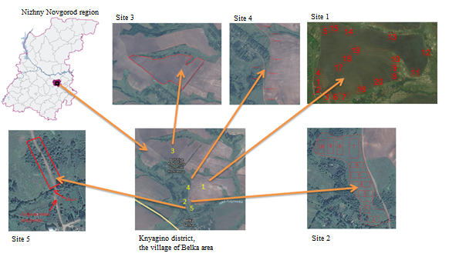

Fig. 1. Map of terrain

The research was conducted during the agricultural season from April to October 2020. For the most complete representation of the specifics of the terrain, photographs of the plots were taken in April (Figure 2).

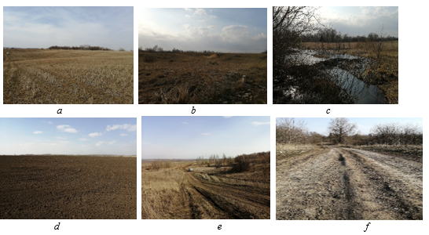

Fig. 2. Photos of the sites where the measurements were conducted.

* 1. Research methodology

In the field conditions were determined: the value of the penetrometer indicator (S, 10-6 m) with a PG-10 ground penetrometer; mass (M, kg) and humidity (%) of the soil by sampling (Figure 3). Further calculation was performed in the MS Excel 2020 environment to determine the following values according to the algorithm (Figure 4).

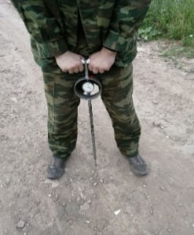 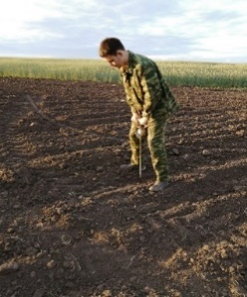 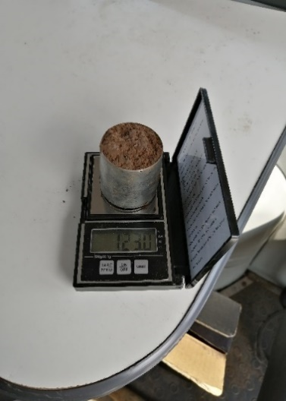

a) b) c)  
Fig. 3. Determination of initial values:   
a) determination of the value of the penetrometer of a dirt road  
b) determination of the value of the penetrometer of arable land   
c) determination of the mass of the soil sample

* 1. Processing of research results

The processing of the research results took place according to the algorithm for calculating the necessary indicators, which is considered in [Belyaev 2018, 2019, 2020, Belyaev and Makarov 2018, Makarov 2017]. The penetration force (P), the modulus of deformation of the soil (E, MPa), the angle of internal friction (φ, rad), the specific adhesion of the soil (C, MPa) are determined by the value of the indicator indicator of the penetrometer (S, microns) (Figure 4).

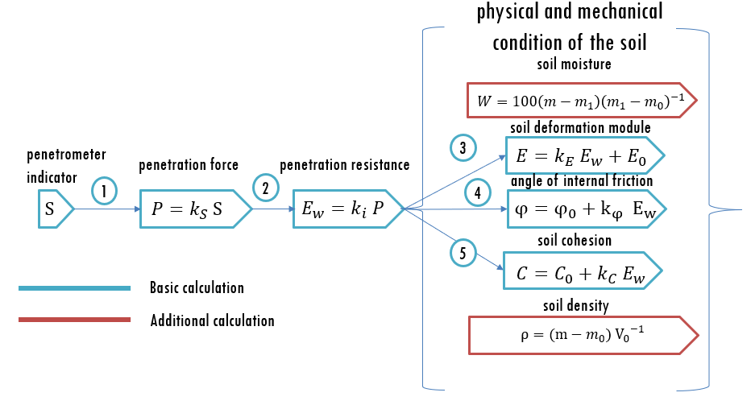

Fig. 4. Algorithm for calculating physical and mechanical characteristics

In the process of data processing, it turned out that some zones of the studied sites are heterogeneous in terms of humidity. Therefore, the data set was divided into ranges of soil moisture, since there was a significant difference between the values. At the end, the following histograms were obtained:

  
  


Fig. 5. Dynamics of changes in physical and mechanical characteristics during the season: a) Soil deformation modulus, E; b) Soil adhesion, C; c) Internal friction angle; d) soil density, r [g/cm3]; e) Mark (LM – low moisture; MM – middle moisture; HM – high moisture)

One of the main tasks of designing transport and technological machines is to predict mobility for any mechanical condition of the movement surface, which means it is necessary to study the dynamics of changes in physical and mechanical characteristics. A number of authors have previously proposed theoretical dependencies that allow determining the traction properties of wheeled vehicles through the use of mathematical dependencies between physical and mechanical parameters of forest soils [2],[3],[4]. Newer researches suggest using the index of the cone indenter *CI* as a more optimal value for predicting mobility [5]. In our research, we use a similar technique for determining the specific adhesion of soil C (MPa) and the angle of internal friction φ (rad) through the main parameter - the deformation modulus E (MPa). The second stage of the study is most relevant for site №1 – field and site № 2 – dirt road, as the most intensive from the point of view of the movement of agricultural machinery. Sites № 3, № 4, № 5 are homogeneous in type of soil, but different in technological condition at this time and with less intensive traffic, the analysis of dependencies has an additional character and will be demonstrated in subsequent works. Thus, we obtain the following mathematical dependencies for site №1 and site №2 (Table 1) and graphs (Figure 2).

Table 1 Mathematical relationship between physical and mechanical parameters

|  |  |
| --- | --- |
| **Month**    **Equation** | 1. **G [kPa] –E [MPa]** 2. **С, [MPa] - E [MPa]** 3. **φ [rad] - E [MPa]** |
| **Site №1** | |
| April | *G = 1838.2E – 10-12 R² = 1*  *C = 4.7458E – 0.0357 R² = 0.8799*  *φ = 0.0085E – 0.0952 R² = 0.8592* |
| May | *G = 1838.2E – 10-12 R² = 1*  *C = 0.2107E + 0.0075 R² = 0.8747*  *φ = 117.86 E +11.216 R² = 1* |
| June | *G = 1838.2E – 7*10-12 R² = 1*  *С = 0.2107E + 0.0075 R² = 0.901*  *φ = 117.86E + 11.216 R² = 0.995* |
| July | *G = 1838.2E – 7*10-13 R² = 1*  *C = 0.2107E + 0.0075 R² = 0.899*  *φ = 117.86E + 11.216 R² = 1* |

|  |  |  |
| --- | --- | --- |
| August | *G=1838.2E R² = 1*  *C = 0.2107E + 0.0075 R² = 0.922*  *φ = 117.86E + 11.216 R² = 0.879* | |
| 1. September | *G = 1838.2E + 5*10-12 R² = 1*  *C = 0.2107E + 0.0075 R² = 0.922*  *φ = 117.86E + 11.216 R² = 1* | |
| October | *G = 1838.2E – 5*10-12 R² = 1*  *C = 0.2107E + 0.0075 R² = 0.871*  *φ = 117.86E + 11.216 R² = 0.9823* | |
| **Site №2** | | |
| April | | *G = 1838.2E R² = 0.989*  *C = 0.2107E + 0.0075 R² = 0.998*  *φ = 117.86E + 11.216 R² = 0.9823* |
| May | | *G = 1838.2E + 1*10-12 R² = 1*  *C = 0.2107E + 0.0075 R² = 0.998*  *φ = 117.86E + 11.216 R² = 0.8891* |
| June | | *G = 1838.2E – 2*10-12 R² = 1*  *C = 0.2107E + 0.0075 R² = 0.998*  *φ = 117.86E + 11.216 R² = 1* |
| July | | *G = 1838.2E R² = 0.988*  *C = 0.2107E + 0.0075 R² = 0.998*  *φ = 117.86E + 11.216 R² = 1* |
| August | | *G = 1838.2E – 4*10-12 R² = 1*  *C = 0.2107E + 0.0075 R² = 0,998*  *φ = 117.86E + 11.216 R² = 0.978* |
| September | | *G = 1838.2E + 2*10-12 R² = 1*  *C = 0.2107E + 0.0075 R² = 0.998*  *φ = 117.86E + 11.216 R² = 1* |
| October | | *G = 1838.2E R² = 0.99*  *C = 0.2107E + 0.0075 R² = 0.998*  *φ = 117.86E + 11.216 R² = 1* |

|  |
| --- |
| a) |
| b) |
| c) |
| Fig. 6. Mathematical relationship between the physical and mechanical parameters of the soil:  a) Dependence of the shear modulus G, [kPa] and the deformation modulus E, [MPa]; b) The dependence of the specific adhesion of the soil C, [MPa] and the modulus of deformation E, [MPa]; c) The dependence of the angle of internal friction φ, [rad] and the modulus of deformation E, [MPa]; |

The key feature of the obtained equations is their reliability and scale: 1) reliability is provided by the empirical method of obtaining and processing physical and mechanical parameters; 2) the scale lies in the fact that each site was surveyed for seven months in the same weather conditions. For each month, graphs of dependencies between parameters were obtained (Figure 6,7) for site №1 and site №2.

For site №2, the physical and mechanical characteristics of the soil are as follows:

|  |
| --- |
| a) |
| b) |
| c) |
| Fig. 7. Mathematical relationship between the physical and mechanical parameters of the soil: a) Dependence of the shear modulus G, [kPa] and the deformation modulus E, [MPa]; b) The dependence of the specific adhesion of the soil C, [MPa] and the modulus of deformation E, [MPa]; c) The dependence of the angle of internal friction φ, [rad] and the modulus of deformation E, [MPa]; |

Graphs of physical and mechanical characteristics are quite informative and give a complete picture of the condition of the site for each month. Figures 6 and 7 show several general patterns: 1) the maximum values are reached in May due to an increase in the intensity of movement of heavy agricultural transport and technological machines; 2) the lowest value is in July, since crops enter the active growing season and the departure of agricultural machines in the field can have negative consequences; 3) on each graph there are similar values in April – the beginning of the departure of agricultural machinery in the field and in August, September and October – this is the period of the harvesting campaign and a further decrease in the activity of agricultural machinery in the field. The result of this research is to obtain a generalized mathematical dependence and the confidence value of the approximation R2 between the parameters (Table 2). The systematization of mathematical dependencies shows that the change in physical and mechanical characteristics occurs according to the same function and obeys a linear law.

Table 2. Equations of dependences of physical and mechanical characteristics

|  |  |
| --- | --- |
| **Month**  **Equation** | **G [kPa] – E [MPa]**  **С, [MPa] - E [MPa]**  **φ, [rad] - E [MPa]** |
| **Site №1** | G = 1838.2E – 5*10-14 R² = 0.9892  C = 0.2107E + 0.0075 R² = 0.9983  φ = 117.86E + 11.216 R² = 0.9823 |
| **Site №2** | G = 1838.2E + 2*10-12 R² = 0.982  C = 0.2107E + 0.0075 R² = 0.993  φ = 117.86E + 11.216 R² = 0.987 |

The third stage of the research is to determine the value of the cone indenter *CI* of the soil for agricultural use. The scientific work [5] describes in detail the essence of «WES-modeling» and the role of the cone indenter *CI*. Also in this research, the author obtained a relationship between the deformation modulus *E* and the value of the cone indenter *CI* for loamy soils [5]:

$E=8.914+5.019\ln{CI}$*(1)*

The data of the deformation modulus *E* is already available in the data array and it is necessary to determine the value *CI* for specific surfaces of motion, for this you need to express the necessary value from the formula:

$CI=e^{\ln{CI}}=e^{\frac{E-8.914}{5.019}}$*(2)*

Using the MS Excel 2020, we determine the values of the cone indenter and plot the dependence graph (Figure 8).

|  |
| --- |
| a) |
| b) |
| Fig. 8. Dependences of the cone indenter on the modulus of loam deformation: a) site № 1; b) site #2 |

The graph provides data on the values of the cone indenter for loamy soil, so the spread of values is indicated in Table 3.

Table 3. Average value and deviation of CI

|  |  |  |  |  |  |
| --- | --- | --- | --- | --- | --- |
| № | ${CI}_{min}$, MPa | ${CI}_{max}$, MPa | $∆CI$,  MPa | $\overline{CI}$,  MPa | σ  % |
| 1. | 0.1717 | 0.1723 | 0.0006 | 0.172 | 0.2 |
| 2. | 0.1717 | 0.17181 | 0.00011 | 0.171755 | 0.1 |

Based on the known dependence (2) and the obtained values of the cone indenter *CI* (Figure 8), it is possible to determine the minimum and maximum values of the indicator, as well as to determine the deviation of the value from the average value. It can be seen from the graphs that the *CI* values for site № 1 and № 2 are quite close. This is due to the fact that the surface of the movement is loam and the mechanics of the soil is homogeneous. Since the dirt road under study leads to the field under study, the intensity of the impact of energy-saturated and heavy machines is approximately the same. Comparing the *CI* values with reference values, it can be seen that the obtained values correspond to loams and clays of low plasticity

1. Results

The relationship between the physical and mechanical parameters and the cone indenter during the agricultural season for loamy soil is investigated. This relationship allows us to evaluate the bearing properties of the movement surface, that is, to select the permissible mass of machinery and predict the mobility of agricultural machinery at any time of the season**.**

1) The physical and mechanical parameters of loam as an agricultural soil and the dynamics of their changes during the agricultural season are determined;

2) A linear distribution law is revealed and a mathematical relationship is determined in the form of equations for each month of the season and a general equation taking into account the space-time factor between:

a) the soil shear modulus G [kPa] and the deformation modulus E [MPa];

b) the specific adhesion of the soil С, [MPa] and the deformation modulus E [MPa];

c) the angle of internal friction, φ [rad] and the modulus of deformation E [MPa]

1. Further research

The developed methodology opens up a wide field of scientific activity in the study of mobility of transport and technological machines for any purpose. The final point of the research is the development and testing of a decision–making algorithm for autonomous robotic agricultural complexes based on artificial intelligence. To reach the final stage, you need to perform the following tasks:

1. To clarify the mathematical relationship between the deformation modulus *E*, [MPa] and the cone indenter *CI* [MPa]. To do this, it is necessary to consider site № 3, №4 and №5 according to the developed methodology, as well as additionally investigate the deformation modulus during a period of large amounts of climatic precipitation.

2. To conduct a "winter" block of researches, according to which it is necessary to develop a physical and mechanical model of snow cover and a statistical model of snow cover changes as a surface of movement of transport and technological machines.

3. On the basis of points 1 and 2, develop a dynamic terrain mobility map to predict the changing conditions of the movement surface on the basis of a mathematical regularity

4. To develop a decision-making algorithm as the basis for the functioning of an adaptive chassis for autonomous robotic agricultural complexes.

1. Acknowledgements

The results of the given study have been obtained with financial support of the grants of the President of the Russian Federation № MK-336.2022.4.

1. References

Zhukov S.S. Study of trafficability conditions of typical agricultural soils in the Nizhny Novgorod region (Russian Federation)/S.S. Zhukov, V.V. Belyakov, V.S. Makarov// Proceedings of the 20th International and 9th Americas Conference of the International Society for Terrain-Vehicle Systems/ - ISTVS 2021, 2021

Investigation of the coefficient of resistance to the movement of wheeled forest vehicles [Studies of rolling resistance coefficient of wheeled forestry machines] / I. V. Grigor'ev [et al.] // Vestnik MGUL – Lesnoj vestnik [Herald MSFU – Forestry Gazette]. – 2014. – No. S2. – P. 36-41.

Posharnikov F. V. Improvement of technical means for forest nurseries [Improvement of technical equipment for forest nurseries] / F. V. Posharnikov, V. S. Popov, V. G. Sviridov // Lesotehnicheskii jurnal [Forestry Journal]. – 2011. – № 4. – P. 110-117.

Calculation of traction mine-technical properties of a wheeled skidding tractor using data from foreign colleagues [Calculation the tractive performance of a wheeled skidder using foreign colleagues data] / S. E. Rudov, E. G. Khitrov, M. E. Rudov, V. V. Ustinov // Aktual'nye napravlenija nauchnyh issledovanij XXI veka: teorija i praktika [Current research trends of the XXI century: Theory and Practice]. – 2015. – T. 3. – No. 1 (12). – P. 223-228.

Khitrov, E. G. Investigation of the connection of the cone index and the modulus of deformation of various types of soils [Text] / E.G. Khitrov, A.M. Khakhina, V.A. Luhminsky,

D. P. Kazakov // Resources and Technologies, volume 14 (2017), number 4, 1 - 16 P.

Ageikin, Ya.S., 1972. All-terrain wheels and dual propellers. Theory and Design. Mashinostroenie. Moscow, 232 p.

Ageikin, Ya.S. and Volskaya, N. S., 2008. Theory of car. Moscow, MGIU, 318 p.

Ageikin, Ya.S., Volskaya, N. S. and Chichekin, I.V., 2010. Trafficability car. Moscow, MGIU, 275 p.

Barakhtanov, L V et al. 1996. Trafficability car. Nizhny Novgorod, NNSTU, 200 p.

Belyaev, A. M. and Makarov, V. S. 2018. Method of assessment of special wheel chassis mobility in cases of sand-gravel bases crossing. Paper presented at the IOP Conference Series: Earth and Environmental Science 194(2) doi:10.1088/1755-1315/194/2/022019

Belyaev, A. M. et al. 2018. Analysis of the main bases of the coastal zone, as a pathway for the movement of special vehicle and monitoring complexes. Paper presented at the IOP Conference Series: Materials Science and Engineering 386(1) doi:10.1088/1757-899X/386/1/012002

Belyaev, A. M. et al. 2019 Field research of drag-and-traction characteristics of mobile robotic system in coastal zone. Paper presented at the Journal of Physics: Conference Series 1177(1) doi:10.1088/1742-6596/1177/1/012050

Belyaev, A. et al. 2020. Experimental Theoretical Study of the Mobile Robotic System Movement with Caterpillar-modular Propulsion on the Beach Line Terrain. In Proceedings of the 6th International Conference on Vehicle Technology and Intelligent Transport Systems (VEHITS 2020), 567-572. DOI:10.5220/0009794705670572

Bekker,M. 1960. Theory of land locomolion. University of Michigan, Press 520 p.

Belyakov, V.V. and Kulyashov, A.P. (Eds.), 2004. All-terrain and technological vehicles. Basics of motion theory. Scientific and technical literature (Monograph). TALAM. N. Novgorod 560 p.

Makarov, V. et al. 2017. Study of trafficability conditions of typical soils of coastal zones of Sakhalin Island (Russian Federation). Paper presented at the 19th International and 14th European-African Regional Conference of the ISTVS

Volskaya, N. S., 2017. Assessment of patency of wheeled vehicles when driving on uneven dirt surface. MGIU, 215 p.

Wong, J. Y. 2010. Terramechanics and Off-Road Vehicle Engineering. Elsevier. 463 p.

3D-DEM Simulation and Post-Process Method of Wheel-Terrain Interaction for Planetary Rovers9352

Qingning Lan

qingninglan_hit@163.com

Zhengyin Wang

wangzhengyin_hit@163.com

Huaiguang Yang*

yanghuaiguang@hit.edu.cn

Liang Ding

liangding@hit.edu.cn

Haibo Gao

gaohaibo@hit.edu.cn

State Key Laboratory of Robotics and System, Harbin Institute of Technology, Harbin 150001, China

*Corresponding author

Abstract

Understanding the physical essence of wheel-terrain interaction is critical to establish the terramechanics model. The discrete element method (DEM) can be used to simulate a series of wheel-terrain interaction quickly and efficiently, which can be convenient to analyze the physical information of the interaction. This paper simulates the interaction of slipping wheel running on soil simulant using 3D-DEM. The information of particles and wheel is obtained from the wheel-terrain interaction. The consequent velocity and stress field of soil simulant is obtained by smoothening the velocity of discrete soil particles and contact interaction force between particles. A method to calculate the fraction field of soil simulant in the particle bed with boundary is proposed to obtain the consequent fraction field distribution. The simulation results are consistent with experimental results. This study can provide instructions for the establishment of physical terramechanics model.

Keywords: terramechanics, DEM simulation, wheel-terrain interaction.

1. Introduction

In recent years, several countries have launched planetary probes, setting off a new trend of space exploration. Planetary rovers are widely used in the exploration of Mars and the Moon, which is efficient and reliable mobile research platforms in complex environments. The terramechanics model for the rover’s wheel is an important part of the planetary rover design and control research, aiming to model the wheel’s stress distribution along the rim during the motion of the wheel on the surface of the extraterrestrial planet. The terramechanics model can be used to optimize the design of the planetary rover’s wheel (Niksirat et al., 2020), improve the movement control effect of the planetary rover (Recuero et al., 2017), and improve the accuracy of the simulation of planetary rover (Zheng et al., 2018).

Most of the current terramechanics models of planetary vehicles are semi-empirical models with less research on the motion of soil particles, which only focus on the motion state of the wheels and the soil’s parameters. Comprehensive analysis of the relationship between velocity, stress and fraction field distribution of the soil during the wheel-terrain interaction can provide new solution ideas for the wheel-terrain interaction and help to improve the accuracy of the terramechanics model.

The most common method to study soil particle flow is the discrete element method (DEM). The planetary soil is simulated as thousands of discrete particles, and the microscopic information of the wheel-terrain interaction can be obtained by recording the motion information of each discrete particle. DEM simulation research is mostly used to predict the sinkage and drawbar pull of a single wheel at different slip ratios, so as to achieve rapid iteration and optimize wheel design (Jiang et al., 2018; Shin et al., 2020). Some studies focus on the flow of planetary soil and the stress distribution of the wheel to study the wheels’ mobility and sinkage. For instance, Pang et al. (2021) simulated the mobility of the bionic wheel in the soil simulant using DEM, observed the velocity of single particles in part of soil simulant, and optimized the design of the bionic lugs. Zhang et al. (2020) conducted a single-wheel test simulation of an irregular legged wheel, compared the force and sinkage of the wheel between the test and the simulation, and optimized the simulation system. Ravula et al. (2021) analyzed the force of the wheel and force chain distribution of soil simulant at different times, which is helpful for the study of the dynamic process of the moving wheel. The current research generally analyzes the motion and force of a large number of discrete particles in the soil. The distribution of microscopic states such as velocity distribution and force chain of particles are relatively chaotic in the local. It is difficult to see the local and integral continuous properties of the particles, which means the analysis of the overall performance of the soil is not intuitive and incomplete. Planetary soil is a kind of granular medium exhibiting the properties of fluid or solid in different motion states. It can be regarded as a continuous medium when it flows under the intrusion of wheels (Li et al., 2013). Regarding granular medium as continuum can facilitate the study of its physical properties. Therefore, it is necessary to analyze the planetary soil in the wheel-terrain interaction as a continuum, which is needed to calculate and analyze the regular and continuous cloud diagrams of the velocity field, stress field and fraction field of the planetary soil.

In this paper, DEM simulation is used to carry out series of single-wheel test simulation with a fixed wheel sinkage, and use a smoothing algorithm to study the continuous physical field of the soil simulant’s velocity field and pressure field in the wheel-terrain interaction. The fraction field of soil simulant with particle object boundary is calculated using a convex hull-based fraction algorithm. It provides an analytical basis for understanding wheel-terrain interaction from the perspective of soil simulant.

1. DEM simulation of wheel-terrain interaction

This section used the DEM simulation to simulate the single-wheel test of the planetary wheel with fixed sinkage. The DEM simulation simulates the overall behavior of the granular medium by simulating the collisions between thousands of tiny particles. In this paper, the discrete element simulation software EDEM is used to conduct 3D-DEM simulation experiments of wheel-terrain interaction.

* 1. Contact model

In the DEM simulation, the soil simulant is composed of many independent tiny particles, and a single particle is a discrete element unit. The simulation calculates the motion and force of all particles in the simulated space, including the position, velocity, contact force and other information of the particles. The forces between different particles include normal force *Fn*, tangential force *Ft* and rolling friction torque ***M***. Normally, both normal and tangential forces are described as a kind of elastic damping spring contact, and there will be a force only when two particles are in contact, as shown in Fig. 1 (Feng et al., 2019). The contact model between particles used in this paper is the standard Hertz-Mindlin model (Tsuji et al., 1993) with the friction coefficient between particles *μ*. The rolling friction between particles is also considered with the rolling friction coefficient *μr* (Sakaguchi et al., 1993). The specific contact force expressions are shown as Eq. (1)~(3).



Fig. 1 Schematic diagram of the force between particles

 (1)

 (2)

 (3)

where *δn* and *δt* are the relative displacements in the normal and tangential directions at the contact point of the two particles, respectively. are  the relative velocities in the normal and tangential directions at the contact point of the two particles, respectively. *d* is the displacement of the particle contact point relative to the particle center of mass, and  is the unit vector in the direction of the angular velocity vector at the point of contact.

Table 1. Parameter expressions of the force model in the simulation

|  |  |  |
| --- | --- | --- |
| **Parameter** | **Particle-particle interaction** | **Particle-object interaction** |
| *kn* |  |  |
| *kt* |  |  |
| *γn* |  |  |
| *γt* |  |  |

*Note:*

where *kn*, *kt*, *γn*, *γt* are functions of particle diameter *d*, Young's modulus *E*, Poisson's ratio *ν* and coefficient of restitution *e*. *G* is the shear modulus of the particle. *m* is the mass of a single particle, i.e., , where *ρg* is the density of particle. The specific function expressions of parameters are shown in Table 1.

The choice of the time step has a great impact on the time consumption and accuracy of simulation. If the time step is too large, the particles may move irregularly, while it may cost more time if the time step is too short. For the DEM simulation of granular medium in quasi-static conditions, the time step can be empirically selected to be 20% of the Rayleigh time step *T*, i.e., the update time of simulation is selected to be about 20% of the period of the elastic wave propagating between particles (Paulick et al., 2015), as shown below:

 (4)

* 1. Establishment of simulation system

Since the research of granular medium physics is generally under the working condition of fixed depth. The wheel-terrain interaction is simulated under the condition of fixed wheel sinkage by EDEM. The motion information of particle and wheel is recorded during the wheel movement, which is beneficial for model analysis and post-process of granular medium.

Slip ratio is an important concept in terramechanics, which is used to describe the degree of wheel slip and skid. In order to facilitate the analysis of the two working conditions, this paper defines the slip ratio as follows (Ding, 2009):

 (5)

where *ω* is the angular velocity of the wheel. *v* is the translational velocity of the wheel, and *r* is the wheel radius. If *s* is less than zero, it is at a status of skid that often occurs in the situation of downhill and break. If *s* is larger than zero, it is at a status of slip that often occurs in the situation of uphill and acceleration.

It can be known from Eq. (5) that when the wheel’s translational velocity is fixed and the slip ratio is small (*s*≤0.2), the wheel’s angular velocity *ω* increases almost linearly with the increase of the slip ratio *s*, and when the slip ratio *s* is large (*s*>0.2), the wheel’s angular velocity *ω* begins to increase rapidly and nonlinearly with the increase of the slip ratio *s.* Because the degree of slip of the wheel is not large when it is working normally, the range of the slip ratio selected in this paper is -1 to 0.6.

The diameter and Young's modulus of the granular medium are the quantities that influence simulation results significantly. The smaller the diameter of the granular medium or the larger the Young's modulus, the closer to the real situation, but the simulation time will be greatly increased. In this paper, DEM simulation parameters were selected to make the response angle of the granular medium as a typical value. The soil simulant is composed with many same single particles to accelerate simulation. This paper chose the shear modulus *G* and Poisson's ratio *ν* commonly used in the literature, whose values are 10MPa and 0.3 respectively (Guillard et al., 2014). The Young's modulus *E* can be determined to be 26MPa. The diameter of the particle *d* was chosen to be smaller than 1/20 of the minimum size of the object. The wheel slip ratio simulated was series typical value selected from -1.0 to 0.6. The wheel’s translational velocity was selected as a typical value of about , and the fixed wheel sinkage was selected so that the wheel entrance angle *θ*1isclose to 30°, which is a typical value of entrance angle. The friction coefficient between particles was selected that the test result of the response angle is about 38°, which is a typical value for simulating the Martian soil. The specific parameter configuration used in the DEM simulation is shown in Table 2.

Table 2 DEM simulation parameter configuration

|  |  |
| --- | --- |
| Parameters | Values |
| Wheel slip ratio *s* | -1.0, -0.6, -0.3, 0.0, 0.3, 0.6 |
| Wheel radius *r* (mm) | 135 |
| Wheel width *b* (mm) | 150 |
| Wheel translational velocity *v* (mm/s) | 70 |
| Wheel sinkage *z* (mm) | 18 |
| Particle diameter *d* (mm) | 6 |
| Particle density *ρ* (kg/m3) | 2660 |
| Particle Poisson's ratio *ν* | 0.3 |
| Particle shear modulus *G* (MPa) | 10 |
| Coefficient of restitution *e* | 0.3 |
| Friction coefficient between particles *μgg* | 0.7 |
| Friction coefficient between particles and objects *μgi* | 0.9 |
| Rolling friction coefficient *μr* | 0.15 |
| Size of particle bed (mm) | 1600×250×300 |

The specific steps of the simulation are as follows:

1. DEM simulation parameters are determined and defined. The parameter calibration program provided by the EDEM software was used for parameter calibration.
2. Particle samples are generated, and the granular medium adopts a single sphere model. This single sphere model can reduce the simulation time and obtain good results.
3. The container for the particle bed is created, and the width direction of the container is set as the periodic boundary, so that the influence of the lateral boundary of the container is as small as possible.
4. The particles bed is piled up by dropping particles under gravity and then resting.
5. The wheel is set to initial position. The simulation wheel adopts a wheel without lugs to explore the essential characteristics of the wheel-terrain interaction. The wheel’s size is very close to that of China's Lunar rover "Yutu-2" (Ding et al., 2022). Create and move the wheel above the initial target position of the wheel and slowly drop it into the target sinkage of granular medium.
6. The sinkage of wheel in the vertical direction is fixed, and the translational and rotational motion of the wheel are defined to fix the slip ratio of the wheel.
7. The appropriate simulation step is set to simulate.

In the simulation, the wheel ran for a total of 15s, and the translational displacement was 1050 mm. The initial and final states of the system in the simulation are shown in   
Fig. 2.

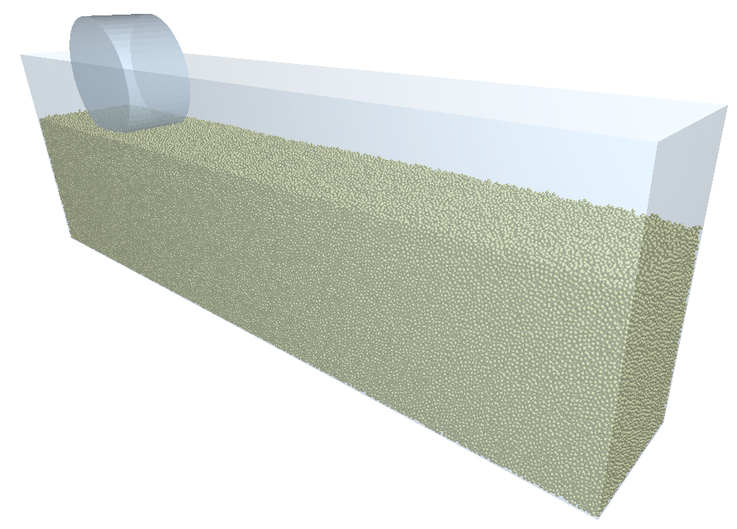 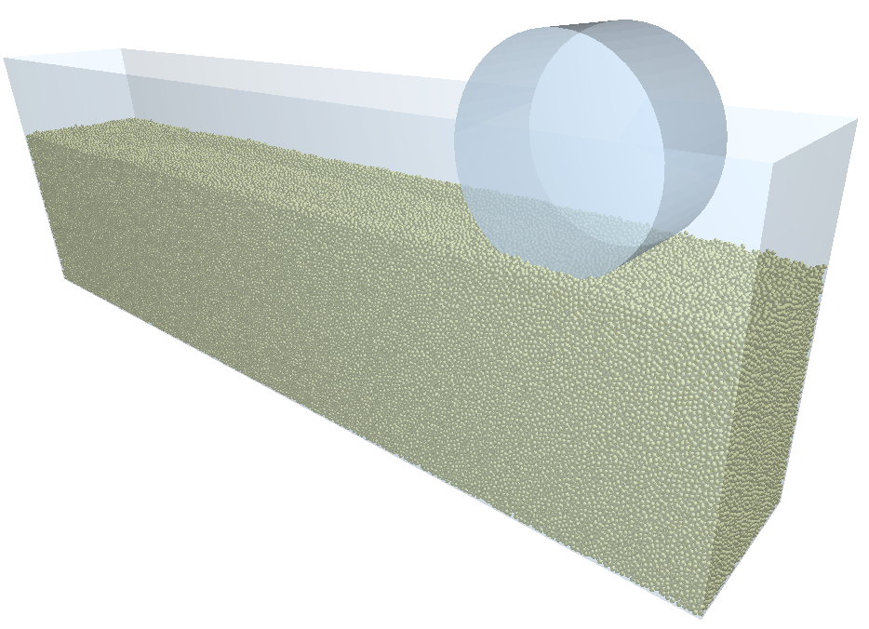

(a) initial state (b) end state  
Fig. 2 Simulation initial and end state

1. Calculation method of smoothed physical field

The position, velocity of particles and force between particles in DEM simulation are often distributed chaotically and irregularly in the local, which only exists a certain continuity in a large spatial range. Since the granular medium can be regarded as a continuum similar to solid and liquid in the wheel-terrain interaction, it is necessary to regard the planetary soil in the wheel-terrain interaction as a continuum for physical field analysis. It can provide new ideas to model the wheel-terrain interaction.

The wheel is symmetrical in the direction of width in the wheel-terrain interaction. This paper mainly focuses on the physical field distribution of the granular medium at the center section of the wheel for post-process, including the velocity, stress and fraction field distribution of granular medium.

In this paper, the velocity and stress field distributions of the soil simulant are calculated based on the physical field smoothing algorithm of DEM proposed by Goldhirsch and Andreotti et al. (Glasser and Goldhirsch, 2001; Goldhirsch, 2010). The algorithm is used to convert the physical quantities of discrete particles into a uniformly distributed physical field by averaging the velocity, stress and density over a spherical region around the target point of the computation. In order to obtain continuous and smoothed physical field distribution, a regular grid is divided for the calculated area and the physical field on each grid point is calculated separately.

Fig. 3 is the schematic diagram of the smoothing algorithm. For each point to be calculated, a spherical area with radius *R* is chosen to average physical quantities. The velocity and stress of continuous medium at this point are averaged weightily by all the particles in this spherical area. The radius *R* ofthe spherical area is equivalent to the threshold value of the particles to be averaged. Only the particles within the area will be averaged, so the size of the spherical area has little effect on the results. *R* is chosen to be 3/2 the diameter of the particle *d* from reference (Guillard et al., 2014)*.*



Fig. 3 Schematic diagram of smoothing algorithm

** (6)

** (7)

where **r** is the displacement vector of the target point. **r*i*** is the displacement vector of the *i*th particle. **v***i*is the velocity vector of the *i*th particle. **f***ij* and **r***ij* are the force and displacement between the *i*th particle and the *j*th particle, respectively, i.e., . is the contribution weight of a single particle to the target point. Since the working condition studied in this paper has a boundary and the diameter of the granular medium is not much smaller than the interval of the requested grid point, the segmented linear function in Eq. (7) is used to weight each particle by the distance from the particle to target point, and the particle completely within the spherical region is regarded as a complete contribution to the target point. *V*smooth is the volume of the spherical smooth region. It can be found that the closer to the target point, the greater the contribution of that particle to the velocity and stress at the target point.

It is worth noting that when the scale of the granular medium particle is not negligibly small relative to the calculational region, the fraction on the boundary of the granular medium calculated by the smoothing algorithm is smaller than the real value. The reason is that the algorithm calculates the fraction based on particles in a given spherical region and the region is larger than real situation near the boundary significantly. The selected spherical region will exceed the boundary of the granular medium. It expands the boundary of the granular medium outward, making the spherical region larger relative to the actual area occupied by the particles, which causes the calculated fraction of the granular medium smaller than real.



Fig. 4 Schematic diagram of fraction algorithm based on convex hull

In order to solve the problems mentioned above, this paper proposed an algorithm to calculate the fraction field of granular medium based on the convex hull of 3D point cloud. This method calculates the fraction of granular medium under the condition of fixed space. As shown in Fig. 4, in order to calculate the fraction of the granular medium at the target point, the *N* particles closest to the requested grid point are identified first, and then a number of points are added uniformly on the surface of these particles. The convex hull of these points on the surface of all particles is used to approximate the smallest polyhedron that can contain these *N* particles. Thus, the volume of the convex hull can be used to approximate the entire space that can contain these *N* particles. The fraction of this target point is the ratio of the volume of these particles to the volume of the convex hull. Therefore, the fraction of target point can be calculated by the following equation.

 (8)

where *Vg* is the volume of a single particle, i.e., . *V*Convex (**r**) is the volume of the convex hull containing the nearest *N* particles at that point. Usually, the spherical region with a radius of 3/2*d* can completely include 13 particles with diameter of *d* at most. So *N* is selected as 13 in this paper.

1. Simulation Result

The diagram of the normal force and drawbar pull of the wheel versus the displacement in the simulation of the fixed sinkage condition is shown in   
Fig. 5. After the wheel’s displacement is greater than 400 mm, the wheel enters the steady state at most slip ratios, and this paper focuses on the steady state. When the wheel slips, the wheel generates a positive drawbar pull, which is consistent with terramechanics theory. In this paper, the period after the wheel’s force curve enters the steady state is selected for post-process.

 

(a) Normal force (b) Drawbar pull  
Fig. 5 The force of wheel versus displacement

As shown in Fig. 6, the velocity field distribution of the soil simulant at different slip ratios is shown. When the wheel slip ratio is -1, the wheel’s angular velocity is zero, and there is only translational motion. The soil simulant piled up in front of the wheel, and the dividing line between the moving and non-moving parts of the soil simulant is almost horizontal, because the soil simulant is pushed by wheel to move forward horizontally. When the wheel starts to rotate, the accumulation of soil simulant in front of the wheel decreases with the increase of the slip ratio. When the wheel slip ratio is -0.3, the dividing line between the moving and non-moving parts of the soil simulant gradually shifts downward for the soil simulant rotating driven by the wheel. The direction of particle flow changes from horizontal to diagonal downward. The characteristics of the particle flow are consistent with the results obtained using PIV measurements in the literature, as shown in Fig. 7(a) (Senatore and Iagnemma, 2014). When the wheel shifts to a slip state, the accumulation of soil simulant in front of the wheel became almost negligible. The flow region of soil simulant under the wheel changes to two sectors, forward and backward respectively. However, the velocity of the particles is significantly smaller than in the skid state. When the wheel slip ratio is larger, as shown in Fig. 6(d), the soil simulant under the wheel moves almost only backward. The overall performance of soil simulant shows a tendency to move backward, while the sector area where the particles move forward almost disappears since the transportation effect of the wheel on the soil simulant gradually becomes significant. The experimental test of the slip condition shown in Fig. 7(b) also shows that the velocity field of the granular medium under the wheel moving forward is very small. The particles almost only transport backward. Comparing the velocity field diagrams of the skid and slip conditions in Fig. 6 and Fig. 7, the particles move forward in the skid and backward in the slip on the whole. The diagrams have the same characteristics, indicating the reliability of the simulation.



Fig. 6 The velocity field of the soil simulant at different slip ratios obtained by simulation

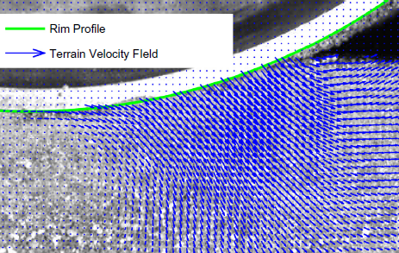 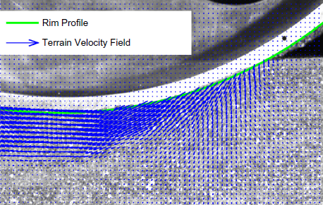

(a) s =-0.3 (b) s = 0.3  
Fig. 7 The velocity field of the soil at different slip ratios measured by PIV (Senatore and Iagnemma, 2014)

Fig. 8 shows the fraction field distribution of soil simulant at different slip ratios based on the convex hull algorithm. The wheel pushes the soil simulant in front and disturbs it when slipping, causing the fraction of the soil simulant in front of the wheel getting smaller than the initial fraction. With the increase of wheel rotation, the area with smaller fraction gradually expands downward, as shown in Fig. 8(b), which is almost the same as the area with larger velocity in the slip state in Fig. 6. It is due to the fact that only the particles disturbed can change their fraction. When the wheel enters the slip state, as shown in Fig. 8(d), the particles transfer from the front of the wheel to the rear of the wheel due to the transportation effect of the wheel on the soil simulant, the wheel squeezes the soil simulant in front and makes the fraction of the soil simulant in front of the wheel increases compared with the skid state. The soil simulant behind the wheel comes from the front of the wheel through the transportation effect, and the fraction of the soil simulant behind the wheel reduces due to the disturbance of the movement.



Fig. 8 The fraction field of soil simulant at different slip ratios

Fig. 9 is the pressure field distribution of the soil simulant under different slip ratio of the wheel. The definition of pressure is the same as that in the fluid, which is the average value of normal stress in three directions, as shown in the following:

 (9)

where *σii* is the diagonal terms of stress tensor of the particle continuum after the being smoothed by algorithm at that point, i.e., the normal stress in the three directions. The pressure can reflect the stress distribution and force chain distribution inside soil simulant to a certain extent. It can be seen that no matter what the wheel slip ratio is, the pressure of the soil simulant is concentrated in the middle part of the contact area between the wheel and the soil simulant, while the pressure of the particles close to the surface of the particle bed accounts for a small proportion. Due to the accumulation of soil simulant in front of the wheel in the skid, the contact area between the wheel and the soil simulant is larger, but the stress inside the soil simulant is small. The force chain of the soil simulant under the wheel extends from the bottom of the wheel to the front of the wheel. The distribution area of the force chain is concentrated in the oblique front of the wheel. When the wheel is in slip state, the direction of transportation of the particles also changes from forward to backward. The force chain of the soil simulant under the wheel also starts to extend to the rear of the wheel, and it will extend both forward and backward at this time.



Fig. 9 The pressure field of soil simulant at different slip ratios

1. Conclusions

In this paper, the 3D-DEM simulation is used to simulate the wheel-terrain interaction with fixed wheel sinkage. The physical field smoothing algorithm is used to obtain the regular and continuous velocity and stress field distribution of the granular medium regarding as continuum. A new method to calculate fraction field of the granular medium with boundary is proposed. The simulation obtained the wheel force-displacement relation, the fraction, velocity and pressure field distribution of the soil simulant. As the slip ratio of the wheel increases, less soil simulant accumulates in front of the wheel. The transportation velocity of the soil simulant shifts from oblique front to rear. The force chain extends from forward to behind the wheel, and the fraction of the soil simulant gradually increases. The smoothed and continuous physical field distribution of soil will help to visualize the process of wheel-terrain interaction, analyze the motion of soil, understand the essence of wheel-terrain interaction, and help to establish a physical model of terramechanics from the perspective of soil physical properties.

1. References

Zheng, J., Gao, H., Yuan, B., Liu, Z., Yu, H., Ding, L., Deng, Z., 2018. Design and terramechanics analysis of a Mars rover utilising active suspension. Mech Mach Theory 128, 125-149.

Niksirat, P., Daca, A., Skonieczny, K., 2020. The effects of reduced-gravity on planetary rover mobility. Int J Robot Res 39, 797-811.

Recuero, A., Serban, R., Peterson, B., Sugiyama, H., Jayakumar, P., Negrut, D., 2017. A high-fidelity approach for vehicle mobility simulation: Nonlinear finite element tires operating on granular material. J Terramechanics 72, 39-54.

Jiang, M., Dai, Y., Cui, L., Xi, B., 2018. Experimental and DEM analyses on wheel-soil interaction. J Terramechanics 76, 15-28.

Shin, Y.-J., Jeong, J.-S., Jun, C.-W., Sohn, J.-H., 2020. Interacting analysis between wheel and sand particles based on DEM and its validation with experiments. J Mech Sci Technol 34, 4537-4544.

Pang, H., Zhang, R., Ge, P., Liu, F., Wang, C., Dong, W., Li, T., Li, J., 2021. 3D DEM analysis on tractive trafficability of a lunar rover wheel with bionic wheel lugs. Rendiconti Lincei. Scienze Fisiche e Naturali 32, 377-387.

Zhang, R., Pang, H., Dong, W., Li, T., Liu, F., Zhang, H., Hu, Z., Li, J., 2020. Three-dimensional discrete element method simulation system of the interaction between irregular structure wheel and lunar soil simulant. Adv Eng Softw 148, 102873.

Ravula, P., Acar, G., Balachandran, B., 2021. Discrete element method-based studies on dynamic interactions of a lugged wheel with granular media. J Terramechanics 94, 49-62.

Li, C., Zhang, T., Goldman, D.I., 2013. A terradynamics of legged locomotion on granular media. Science 339, 1408-1412.

Feng, Y., Blumenfeld, R., Liu, C., 2019. Support of modified Archimedes' law theory in granular media. Soft matter 15, 3008-3017.

Tsuji, Y., Kawaguchi, T., Tanaka, T., 1993. Discrete particle simulation of two-dimensional fluidized bed. Powder Technol 77, 79-87.

Sakaguchi, H., Ozaki, E., Igarashi, T., 1993. Plugging of the flow of granular materials during the discharge from a silo. Int J Mod Phys B 7, 1949-1963.

Paulick, M., Morgeneyer, M., Kwade, A., 2015. Review on the influence of elastic particle properties on DEM simulation results. Powder Technol 283, 66-76.

Ding, L., 2009. Wheel-soil interaction terramechanics for lunar/planetary exploration rovers: modeling and application, Harbin Institute of technology.

Guillard, F., Forterre, Y., Pouliquen, O., 2014. Lift forces in granular media. Phys Fluids 26, 043301

Ding, L., Zhou, R., Yuan, Y., Yang, H., Li, J., Yu, T., Liu, C., Wang, J., Li, S., Gao, H., 2022. A 2-year locomotive exploration and scientific investigation of the lunar farside by the Yutu-2 rover. Sci Robot 7, eabj6660.

Goldhirsch, I., 2010. Stress, stress asymmetry and couple stress: from discrete particles to continuous fields. Granul Matter 12, 239-252.

Glasser, B., Goldhirsch, I., 2001. Scale dependence, correlations, and fluctuations of stresses in rapid granular flows. Phys Fluids 13, 407-420.

Senatore, C., Iagnemma, K., 2014. Analysis of stress distributions under lightweight wheeled vehicles. J Terramechanics 51, 1-17.

Design and Traction Performance Test of Bionic Paddy Wheel Based on Cattle Hoof9768

Lan Lia

lloct20@163.com

Jing lia,b

lijing3815@163.com

Baofeng Xiea

2284098060@qq.com

Fei Lina

2602864402@qq.com

Long Xuea,b*

[ultimata@163.com](mailto:ultimata@163.com)

aJiangxi Agricultural University, Nanchang, Jiangxi, China

bKey Lab of Modern Agricultural Equipment, Nanchang, Jiangxi, China

*Corresponding author

Abstract

In order to improve the traction performance of the micro-tiller wheel on the paddy soil surface, a bionic paddy wheel was designed with a cattle hoof as the bionic prototype, and its diameter and wheel width were 0.46 m and 0.08 m, respectively. The traction performance test was carried out in a soil bin test-bed with a moisture content of 36 %. The vertical loads were 82.57 N, 131.40 N and 179.42 N, respectively. The driving speeds were 0.3 m/s, 0.5 m/s and 0.7 m/s, respectively. The drawbar pull was in the range of 10 – 120 N. The results showed that at the driving speed of 0.7 m/s, with the increase of the vertical load, the driving torque and the drawbar pull are increasing. The vertical load has a significant effect on the change of driving torque and maximum drawbar pull. Under the vertical load of 179.42 N and different driving speeds, when the slip ratio is less than 0.37, the efficiency coefficient begins to grow rapidly, and the greater the driving speed is, the greater the growth rate is. When the slip ratio is about 0.37, the efficiency coefficient reaches the maximum and then begins to decrease. Driving speed has a significant effect on the maximum efficiency coefficient of wheels. This paper can provide a reference for the traction performance of the micro-tiller wheel on the paddy soil surface and the design of the new bionic paddy wheel.

Keywords: Paddy Soil, Traction Performance, Structure Design, Micro-Tiller Wheel, Slip Ratio.

1. Introduction

Rice is one of the world’s major food crops because its growth characteristics must be planted in paddy soils. Paddy soil is a typical soft ground type with obvious stratification, which is composed of a plough layer and plow layer. The main power source of paddy tillage machinery in hilly areas of southern China is micro-tillers. When the wheels of conventional micro-tillers travel on the surface of paddy soil and operate normally, serious vehicle subsidence and slippage often occur, and there are problems such as poor traction performance, large energy consumption, and even unable to travel, which seriously restrict the development of rice planting in hilly areas of southern China. Thus, it is of great significance to carry out the design and traction performance research of the paddy soil micro-tiller wheel to improve its passing ability on the paddy soil surface.

In order to improve the passing ability of vehicles on soft ground, many scholars have conducted a large number of traction performance tests on soft ground and explored the wheels by using bionic engineering technology. Tested the wheel with grousers, studied the influence of wheel radius and grousers height on wheel performance(Iizuka et al., 2011). Used single-wheel testbed to test the wheel of planetary exploration vehicle with different radius, width, lug height, lug number, and lug inclination under different slip rates to evaluate the traction performance of the wheel in deformed soil(Ding et al., 2011). Conducted Traction performance tests by controlling tire and soil parameters to understand tire-soft soil interaction(Naranjo et al., 2014). Obtained the stress distribution under the wheel with grooves at each angle during wheel rotation by measuring the three-dimensional force acting on the three positions of the grousers and the wheel surface, respectively. The test showed that the shear stress almost did not affect the wheel surface between each grouser (Higa et al., 2016). Studied the effects of four types of grouser (parallel, inclined, V-shaped, and offset V-shaped) on the traction performance of wheels in the sand. The results show that the inclined shape is the optimal design of the grouser for wheeled roamers on lunar and planetary soils(Nagaoka et al., 2019). Simulated the interaction between camel hoof and sand, and developed a kind of bionic tire for desert. The test results showed that the bionic camel hoof tire had a high sand passing ability(Li et al., 1999). Proposed a deployable wheel structure to realize the change of 1 – 2.1 times wheel diameter. Based on the wheel-soil interaction mechanical model of stress distribution, the obstacle-crossing performance of the wheel was analyzed. It was concluded that using a large diameter relative to a small diameter can reduce resistance and increase the drawbar pull and driving torque(Wei and Cheng, 2013). Studied the traction performance of wheeled tractors in rice production, discussed soil utilization, environmental impact, and planting methods, and linked them to tractor operations(Keen et al., 2013). Proposed a new type of wheel mechanism with an active driving lug, which can generate stable traction by actively adjusting the subsidence length of the lug(Yang et al., 2014). Proposed a new type of agricultural machinery rigid wheel suitable for mud paddy soil. The test results show the arc wheel has good driving performance in wheel sinking and soil reaction force(Chen et al., 2020). Developed a new type of grousers wheel, so that the grousers can be telescopic in various regions around the wheel. Especially when the wheel rotates, the grousers can always be extended in front of the wheel and retracted under the wheel, explaining how the thrust is mainly generated by the front grousers(Nassiraei and Skonieczny, 2020). Designed and tested four bionic walking wheels by imitating the structure and posture of ostrich foot walking on the sand. The experimental results show that the bionic walking wheel designed by multi-pose wheel lugs can reduce soil resistance and sand disturbance, and obtain superior sand walking performance(Zhang et al., 2020). Designed a bionic wheel surface monomer according to the structural characteristics and plantar geometry of the ostrich plantar convex ball. The experimental results show that the bionic convex ball structure greatly improves the friction performance of the wheel surface(Pang et al., 2021).

The above research mainly focuses on wheel traction performance and bionic wheel design in sand or simulated lunar soil. However, there are few studies on the traction performance of the wheel in paddy soil and the bionic wheel in paddy soil. In addition, in order to solve the problem of restricting the development of the rice industry in southern hilly areas due to the passing of tillage machinery. Thus, in this paper, a bionic paddy wheel is designed based on the surface morphology of cattle hoof. In the single wheel soil bin test-bed, the traction performance test is carried out by controlling the vertical load, driving speed and drawbar pull on the wheel to evaluate its traction performance in paddy soil. At the same time, it can provide a reference for the design of a new bionic paddy wheel.

1. Methods
   1. Design of bionic paddy wheel

Buffalo often walks in paddy soil. In the long-term interaction with the soil, the cattle hoof has gradually formed an excellent geometric shape through continuous evolution, which has the characteristics of strong passing ability, small movement resistance and high action efficiency in paddy soil. In this paper, a bionic paddy wheel was designed based on the excellent geometric shape of the cattle hoof and the previous research and design experience of the paddy wheel of micro-tiller, according to the conventional paddy wheel size, wheel width and blade number. Its diameter and wheel widths were 0.46 m and 0.08 m, respectively. The number of bionic wheel lugs was 10, as shown in *Fig. 10*.

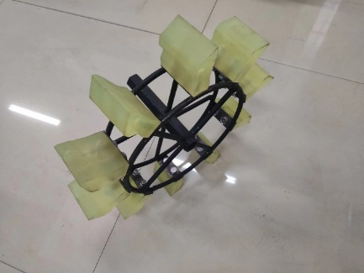

Fig. 10. Bionic paddy wheel.

The bionic paddy wheel is composed of a bionic wheel lug and wheel ring. The bionic wheel lug is fixed in the wheel ring by bolts. When the bionic paddy wheel works, the bionic wheel lugs interact with the soil, resulting in force and reaction force, so that the micro-tiller moves forward. The bionic wheel lug surface morphology is to use the three-dimensional scanner (ATOS II Triple Scan, GOM, Germany) to scan the three-dimensional point cloud data of the cattle hoof surface, and then reconstruct the cattle hoof model by Geomagic Wrap reverse software, extract the shape characteristic curve, and finally convert it into a 3D model by UG software. The process is shown in *Fig.* 11.

  

Fig. 11.3D Point cloud data acquisition (left), and model reconstruction (center), and 3D model(right).

The obtained shape characteristic curve is imported into CAD software. The selected characteristic curve data are extracted by CAD drawing software, and the point coordinates are generated. The coordinate points obtained from CAD software are input into Origin software for drawing, as shown in *Fig. 12*. Analysis of buffalo walking in paddy soil, cattle hoofs into the soil, unearthed when the action, will be extracted in *Fig. 12* shape characteristic curve of cattle hoofs is divided into soil curve section AB, soil curve section BC, transition curve section CD, bulldozing curve section DE.

By analyzing the changing trend of soil curve AB, it can be seen that the curve section is similar to a slope. Combined with the fluidity of paddy soil, the slope has the effect of accelerating the separation of paddy soil and bionic wheel lugs. The BC section of the soil-entry curve is a cone, which is conducive to the penetration of the bionic lug into paddy soil when it works, and reduces the resistance of the bionic lug when it enters the soil. The transition curve section CD increases the thickness of the bionic wheel lug in the longitudinal direction, thereby increasing the shear strength of the bionic wheel lug. At the same time, it increases the contact with paddy soil in the transverse direction, and increases the bulldozing resistance. When the DE of the bulldozing curve is concave inward, the contact area between the bionic wheel lug and the paddy soil increases, the bulldozing resistance increases, and the drawbar pull force of the bionic paddy wheel is increased, and the traction performance in the paddy soil is improved.



Fig. 12. Shape characteristic curve of cattle hoof.

By fitting the above four curves in Origin software using the least square method, The general fitting equation is shown in *Eq.1*, the fitting parameters are shown in *Table 3.*



It can be seen from the above fitting that the regression coefficient R2 of curve fitting is greater than 0.99, and the relationship of the BC section is obtained by curve fitting after a coordinate transformation. According to the size of the paddy wheel of the conventional micro-tiller, the 3D model of the bionic wheel lug was scaled down. At the same time, in order to ensure the accuracy of the surface morphology of the bionic wheel lug, the polyurethane material is selected to process the bionic wheel lug through CNC. The external size of the bionic wheel lug is 0.08m🞨0.08m🞨0.04 m.

Table 3. Fitting parameters

|  |  |  |  |  |
| --- | --- | --- | --- | --- |
| **Type** | **Curved portion** | | | |
| **AB** | **BC** | **CD** | **DE** |
| **a1** | 2E-06 | 3E-06 | -1E-08 | -2E-08 |
| **a2** | -0.0055 | -0.0096 | 7E-05 | 9E-05 |
| **a3** | 7.9283 | 12.65 | -0.115 | -0.1184 |
| **a4** | -5727.4 | -8309.8 | 95.764 | 82.287 |
| **a5** | 2E+06 | 3E+06 | -38901 | -28581 |
| **a6** | -3E+08 | -4E+08 | 6E+06 | 4E+06 |
| **R2** | 0.9977 | 0.9998 | 0.9965 | 0.9972 |

* 1. Experimental setup

The experiment was carried out on a self-designed single wheel soil bin testbed (5.00m🞨1.20m🞨1.20m) to explore the traction performance of a bionic paddy wheel in paddy soil. The paddy soil in the soil bin was taken from Lianwei Town, Xinjian district in Jiangxi Province, and its physical parameters were shown in ***Error! Reference source not found.***.

The single wheel soil bin testbed is mainly composed of a soil bin, soil leveling device, test vehicle and data acquisition system, as shown in *Fig. 13*. The moisture content of paddy soil in the soil trough was 36 %, and the test wheel was the bionic paddy wheel designed above. The leveling of paddy soil was referred to in the previous study(Zeng et al., 2022).



Fig. 13. The single wheel soil bin testbed.



Fig. 14. The structure diagram of the test vehicle.

*Fig. 14* shows the structure diagram of the test vehicle, where the encoder A (E6B2, OMRON, Japan) contacts the optical axis guide rail, and the actual driving distance of the wheel is recorded in the test. Encoder B contacts the motor shaft, and the theoretical driving distance of the wheel is recorded in the test. The theoretical driving speed and actual driving speed are calculated by *Eq.2*.



where *v* is the driving speed (m/s), *s* is the driving distance (m), *t* is the driving time (s).

Test factors are vertical load, driving speed, which vertical load was 82.57N, 131.40N and 179.42N, driving speed were 0.3m/s, 0.5m/s and 0.7m/s, drawbar pull 10-120N, the change is realized by adding and subtracting weighter to achieve. The specific drawbar pull is obtained by pre-test, such as the vertical load is 82.57N, the drawbar pull range is 10-55N. When the vertical load is 131.40N, the drawbar pull range is 10-95N. When the vertical load is 179.42N, the drawbar pull is10-120N.

In this paper, the drawbar pull and efficiency coefficient were used as test indexes to evaluate the traction performance of the bionic paddy wheel on paddy soil. The driving torque is measured directly by a dynamic torque sensor (JN-DN, Bengbu Sensor Systems Engineering Co Ltd, China), and the efficiency coefficient is calculated by *Eq. 3*. The slip ratio is calculated by the actual speed of the wheel and the theoretical speed of the wheel by *Eq. 4*.





where  for the efficiency coefficient, *DP* is the drawbar pull (N), *T* is the drive torque (N · m),  is the theoretical speed (m/s),  is the actual speed (m/s), and  is the wheel drive radius (m).

1. Results and discussion
   1. Influence of vertical load on traction performance of bionic paddy wheel

The driving torque of the wheel is one of the evaluation indexes of vehicle traction performance, and understanding its variation law is helpful to study the traction performance of the wheel. *Fig. 15* shows the relationship between different vertical loads and wheel driving torque at a speed of 0.7 m/s obtained by polynomial fitting. It can be seen from Fig. 6 that with the increase in slip ratio, the driving torque gradually increases, and finally tends to be flat. The reason is that the maximum shear strength of paddy soil has been reached under this test condition, and the weight is further increased in the test to increase the drawbar pull, and the wheel will slip in situ. At the same slip rate, with the increase of vertical load, the reaction force obtained by wheel shearing the paddy soil breaking the ring increases, and the driving torque increases. When the driving speed is 0.7 m/s, the maximum driving torque of the wheel is 47.04 N·m when the vertical load is 179.42 N, which is increased by 55.71 % compared with the minimum driving torque. At the same time, the maximum driving torque of the wheel is increased by 135.67 % and 35.91 % compared with the vertical load of 82.57 N and 131.40 N.

*Fig. 16* shows the relationship between the vertical load and the maximum drawbar pull when the driving speed is 0.7m/s. It can be seen from the figure that as the vertical load increases, the maximum drawbar pull increases. When the vertical load is 179.42 N, the maximum drawbar pull of the wheel is 120 N, which increases by 166.67 % and 33.33 % respectively compared with the vertical load of 82.57 N and 131.40 N.

*Fig. 17* is the curve of the relationship between the wheel drawbar pull and slip ratio under different vertical loads when the driving speed is 0.7 m/s. It can be seen from *Fig. 17* that the drawbar pull increases with the increase in slip ratio. In the range of 0.15 – 0.50 slip ratio, the drawbar pull increases by 3.5 – 11 times.



Fig. 15. Influence of vertical load on the wheel driving torque.



Fig. 16 Relation curve between vertical load and wheel maximum drawbar pull.



Fig. 17. Influence of vertical load on wheel drawbar pull.

* 1. Influence of driving speed on traction performance of bionic paddy wheel

The efficiency coefficient refers to the ratio of the output power to the input power on the driving wheel, which is calculated by the drawbar pull, driving torque, theoretical speed, actual speed and other parameters by *Eq. 3*. When the vertical load is 179.42 N, the influence of different driving speeds on the efficiency coefficient is shown in *Fig. 18*.



Fig. 18. Influence of driving speed on efficiency coefficient.

*Fig. 18* shows that the maximum efficiency coefficient increases with the increase of wheel driving speed. Under the same vertical load and driving speed, the efficiency coefficient first increases and then decreases with the increase of slip ratio. When the slip ratio is less than 0.37, the efficiency coefficient begins to grow rapidly, and the greater the driving speed is, the greater the growth rate is. When the slip ratio is about 0.37, the efficiency coefficient reaches the maximum, and then begins to decrease. When the vertical load is 179.42 N, the maximum efficiency coefficient of the wheel with a driving speed of 0.7 m/s is 554 % and 98 % higher than that of the wheel with a driving speed of 0.3 m/s and 0.5 m/s, respectively.

1. Conclusions

Based on the structure and morphology of cattle hoof, a bionic paddy wheel is designed by using bionic engineering technology and according to the design index of the soft ground walking mechanism. Through the traction performance test in a single wheel soil bin test-bed, the influence of vertical load on the traction performance of the bionic paddy wheel is analyzed. At the driving speed of 0.7 m/s, under different vertical loads, with the increase of slip ratio, the driving torque increases gradually, and finally tends to be gentle. Maximum drawbar pull increases as vertical load increases, when the driving speed is 0.7 m/s and the vertical load is 179.42 N, the maximum drawbar pull of the wheel is 120 N, which increases by 166.67 % and 33.33 % respectively compared with the vertical load of 82.57 N and 131.40 N. The influence of driving speed on traction performance of bionic paddy wheel is analyzed, under the vertical load of 179.42 N, with the increase of slip ratio, the efficiency coefficient first increases and then decreases, and reaches the maximum when the slip ratio is about 0.37.

1. Acknowledgements

This work was funded by the National Natural Science Foundation of China (51865018), the Natural Science Foundation of Jiangxi Province (20192BAB206025).

1. References

Chen, Z., Gu, J., Yang, X., 2020. A novel rigid wheel for agricultural machinery applicable to paddy field with muddy soil. Journal of terramechanics 87, 21-27.

Ding, L., Gao, H., Deng, Z., Nagatani, K., Yoshida, K., 2011. Experimental study and analysis on driving wheels' performance for planetary exploration rovers moving in deformable soil. Journal of Terramechanics 48, 27-45.

Higa, S., Sawada, K., Nagaoka, K., Nagatani, K., Yoshida, K., 2016. Measurement of stress distributions of a wheel with grousers traveling on loose soil, 2016 IEEE International Conference on Robotics and Automation (ICRA), pp. 2828-2833.

Iizuka, K., Yoshida, T., Kubota, T., 2011. Effect of tractive given by grousers mounted on wheels for lunar rovers on loose soil.

Keen, A., Hall, N., Soni, P., Gholkar, M., Cooper, S., Ferdous, J., 2013. A review of the tractive performance of wheeled tractors and soil management in lowland intensive rice production. Journal of Terramechanics 50, 45-62.

Li, J., Zhuang, J., Wei, D., 1999. Design and Test of the Bionic Camel Foot Rubber Tire for Desert Vehicles. Agricultural Engineering, 38-42.

Nagaoka, K., Sawada, K., Yoshida, K., 2019. Shape effects of wheel grousers on traction performance on sandy terrain. Journal of Terramechanics 90.

Naranjo, S.D., Sandu, C., Taheri, S., Taheri, S., 2014. Experimental testing of an off-road instrumented tire on soft soil. Journal of Terramechanics 56, 119-137.

Nassiraei, A.A.F., Skonieczny, K., 2020. Grousers improve drawbar pull by reducing resistance and generating thrust at the front of a wheel. Journal of Terramechanics 91, 73-84.

Pang, H., Zhang, H., Zhang, R., Dong, W., Li, J., 2021. Design of the bionic wheel surface based on the friction characteristics of ostrich planta. Rendiconti Lincei. Scienze Fisiche e Naturali.

Wei, Y., Cheng, Z., 2013. Design and Cross-barrier Capability Analysis of Road Condition Adaptive Variable Diameter Wheel. Journal of Mechanical Transmission 37, 125-129.

Yang, Y., Sun, Y., Ma, S., 2014. Effect of lug sinkage length to drawbar pull of a wheel with an actively actuated lug on sandy terrain, 2014 IEEE International Conference on Robotics and Automation (ICRA).

Zeng, J., Li, J., Li, L., Qiu, H., Wu, C., Bao, Y., Liu, M., Xue, L., 2022. Traction Performance Test of Micro-cultivator Wheel in Paddy Soil. Acta Agriculturae Universitatis Jiangxiensis, 1-9.

Zhang, R., Pang, H., Ji, Q., Li, G., Li, J., 2020. Structure design and traction trafficability analysis of multi-posture wheel-legs bionic walking wheels for sand terrain. Journal of Terramechanics 91, 31-43.

Table 2. Physical parameters of the tested soil

|  |  |  |  |  |  |
| --- | --- | --- | --- | --- | --- |
| Clay particles [%] | Soil particles [%] | Sand particles [%] | Plastic limit [%] | Liquid limit [%] | Specific gravity [g/cm3] |
| 10.84 | 83.87 | 5.29 | 21.78 | 34.17 | 2.57 |

Acquisition of Flipper Motion in Step-Climbing of Tracked Robot Using Reinforcement Learning9913

Ryosuke Etoa*

eto@nda.ac.jp

Junya Yamakawaa

yamakawa@nda.ac.jp

aNational Defense Academy of Japan, Yokosuka, Kanagawa, Japan

*Corresponding author

Abstract

Remotely piloted robots have been expected for disaster operations to prevent secondary disasters to rescuers. The robots are required to have a high performance to overcome obstacles such as debris and bumps. Tracked robots with flipper arms on the front, back, left, and right sides can improve their ability to overcome bumps by changing the flipper angles, and are thus expected to be used as rescue robots. However, the six degrees of freedom of the left and right crawlers and four flipper arms require a high level of skill to maneuver the robot. Therefore, a semi-autonomous control system that automatically controls the flipper arms according to the terrain is expected.

In this study, we proposed a method to determine the front and rear flipper angles in step-climbing using reinforcement learning with Double Deep Q Network. The input data were the step height, distance to the step, and current front and rear flipper angles. The outputs were amounts of front and rear flipper angle variations. The behavior of the robot and rewards were calculated using a quasi-static model that considers the slips between the step, floor, and crawler. Positive rewards were given for successful step stepping over steps and negative rewards for unsuccessful steps. Furthermore, the flipper motions at which slippage decreased were obtained by subtracting the sum of the squared values of the slippage rates from the rewards. As the results, it was confirmed that the robot slips less when the body is lifted by the rear flipper than when it runs over along the step shape.

Keywords: Tracked robot, Flipper, Slip, Step-climbing, Reinforcement learning.

1. Introduction

In disaster operations, remotely piloted robots are effective in preventing secondary disasters to rescuers. The rescue robots are required to have a high performance to overcome obstacles such as debris and bumps and to travel on soft terrain. For this reason, tracked robots are commonly employed. Tracked robots with flipper arms on the front, back, left, and right sides can improve their performance of overcoming obstacles by changing the flipper angles, and are thus expected to be used as rescue robots.

On the other hand, high skill is required to maneuver the left and right crawlers and the four flipper arms in a total of six degrees of freedom. Therefore, a semi-autonomous control system that automatically controls the flipper arms according to the terrain is expected. As shown in Fig. 1, the control plan for the flipper angles relative to a step when climbing a step can be divided into two methods: one in which the robot body is controlled to maintain a horizontal position and the other in which the robot is controlled to move along the step shape. The latter method is effective on soft ground because the rear flipper can increase the ground contact area. However, these control methods determine the flipper angles based on geometric relationships and do not consider the slip state of the crawler. The objective of this study is to obtain a motion plan for the flippers that reduces the slip to prevent the robot from slipping down from the step on hard ground.

Reinforcement learning is a method for determining the robot's action plan. Reinforcement learning is a method of acquiring optimal action rules for a robot through repeated trial and error. Reinforcement learning for flipper arms has been studied (Isabell, 2012, Totani, 2019), however, they only judge whether the robot was able to climb the steps and do not consider the state of slip of the robot.

In this study, reinforcement learning with Deep Q Network (DQN) is adapted to determine the angles of the front and rear flippers that minimizes slip and enables the robot to climb a step. Repeating the trial-and-error process necessary for reinforcement learning through experiments takes a lot of time. Therefore, in this study, we aim at acquiring the flippers motion by learning through a step-climbing simulation using a quasi-static model that considers slips between the floor and the crawler and between the step and the crawler.

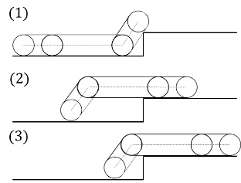 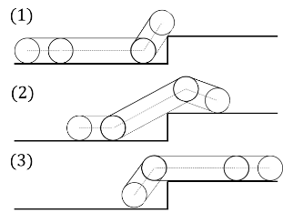

(a) keeping body horizontal (b) along a step shape  
Fig. 1 Difference in flipper angles when climbing a step

1. Quasi-Static Model
   1. Calculation of slip ratio and normal load

The quasi-static model used in this study assumes that the crawler robot moves at extremely low speeds and calculates the statics balance at each position of the robot (Eto, 2021). The crawler is not deformed and the circumferential speeds of the main crawler and subcrawler are assumed to be the same.

Figure 2 shows the dynamic model of a crawler robot without grousers climbing a step. $F_{b}, N_{b}$, and $R_{b}$ are the driving force, vertical drag force, and driving resistance acting at the contact point between the rear subcrawler and the floor, and $F_{a}, N_{a}$ and $R_{a}$ are the driving force, vertical drag force, and driving resistance acting at the contact point between the step and crawler. $X, m, g$ are the distance between the robot and the step, the mass of the entire robot, and the acceleration of gravity, respectively. $ϕ_{f}, ϕ_{r}, θ_{x}$ are the front flipper angle, the rear flipper angle, and contact angle, respectively. The angles are positive in the counterclockwise direction.

In this model, the vertical forces $N_{a}, N_{b}$ and the slip ratios $s_{a}, s_{b}$ are calculated by solving four simultaneous equations: (1) the equilibrium of the horizontal forces, (2) the equilibrium of the vertical forces, (3) the equilibrium of the moments, and (4) the relationship between the slip ratios at the contact point between the floor and the step. The conditions that make it impossible to climb a step in this method are when the center of gravity of the robot cannot pass directly above the step angle and when the solution of the simultaneous equations cannot be obtained. Changing the flipper angles changes the pitch angle and the location of center of gravity of the robot, allowing the robot to pass directly above the step angle and changing the critical height for climbing a step.

The slip ratio $s_{i}$ is the ratio of the slip velocity to the crawler circumferential velocity $v_{t}$ and is defined by the following equation.

$s_{i}=\frac{v_{t}-v_{i}}{v_{t}}$　 (1)

where $i$ is the contact point and $v_{i}$ is the velocity of movement at each contact point. The relationship of the slip ratio at each contact point is obtained from the relation of the angular velocity $ω_{c}$ around the instantaneous center $O$ in Fig. 2 as follows.

$l_{a}(1-s_{b})=l_{b}(1-s_{a})$ (2)

The relationship between vertical force and driving force can be expressed by the following equation using the coefficient of friction.

* $F_{i}=μ_{i}N_{i}$ (3)

The friction coefficient $μ_{i}$ is expressed by the following equation using the sliding ratio $s_{i}$.

* $μ_{i}=μ_{i0}(1-exp⁡(-K_{i}|s_{i}|))∙sign(s_{i})$ (4)

where $μ_{i0}$ is the maximum coefficient of friction and $K_{i}$ is a positive constant, determined by the floor, the step, and the crawler material.



Fig. 2 Dynamic model of stepping over a step

* 1. Model with grousers

Figure 3 shows the dynamic model of a crawler robot with grousers. In the case of the state in which the main crawler is in contact with a step, the moving velocity of the contact point $A(x_{a},y_{a})$ between the grouser and the step can be expressed as follows.

$${\dot{x}}_{a}={\dot{x}}_{b}+{\dot{l}}_{X}(cosθ_{c}-tanθ_{d} sinθ_{c})$$

$-ω_{c}\left\{l_{r}sinθ_{r}+l_{X}sinθ_{c}-\left(r-l_{X}+h_{gr}\right)cosθ_{c}\right\}$ (5)

$${\dot{y}}_{a}=ω_{c}\{\left(l_{r}cosθ_{r}+l_{X}cosθ_{c}\right)$$

$+\left(r-l_{X}tanθ_{d}\right)sinθ_{c}+h_{gr}sinθ_{x}\}$

$+{\dot{l}}_{X}(tanθ_{d}cosθ_{c}+sinθ_{c})=0$ (6)

where $x,y$ are the horizontal and vertical positions, respectively. ${\dot{x}}_{b}$ is the horizontal velocity of the contact point $B(x_{b}, y_{b})$, $ω_{c}$ is the pitch angular velocity of the robot, $l_{r}$ is the rear crawler length, $l_{X}$ is the distance to the main crawler contact point from the rear wheel of main crawler, $r$ is the main crawler wheel diameter, $θ_{r}$ is the rear flipper pitch angle, $θ_{c}$ is the robot pitch angle, $θ_{d}$ is the angle between the crawler centerline and the belt ( $θ_{d}=0$ for the main crawler), and $h_{gr}$ is the height of the grouser. The vertical position of contact point $A$ is equal to the step height, so ${\dot{y}}_{a}=0$. The moving velocity ${\dot{x}}_{b}$ of contact point $B$ can be obtained from equation (1) as follows.

${\dot{x}}_{b}=\left(1-{ s}_{b}\right)(r_{r}+h_{gr})ω_{r}$　 (7)

where $r_{r}$ is the diameter of the rear flipper idler wheel and $ω_{r}$ is the rotation speed of the rear flipper idler wheel. Since the circumferential speed of the main crawler can be obtained from equation (7), ${\dot{l}}_{X}$ is given by

${\dot{l}}_{X}=-\frac{{\dot{x}}_{b}r_{r}cosθ_{d}}{(r_{r}+h_{gr})\left(1-{ s}_{b}\right)}$ (8)

The pitch angular velocity $ω_{c}$ is obtained by substituting ${\dot{l}}_{X}$ into equation (6). And, the velocity ${\dot{x}}_{a}$ is obtained by substituting $ω_{c}$, ${\dot{l}}_{X}$, and ${\dot{x}}_{b}$ into Eq. (5).

${\dot{x}}_{a}={\dot{x}}_{b}-a_{1}a_{2}\frac{{\dot{x}}_{b}r_{r}}{\left(r_{r}+h_{gr}\right)\left(1-{ s}_{b}\right)}+a_{3}\frac{{\dot{x}}_{b}r_{r}}{(r_{r}+h_{gr})\left(1-{ s}_{b}\right)}$ (9)

$a_{1}=\frac{sinθ_{d}cosθ_{c}+cosθ_{d}sinθ_{c}}{l_{r}cosθ_{r}+l_{X}cosθ_{c}+\left(r-l_{X}tanθ_{d}\right)sinθ_{c}+h_{gr}sinθ_{x}}$ (10)

$a_{2}=l_{r}sinθ_{r}+l_{X}sinθ_{c}-\left(r-l_{X}+h_{gr}\right)cosθ_{c}$ (11)

$a_{3}= cosθ_{d}cosθ_{c}+sinθ_{d}sinθ_{c}$　　　 (12)

Since ${\dot{x}}_{a}$ is the sliding velocity at contact point $A$, dividing ${\dot{x}}_{a}$ by the crawler belt circumferential velocity horizontal component yields the following slip ratio relationship.

$s_{a}=b_{1}\left(1-s_{b}\right)+b_{2}$ (13)

where, $b_{1}，b_{2}$ are values obtained from the robot specifications and pitch angle. When considering grousers, the vertical forces $N_{a}, N_{b}$ and the slip ratios $s_{a}, s_{b}$ are obtained by solving the simultaneous equations using the relationship in Eq. (13) instead of Eq. (2).



Fig. 3 Dynamics model considering grousers

1. Acquisition of flipper motion
   1. Reinforcement Learning with DQN

In this study, we used reinforcement learning with DQN as a method of acquiring flipper motion. DQN is a method that uses deep neural network (DNN) model for Q-learning that is a typical method of reinforcement learning (Volodymyr, 2015). In Q-learning, the agent learns a strategy for selecting the action that maximizes the action value Q, when the agent selects action $a$ in state $s$. The Q value is updated using the action value function $Q(s_{t},a_{t})$ as follows.

$$Q(s_{t},a_{t})←Q(s_{t},a_{t})+α(r_{t}+γ\max_{a'}{Q\left(s_{t+1},a'\right)}$$

$-Q(s_{t+1},a_{t+1})$) (14)

where $s_{t},a_{t},$ and $r_{t}$ are the state, action, and reward at step $t$, respectively. $α$ is the learning rate and $γ$ is the discount rate.

DQN is a method that uses a DNN model as a function approximator of the action value function $Q(s_{t},a_{t})$. In DQN, the target value function $q_{n}$ are set as follows for each of the total $N$ experience data ($s_{n}, a_{n}, r_{n}, s_{n}^{'}$)， $n∈\{1,…,N\}$ in the historical data.

$q_{n}=r_{n}+γ\max_{a'}{Q\left(s_{n}^{'},a'\right)}$ (15)

Where, $s_{n}^{'}$ is the state after the transition. The parameters of the DNN model are updated so that the loss function for the mean squared error is smaller. the loss function $η$ is defined as follows.

$η=\frac{1}{N}\sum_{n=1}^{N}{{\left(Q'\left(s_{n},a_{n}\right)-q_{n}\right)}^{2}}$ (16)

Where, $Q'$ is a network after parameter optimization.

* 1. Learning Conditions

The robot targeted for learning is Dr Robot's Jaguar V6 with Arm shown in Fig. 4. The driving resistance in the quasi-static model was set to 0, the maximum friction coefficient $μ_{i0}$ in the friction model was 1, and $K$ was 20.

The targets of the acquired motion are the front flipper angle and the rear flipper angle. There are four states: step height $H$, distance to step $X$, front flipper angle $ϕ_{f}$, and rear flipper angle $ϕ_{r}$. The actions were set to three changing angles for each flipper relative to the distance the robot travels: 2.5 deg/cm, 0 deg/cm, and -2.5 deg/cm. Therefore, there are 9 actions in each step. The initial front and rear flipper angles were set to 10 deg. and -10 deg., respectively. The step height was set to 20 cm.

The reward was defined as follows using the slip ratios.

$r_{n}=-20(s_{an}^{2}+s_{bn}^{2}$) (17)

In addition, we added a reward of 10 for a successful climbing and -10 for an unsuccessful. Since learning is performed to maximize the reward, it is expected that the robot will acquire the behavior that allows it to successfully climbing a step with a small slip. The learning rate $α$ was 0.05 and the discount rate $γ$ was 0.99.

The max operator in DQN, in Eq. (15), uses the same values to select and evaluate an action. This makes it more likely to select overestimated values, resulting in overoptimistic value estimates. In this study, the Double DQN method (Hado, 2016) was employed to prevent the overestimation. Double DQN uses the action value estimate $Q'$ based on the latest parameters for action selection and the target network based on previous parameters for action evaluation. The target value in Eq. (15) is replaced as follows.

$q_{n}^{'}=r_{n}+γ\max_{a'}{Q\left(s_{n}^{'},\underset{a'}{argmax}{Q'\left(s_{n}^{'},a'\right)}\right)}$ (18)

The action is selected by the ε-greedy policy (Volodymyr, 2015). The greedy policy is $a^{'}=\underset{a'}{argmax}{Q'\left(s_{n}^{'},a'\right)}$. In this study, ε was updated by the following equation.

$ε_{n}={0.995}^{n-1}$ (19)

The minimum value of *ε* was 0.01.

The DNN model is a four-layer network model consisting of an input layer with 4 neurons, an output layer with 9 neurons, and two intermediate layers which have 30 and 60 neurons, respectively. The numbers of neurons of input and output layers are determined by the number of states and the number of actions in learning. The intermediate layer was determined by trial and error. The ReLU function was used as the activation function.



Fig. 4 Tracked robot

Table 1 Specification of robot

|  |  |
| --- | --- |
| Parameter | Value |
| Body mass | 50 [kg] |
| Flipper mass | 1 [kg] |
| Main crawler length | 0.46 [m] |
| Subcrawler length | 0.22 [m] |
| Driving wheel diameter | 0.115 [m] |
| Idler wheel diameter | 0.07 [m] |
| Grouser height | 0.01 [m] |

* 1. Results

Figure 5 shows the obtained reward for each episode. The gray line is the unprocessed data, and black line is the smoothed data with 15 points. In the case of the tracked robot without grousers, the reward was relatively stable after 500 episodes. In the case of the tracked robot with grousers, the increase in reward stopped when the episode exceeds 1500. In some episodes, rewards were low even when the number of episodes was a lot due to the random selection of actions by the *ε*-greedy policy. The reason why the reward does not increase to nearly 10 that is a reward for a successful climbing is that it is not possible to climb a step with zero slip. The reason why the reward of the robot with grousers is smaller is that the forward slip at the point of contact with the step is larger than without grousers during the first half of climbing the step.

Table 2 shows the integral of the sum of the squares of the slip ratios at the two contact points and the success or failure of the climbing. Figure 6 also shows the acquired flipper angles. When the flipper angle is not changed (episode number 0), the robot's center of gravity is not able to move above the step and the robot cannot climb it. However, with repeated learning, as shown in Figure 6(a) and (b), the robot makes the pitch angle of the main body closer to horizontal by lowering the rear flipper and moves its center of gravity forward, regardless of the presence or absence of grousers and can climb a step. The learning process also reduces the slip ratio. After the learning, the rear flipper was lowered to a maximum angle of 45 degrees immediately after the start of driving, and the robot climbed a step while maintaining that pitch angle. Therefore, to reduce the total slip ratio up to the time when the robot climbs a step, it is better to run the robot while keeping the body close to the horizontal. However, the front flipper angle dose not changed from the initial angle after learning. Since the impact of landing on a step can be reduced by lowering the front flipper when climbing up a step, it is thought that the motion of the front flipper can be acquired by adding a parameter related to this to the reward.



(a) without grouser



(b) with grouser  
Fig. 5 Rewards in learning

Table 2 Results of tests

|  |  |  |  |
| --- | --- | --- | --- |
| Episode number | | Without grouser | With grouser |
| 0 | Slip ratio | 0.0071 | 0.068 |
| Success/Failure | Failure | Failure |
| 1000 | Slip ratio | 0.0062 | 0.066 |
| Success/Failure | Success | Failure |
| 5000 | Slip ratio | 0.0061 | 0.048 |
| Success/Failure | Success | Success |

As described in the introduction, another motion for the robot to climb a step is to drive along the step shape. In order to compare this method with the acquired motion, slip ratios of the robot are analyzed when the robot climbs a step with the motion plan of the rear flipper as shown in Fig. 7 with red lines. In the acquired motion, the rear flipper is lowered after the start of the drive, but in the drive along a step shape, the rear flipper is raised in the first half of the run and lowered in the second half for climbing the step. The front flipper remains unchanged. In this method, the pitch angle of the robot is larger than that of the acquired motion, as shown in Fig. 8. The black dots in Fig. 8 indicate the center of gravity of the robot. Finally, the center of gravity is located above the step in both methods, and the robot succeeds in climbing the step.

Figure 9 shows the results of the slip ratios in the cases of driving with the acquired motion and driving along a step shape. The differences in slip ratios are small up to a travel distance of 0.25 m. However, when the travel distance exceeds 0.25 m and the main crawler contacts a step, the both slip ratios at the contact point with the step become larger when traveling along the step shape. This is because the pitch angle of the main body is large, and a larger driving force is required to balance the vertical forces in the case without grousers. In the case with grousers, the horizontal component of the moving velocity of the main crawler's grouser becomes small, and the difference between it and the travel velocity at the contact point with the floor becomes large, which causes forced slip. Therefore, regardless of the presence or absence of the grousers, the slip can be reduced by lifting the main body to bring its posture closer to the horizontal. When the pitch angle is large, slippage is likely to occur at the contact point with the step if there is no grouser and is likely to occur on the floor if there are grousers.



(a) with grouser



(b) without grouser  
Fig. 6 Acquired flipper motions



Fig. 7 Rear flipper angles



(a) Learning (b) Along a step shape  
Fig. 8 States of robot in step-climbing



(a) with grouser



(b) without grouser  
Fig. 9 results of slip ratios on step and floor

1. Conclusions

In this study, we proposed a method for acquiring a motion when climbing a step using reinforcement learning with Double DQN for a tracked robot with flippers. The proposed method can acquire the motion of climbing a step with small slip by analyzing a quasi-static model of climbing a step. It was confirmed that the robot slips less when the rear part of body is lifted by the rear flipper than when the robot drives along the step shape.

In the future, we will further study the initial conditions and step height. Further studies are also needed for more complex terrain and the case where the crawler rotation speed is also considered.

1. References

Eto, R., Yamakawa, J., 2021. Evaluation of step-climbing performance of tracked robot with flippers. Proceedings of the 20th International and 9th Americas Conference of the ISTVS. 039, 1-9.

Hado, v. H., Artuhr, G., David, S., 2016. Deep reinforcement learning with double Q-Learning. Proceedings of the Thirtieth AAAI Conference on Artificial Intelligence. 2094-2100.

Isabelle, V., Qiao, S., 2012. A combined reactive and reinforcement learning controller for an autonomous tracked vehicle. Robotics and Autonomous Systems. 60, 599-608.

Totani, M., Sato, N., Morita, Y., 2019. Step climbing method for crawler type rescue robot using reinforcement learning with Proximal Policy Optimization. Proceedings of the 12th International Workshop on Robot Motion and Control. 154-159.

Volodymyr, M., Koray, K., et al., 2015. Human-level control through deep reinforcement learning. Nature. 518, 529-533.

Configuration Design and Nonlinear Mechanical Properties Analysis of Tensegrity Robot9943

Ruiwei Liu a,b*

liuruiwei8124@163.com

Yating Fana

fanfan10121217@163.com

Xuntao Lina

tarynl123@163.com

Hongwei Guob

guohw@hit.edu.cn

aCollege of Naval Architecture and Ocean Engineering, Guangzhou Maritime University, Guangzhou 510725, China

bState Key Laboratory of Robotics and System, Harbin Institute of Technology, Harbin 150001, China

*Corresponding author

Abstract

The six-bar tensegrity has comparatively large application potential in the field of robotics. This structure is balanced by the internal force distribution between the cable and the bar, and has the characteristics of large displacement and strong nonlinearity. To obtain the nonlinear mechanical properties of the structure, first, the mathematical model of the six-bar tensegrity is constructed by the node matrices, adjacency matrices, and vector matrices. On this basis, considering the geometric nonlinearity of the structure, the mechanical analysis model was established by ANSYS software, and the influence of different loads and structural parameters on the mechanical properties is analyzed. Then, the deformation sensitivity of each parameter is calculated, and the effective method to improve the stiffness of the six-bar tensegrity is obtained. Finally, the six-bar tensegrity robot prototype is fabricated and rolling over experiments are implemented, this conclusion provides certain theoretical support for the follow-up dynamic analysis, structural optimization and kinematic control.

Keywords: Robotics Engineering, Tensegrity Robot, Nonlinear Mechanics, Mathematical Model, Pretension, Prototype.

1. Introduction

In recent years, deep space exploration has become a key research direction in the aerospace field**Error! Reference source not found.**-**Error! Reference source not found.**. However, the traditional detection robots are difficult to solve problems such as expensive construction, complicated landing methods, and small delivery quantities**Error! Reference source not found.**-**Error! Reference source not found.**. Such characteristics as lightweight, simple structure and strong impact resistance have made tensegrity structure will be a new type of planetary detector.

Tensegrity structure is a self-equilibrium system composed of a continuous set of cables and a discrete set of struts, which designs are characterized by rigid bodies that are suspended in a balanced tension network of elastic elements. As an emergent type of soft-robotics, the tensegrity structure is compliant, lightweight and impact-resistant under load, while their light weight and low cost mean that multiple robots can be assigned to collaboratively achieve a given task, this novel structure could act as probes and landers**Error! Reference source not found.**-**Error! Reference source not found.**. The tensegrity robot can finish the corresponding tasks, such as deep space exploration, deep sea exploration and disaster response**Error! Reference source not found.**-**Error! Reference source not found.**. Similarly, they have been research hotspots in the field such as bridge architecture, aerospace, and even robot. As show **Error! Reference source not found.**, The planning of the exoplanet exploration mission of the six-bar tensegrity robot is proposed in 2015 by the NASA’s Ames Research Center.



Fig. 19. Schematic diagram of the exoplanet exploration mission.

At present, studies about tensegrity structure mostly focused on the form finding and shape optimization, several methods have been utilized in the form finding design, including the force density method**Error! Reference source not found.**, dynamic relaxation method**Error! Reference source not found.**, energy method**Error! Reference source not found.**, and inverse iteration algorithm**Error! Reference source not found.**. Zhang**Error! Reference source not found.** present a highly efficient form-finding method of tensegrity on the basis of the structural stiffness matrix, the method can effectively improve the computational efficiency. K. Koohestani**Error! Reference source not found.** advanced a very effective platform utilizing the Faddeev-LeVerrirt algorithm for analytical form-finding of the tensegrities; this method considerably reduces the complexity of the analytical form-finding process. Cai**Error! Reference source not found.** developed a form finding technique for multimode tensegrity structures based on the force density and grouping methods; moreover, the coordinates of the points and the cable lengths of the tensegrity structures were obtained by minimizing the extreme value of the energy function. Li**Error! Reference source not found.** proposed an improved artificial fish swarm algorithm (IAFSA) to solve the form-finding problem of the tensegrity structures, and the experimental results indicate that the form finding results of the IAFSA are reliable. Luo**Error! Reference source not found.**completed a self-stress stable configuration and analysis based on the force balance principle and the definition of the component and node connection matrix.

Compared with form-finding, tensegrity structures are rarely studied in engineering applications. Typical tensegrity structure applications, including deployable antenna DMRs, were proposed by You**Error! Reference source not found.**, and the tensioned antenna structure was developed by Liu's team**Error! Reference source not found.**-**Error! Reference source not found.**. Six-bar tensegrity robots were designed by NASA and UC**Error! Reference source not found.**-**Error! Reference source not found.**.

However, problems such as the buckling failure of the compression bar and the yield failure of a cable caused by a large impulsive load are encountered in actual applications. Thus, the investigation of tensegrity structure mechanical properties has wide implications. Cai**Error! Reference source not found.** researched the mechanical behavior of tensegrity structures considering the initial imperfections, based on a basic model of a simple tensegrity structure. Tran**Error! Reference source not found.** presented a numerical method for the large deflection in the elastic analysis of tensegrity structures, including geometric and material nonlinearities.

Therefore, the mathematical model of the six-bar tensegrity is constructed by the node matrices, connection matrices and vector matrices. Then, the nonlinear mechanical analysis model of the six-bar tensegrity structure is established by ANSYS software. Subsequently, the influence of different loads and structural parameters on the mechanical properties is analyzed, and the deformation sensitivity of each parameter is calculated. Additionally, an effective method to improve the stiffness of the six-bar tensegrity is obtained. Finally, a six-bar tensegrity robot prototype is developed to verify the correctness of the configuration.

1. Configuration design of six-bar tensegrity structure

In this section, the mathematical model of a six-bar tensegrity structure is first developed by the node matric, connection matrix and vector matrix, which offers a theoretical foundation for subsequent nonlinear mechanical analyses.

* 1. Node matrix

A node is the basis of the mathematical model of a tensegrity structure, and the position of the nodes should be determined. Let *L* denote the distance between the parallel bars; the length of the rod is *L*b, and the length of the cable is *L*s*.* The six-bar tensegrity structure is a centrosymmetric structure; by calculating *L*b=2*L*, *L*s= *L*b/4can be obtained.

Therefore, the node coordinates are given as:



where **n***i*(*i*=1, 2, 3, …, 12) denotes the *i*th node and *Xi*, *Yi*, and *Zi* denote the coordinatesof *i*th node.

Therefore, the node matrix of the six-bar tensegrity structure is:



* 1. Connection matrix

In the connection matrix, suppose that a tensegrity structure has *m* elements, *n* free nodes. Let *k* denote an element, and let *i* and *j*(*i*<*j*) denote two nodes. If element *k* is connected to nodes *i* and *j*, then the *i*th and *j*th entries of the *k*th row of connectivity matrix **C** are 1 and -1, respectively; otherwise, if nodes *i* and *j* are not connected by element *k*, then the corresponding elements in **C** are zero. The specific connections of the bar are illustrated in **Error! Reference source not found.**.

Table 4. Relationship between the bar and node

|  |  |  |
| --- | --- | --- |
| Bar element | Start Node | Terminal Node |
| Bar1 | n1 | n7 |
| Bar2 | n2 | n8 |
| Bar3 | n3 | n9 |
| Bar4 | n4 | n10 |
| Bar5 | n5 | n11 |
| Bar6 | n6 | n12 |

Thus, the bar connection matrix **C**T B can be expressed as:



Similarly, the cable connection matrix CT S can be obtained.



* 1. Vector matrix

The vectors of all the elements are combined to form the element vector matrix of the structure, and the element vectors can express the length and direction. The bar vector matrix in the *XOZ* plane can be expressed as the product of the node matrix and the connection matrix:



where **b***i* (i=1, 2, …, 6) denotes the *i*th bar.

Similarly, the cable vector matrix is:



where **s***i* (*i*=1, 2, …, 6) denotes the *i*th cable.

Through the above analysis, the mathematical model of the six-bar tensegrity structure is developed showing in **Error! Reference source not found.**.



a) Left view b) Front view  
Fig. 20. Mathematical model of the six-bar tensegrity structure.

1. Nonlinear mechanical analysis of six-bar tensegrity structure

As the six-bar tensegrity structure is a type of prestressed structure, the geometric nonlinearity should be considered. Thus, the nonlinear mechanical characteristics of six-bar tensegrity structure are analyzed by obtaining the influences including different loads, prestressing forces and structural parameters of the axial, radial, and torsional deformation. A prototype is fabricated and the single-step tumbling experiment is carried out, subsequently. The feasibility of six-bar tensegrity robot oriented the tensegrity structure is verified.

* 1. A nonlinear analysis model of six-bar tensegrity structure

The basic parameters of cables and bars of six-bar tensegrity structure are selected as **Error! Reference source not found.** and the ANSYS nonlinear finite element analysis model is constructed as shown in **Error! Reference source not found.**.

Table 5 Basic parameters of cable and bar

|  |  |  |
| --- | --- | --- |
| Parameter | Bar | Cable |
| Unit | Link8 | Link10 |
| Elastic modulus [MPa] | 105 | 12.6×104 |
| Poisson | 0.5 | 0.22 |
| Cross area [mm²] | 28.26 | 0.3 |
| Initial strain | 0 | 0.05 |



a) Left view b) Front view  
Fig. 21. Nonlinear finite element analysis model of six-bar tensegrity structure.

* 1. The deformation influence of axial load

To avoid the buckling failure of the compression bar and the yield failure of the cable, the axial load is applied to the six-bar tensegrity structure, for which simulating the impact from the robot dropping into the detection areas. The influence of the axial load for the nonlinear mechanical characteristic of the structural deformation is obtained.

**Error! Reference source not found.** shows that the *Z*-axis directions along the highest nodes *n*7、*n*8 and *n*12 are defined as the directions of axial loads. The lowest nodes *n*1、*n*2 and *n*5 are selected as the fixed constraints.



a) Left view b) Front view  
Fig. 22. The directions of the axial loads.

The axial loads are assumed from 0 N to 7000 N, totally 8 simulation analyses are carried out. The result is shown in **Error! Reference source not found.**, which the dotted line and the scale from blue to red represent the undeformed structure and the displacements of nodes from minimum to maximum respectively.

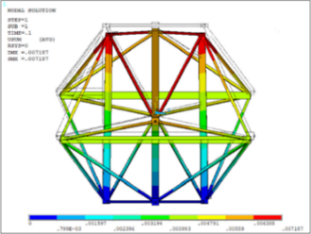 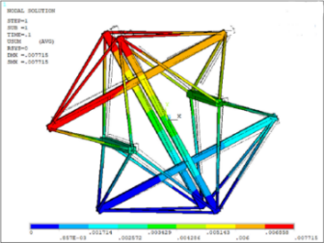

a) Left view b) Front view  
Fig. 23. The deformations of axial loads for the six-bar tensegrity structure.

**Error! Reference source not found.** lists the maximum node displacements of axial and radial deformations under different axial loads. As the axial loads increase, the axial and radial deformations increase smoothly from 0 to 0.94 mm and 0 to 0.28 mm respectively showing in **Error! Reference source not found.**.

Table 6. The maximum displacements of nodes in different axial loads

|  |  |  |
| --- | --- | --- |
| Axial load [kN] | Axial [mm] | Radial [mm] |
| 0 | 0 | 0 |
| 1 | 0.13 | 0.04 |
| 2 | 0.26 | 0.08 |
| 3 | 0.39 | 0.12 |
| 4 | 0.53 | 0.16 |
| 5 | 0.66 | 0.20 |
| 6 | 0.80 | 0.24 |
| 7 | 0.94 | 0.28 |



Fig. 24. The axial and radial deformations in different axial loads.

Therefore, the nonlinear mechanical characteristic of structural deformation is less influenced by axial loads.

* 1. The deformation influence of torsional load

Similarly, the connection directions among the highest nodes *n*7、*n*8 and *n*12 are defined as the directions of torsional loads, and the lowest nodes *n*1、*n*2 and *n*5 are selected as the fixed constraints showing in **Error! Reference source not found.**.



a) Left view b) Front view

Fig. 25. The directions of the torsional loads.

The torsional loads are assumed from 0 to 4200 N·m. The results of deformations are shown in **Error! Reference source not found.**, and the maximum displacements of nodes under different torsional loads are shown in **Error! Reference source not found.** and **Error! Reference source not found.**.

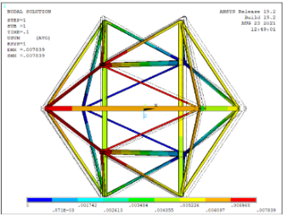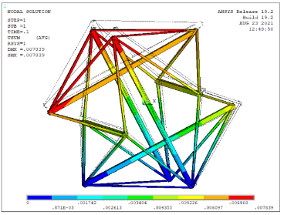

a) Left view b) Front view

Fig. 26. The deformations of torsional loads for the six-bar tensegrity structure.

It can be found that the torsional loads increase, the increase trend of the axial deformation is the largest, which is obvious at 0.6 kN·m ~ 3 kN·m. The radial deformation increases from 0 to 1.08 mm, and the trend is relatively gentle. The torsion angle adding from 0 to 0.03 rad, which the increase trend is the smallest.

Table 7. The maximum displacements of nodes in different torsional loads

|  |  |  |  |
| --- | --- | --- | --- |
| Torsional load [kN·m] | **Axial**  **[mm]** | **Radial**  **[mm]** | **Torsional**  **[rad]** |
| 0.6 | 0.02 | 0.13 | 0 |
| 1.2 | 0.06 | 0.27 | 0.01 |
| 1.8 | 0.13 | 0.40 | 0.01 |
| 2.4 | 0.21 | 0.53 | 0.01 |
| 3 | 0.31 | 0.67 | 0.02 |
| 3.6 | 0.43 | 0.80 | 0.02 |
| 4.2 | 0.57 | 0.95 | 0.03 |
| 4.8 | 0.70 | 1.08 | 0.03 |



Fig. 27. The axial and radial deformations in different torsional loads.

Thus, compared with the torsional deformation, the nonlinear mechanical characteristic of axial deformation is greatly influenced by torsional loads. Moreover, the increase of torsion angle is linear under torsional loads.

* 1. The deformation influence of prestressing force

To analyze the deformation of six-bar tensegrity structure influencing by prestressing force, five groups of initial prestressing forces are drawn up with constraining the other parameters of structure.

As shown in **Error! Reference source not found.** and **Error! Reference source not found.**, to the structure applying axial loads of 100 N, the axial and radial deformations with the multiples of prestressing forces from 0 to 5 times are obtained, which the increase trends of both are about 2%, not increase exponentially with prestressing forces.

Table 8. The maximum displacements of nodes in different multiples of prestressing forces under axial loads

|  |  |  |
| --- | --- | --- |
| Multiple of prestressing force | Axial [mm] | Radial [mm] |
| Non | 0 | 0 |
| Initial | 7.10 | 6.67 |
| Double | 13.88 | 13.24 |
| Trible | 20.68 | 19.82 |
| Quadruple | 27.57 | 26.49 |
| Quintuple | 34.57 | 33.26 |



Fig. 28. The axial and radial deformations in different prestressing forces under axial loads.

Similarly, **Error! Reference source not found.** lists the maximum displacements of nodes with the structure applying same torsional loads of 600 N m but the multiples of prestressing forces from 0 to 5 times. As shown in **Error! Reference source not found.**, the increase trends of axial and radial deformations are relatively gently, which from 0 to 34.57 mm and from 0 to 28.98 mm respectively. Besides, the torsion angle is slightly increased.

Table 9. The maximum displacements of nodes in different multiples of prestressing forces under torsional loads

|  |  |  |  |
| --- | --- | --- | --- |
| Multiple of prestressing force | Axial  [mm] | Radial  [mm] | Torsional  [rad] |
| Non | 0 | 0 | 0 |
| Initial | 7.09 | 5.51 | 0.04 |
| Double | 13.88 | 11.14 | 0.07 |
| Trible | 20.68 | 16.97 | 0.10 |
| Quadruple | 27.57 | 22.91 | 0.13 |
| Quintuple | 34.57 | 28.98 | 0.16 |



Fig. 29. The axial, radial and torsional deformations in different prestressing forces under torsional loads.

Through analyzing the deformation results of different prestressing forces of the structure under the same axial loads or the same torsional loads, the nonlinear mechanical characteristics of structural deformations are influenced linearly by prestressing forces.

* 1. The deformation influence of structural parameters

The elastic stiffness of six-bar tensegrity structure depending on the product of the elastic modulus and area, thus, the areas of bar, horizontal and oblique cables for the structure are selected as the analysis parameters showing in **Error! Reference source not found.**.



Fig. 30. The distribution of bar, horizontal and oblique cables.

The axial loads of 1000 N are applied to the structure, and the structural deformations influencing by the halving of areas of bars, horizontal and oblique cables are shown in **Error! Reference source not found.**. The axial and radial deformations are mainly influenced by the halving of areas of oblique cables, with an increase of deformation about 18%. The axial and radial deformations for the halving of bars increase about 12%, which are 0.78 mm and 0.62 mm, respectively. The structural deformations for the halving of horizontal cables are the smallest, only about 2%.



Fig. 31. The maximum displacements of nodes in different structural parameters.

Therefore, the nonlinear mechanical characteristics of structure are influenced slightly by the change of element areas of the six-bar tensegrity structure within the elastic range.

* 1. Sensitivity analysis of structural parameters of the six-bar tensegrity structure

To further analyze nonlinear mechanical characteristic influencing by the parameters for six-bar tensegrity structure, the sensitivities of axial and radial deformations *fi* to the structural parameters *xi* are defined, the sensitivity analyses with influencing factors are performed subsequently.

The sensitivity is expressed as



where *fi* is the axial or radial deformation of the six-bar tensegrity structure; *xi* is a certain parameter of structure; Δ*xi* and Δ*fi* are the variations of structural parameters and the corresponding displacements, respectively.



Fig. 32. The sensitivity of structural deformations to different structural parameters.

The sensitivity of the structural deformations to each parameter of six-bar tensegrity structure is obtained by Eq. . As shown in **Error! Reference source not found.**, the axial and radial deformations are mainly influenced by the prestressing forces and loads, which the positive sensitivity of torsional load is the highest. Besides, the sensitivity to horizontal cable areas is slight.

* 1. Prototype and experiments

In this section, a prototype is fabricated to verify the rationality of the configuration design proposed above, the rolling over experiment is preformed subsequently. As shown in **Error! Reference source not found.**, the linear motor is selected as the bar of the prototype, and the Kevlar fiber and spring are selected as the cable. The veracity of the parameter relationships between bar and cable can be proved with the prototype maintaining the shape of six-bar tensegrity structure. **Error! Reference source not found.** lists the basic parameters of the prototype.



a) Left view b) Front view  
Fig. 33. The prototype of the six-bar tensegrity robot.

Table 10. Basic parameters of prototype

|  |  |  |
| --- | --- | --- |
| Length of bar [mm] | Length of cable [mm] | Spacing of bar [mm] |
| 300.0 | 183.7 | 150.0 |

The initial landing is assumed to open triangle, and the rolling over experiment is carried out. The center of gravity of the six-bar tensegrity robot is offset by driving the linear motor to extend or retract the bars, and the close triangle as the new landing. The tumbling motion is achieved, which verifying the mobility of the six-bar tensegrity robot as shown in **Error! Reference source not found.**.



a) Open triangle b) Retract bar2 c) Retract bar5



d) Extend bar2 e) Extend bar5 f) Close triangle

Fig. 34. The motion process of the six-bar tensegrity robot

The further research such as kinematics, dynamics and the trajectory planning of the six-bar tensegrity robot are guaranteed by this experiment approach.

1. Conclusions

The vector matrices of six-bar tensegrity structure are established through combining the node matrix and the connection matrix, and the functional relationships between the model of six-bar tensegrity structure and the structural parameters are confirmed.

A nonlinear mechanics model of six-bar tensegrity structure is constructed with ANSYS, and the most significant nonlinear mechanical characteristics of structural deformations are obtained with torsional loads comparing with the axial loads, initial pre-stressing forces and the halving areas.

Through the analysis of the sensitivities with structural parameters, the mechanical characteristic of the six-bar tensegrity structure can be effectively improved by increasing the prestressing forces and the areas of oblique cables.

The feasibility and the mobility of the six-bar tensegrity robot designing with the six-bar tensegrity structure are verified through the rolling over experiment. The in-depth research on the trajectory, kinematics and the dynamics of six-bar tensegrity robot are planned for future work.

1. Acknowledgements

This work was supported by the National Natural Science Foundations of China (grant numbers 52105011, 52102410); and the Young Innovative Talents Project of

Guangdong Province (2021KQNCX071 and 2021KQNCX073).

1. References
2. Meguro A, Shintate K, Usui M, et al, 2009. In-orbit deployment characteristics of large deployable antenna reflector onboard engineering test satellite viii. *J. Acta Astronautica*. 65(9-10), 1306-1316.
3. Nakamura K, Nakamura N, Ozawa S, et al, 2016. Concept design of 15m class light weight deployable antenna reflector for L-band SAR application[C]//3rd AIAA Spacecraft Structures Conference. 0701.
4. Wang L, Dong X, 2013. Simple technique for form-finding and tension determining of cable-network antenna reflectors. *J. Journal of Spacecraft and Rockets*. 50(2), 479-481.
5. Hanayama E, Kuroda S, Takano T, et al, 2004. Characteristics of the large deployable antenna on halca satellite in orbit. *J. IEEE Transactions on Antennas and Propagation*. 52(7), 1777-1782.
6. Zhang T, Xu K, Ding X, 2021. China’s ambitions and challenges for asteroid–comet exploration. *J. Nature Astronomy*. 5(8), 730-731.
7. Chiodini S, Colombatti G, Pertile M, et al, 2014. Numerical study of lander effects on dreams scientific package measurements[C]//2014 IEEE Metrology for Aerospace. 433-438.
8. Liu R, Guo H, Liu R, et al, 2019. Design and form finding of cable net for a large cable–rib tension antenna with flexible deployable structures. *J. Engineering Structures.* 199, 109-662.
9. Cai J, Wang X, Deng X, et al, 2018. Form-finding method for multi-mode tensegrity structures using extended force density method by grouping elements. *J. Composite Structures*. 1-9.
10. Zhang J, Guest S, Ohsaki M, 2006. Symmetric prismatic tensegrity structures. [C]//Proc. Of Symposium of IASS.
11. Barens M, 1999. Form finding and analysis of tension structures by dynamic relaxation. *J. International Journal of Space Structures*. 14(2), 89-104.
12. Pellegrino S, Tibert A, 2011. Review of form-finding methods for tensegrity structures. *J. International Journal of Space Structures*. 18(4), 209-223.
13. Koohestani K, Guest S, 2013. A new approach to the analytical and numerical form-finding of tensegrity structures. *J. International Journal of Solids and Structures*. 50(19), 2995-3007.
14. Zhang L, Li Y, Cao Y, et al, 2014. Stiffness matrix based form-finding method of tensegrity structures. *J. Engineering Structures*. 58(7), 36-48.
15. Koohestani K, 2017. On the analytical form-finding of tensegrities. *J. Composite Structures.* 166, 114-119.
16. Cai J, Feng J, 2015. Form-finding of tensegrity structures using an optimization method. *J. Engineering Structures*. 104, 126-132.
17. Lin M, Li T, Ji Z, 2014. Form-finding of tensegrity structures based on IAFSA. *J. Journal of Xidian University*. 41(5), 112-117.
18. Luo A, Ji W, Liu H, et al, 2019. Study on the equilibrium of the assembling two-unit tensegrity structure[C]//IFToMM World Congress on Mechanism and Machine Science. 2985-2994.
19. You Z, Pellegrino S, 1997. Cable-stiffened pantographic deployable structures part 2 mesh reflector. *J. AIAA journal*. 35(8), 1348-1355.
20. Liu R, Guo H, Liu R, et al, 2017. Shape accuracy optimization for cable-rib tension deployable antenna structure with tensioned cables. *J. Acta Astronautica*. 140, 66-77.
21. Liu R, Guo H, Liu R, et al, 2018. Structural design and optimization of large cable–rib tension deployable antenna structure with dynamic constraint. *J. Acta Astronautica*. 151, 160-172.
22. Bruce J, Caluwaerts K, Iscen A, et al, 2014. Design and evolution of a modular tensegrity robot platform[C]//2014 IEEE International Conference on Robotics and Automation. 3483-3489.
23. Zhang M, Geng X, Bruce J, et al, 2017. Deep reinforcement learning for tensegrity robot locomotion[C]//2017 IEEE International Conference on Robotics and Automation.634-641.
24. Kim K, Agogino A, Toghyan A, et al, 2015. Robust learning of tensegrity robot control for locomotion through form-finding[C]//2015 IEEE International Conference on Intelligent Robots and Systems. 5824-5831.
25. Cai J, Wang X, Yang R, et al, 2018. Mechanical behavior of tensegrity structures with High-mode imperfections. *J. Mechanics Research Communications*. 94, 58-63.
26. Tran H, Lee J, 2011. Geometric and material nonlinear analysis of tensegrity structures. *J. Acta Mechanica Sinica*. 27(6), 938-949.